IJGA

Camp Manual

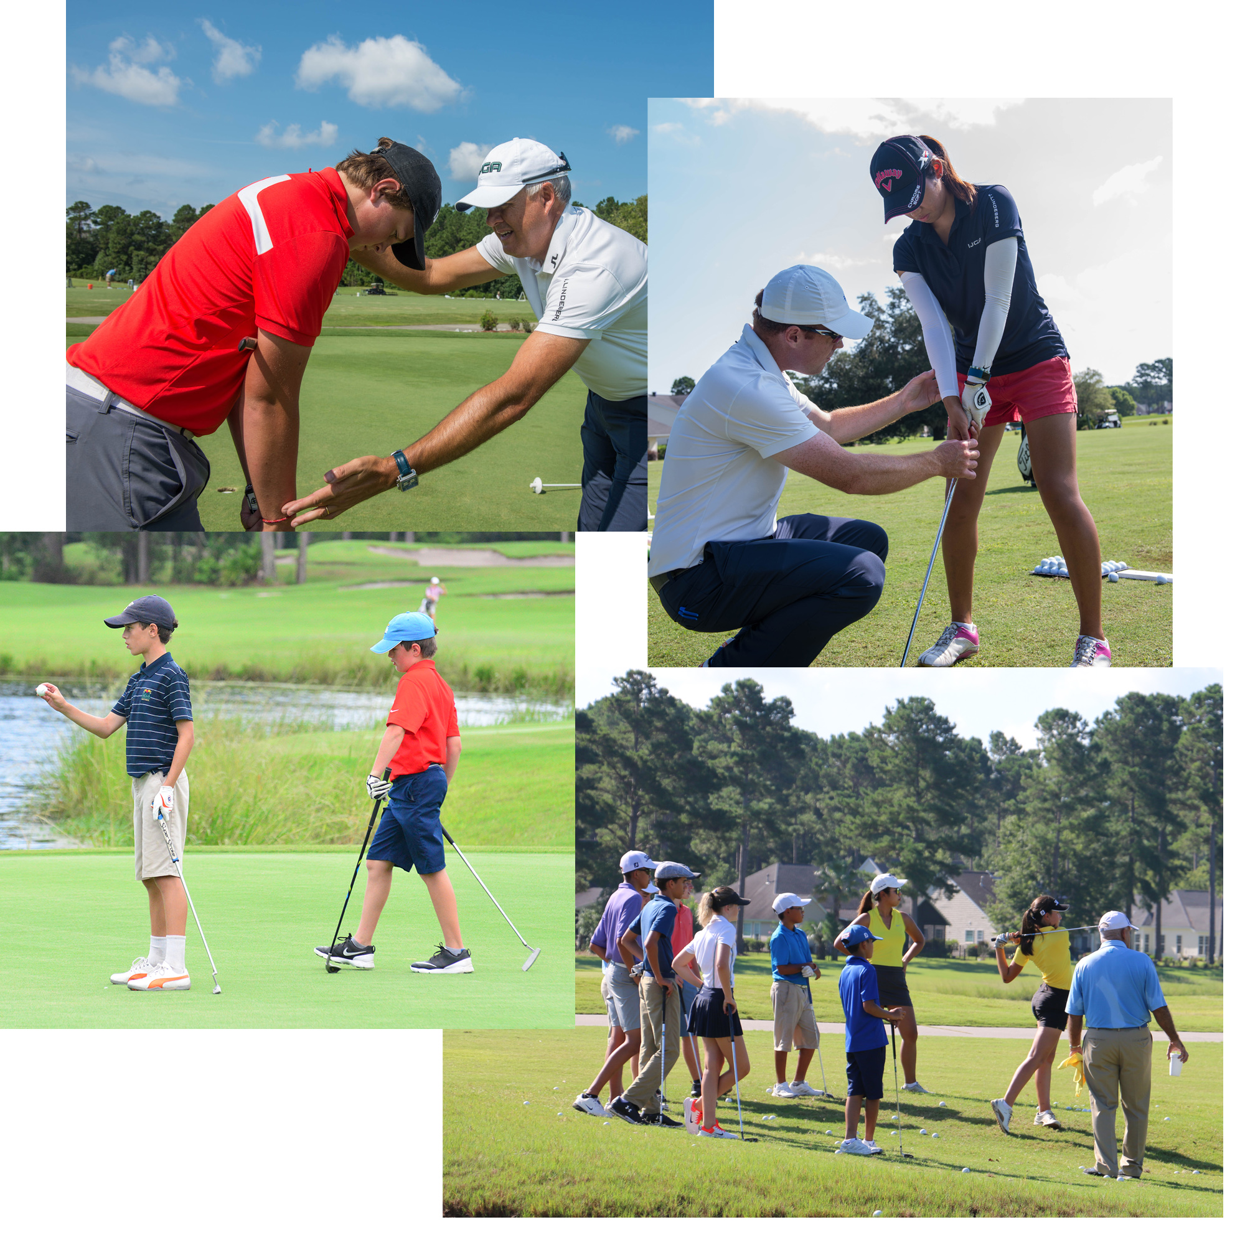

Welcome to the International Junior Golf Academy Summer Camp!

I know you will enjoy your time here. My coaches, myself and all the staff will ensure you do.

Our program is structured in a way that we will be incorporating the latest learning and practice techniques combined with modern technology like Trackman and video. Everything you work on will be fact based, not opinion based. The resulting data and information will guide your coaches towards the best way to coach you and to make you the best you can be. The coaching staff are well versed in many different styles of swing and aim to make you a great version of yourself based on the facts we gain from your initial evaluation.

Your practice habits will be based on developing technical competence, mastery of those skills then transferring them into tools to use in play through well-choreographed and planned training sessions which will incorporate many forms of training like interleaved, random and constraints. Your training will culminate in a tournament day to get you to complete the Performance Cycle.

Your coaches will transform your short-game using some ‘Tour Proven’ and proprietary short game techniques. Fitness is also a vital component and something we take seriously. Golf is an athletic and modern sport. If you are not fit and strong, you will find it hard to compete. So, your fitness trainers will assess your fitness and mobility and make recommendations for you to become a “Golf Athlete” which will enable you to swing and compete at your optimum level.

Again, welcome. Apply yourself diligently and you will get your rewards. Remember ‘Someone, somewhere is practicing smarter and harder than you’. Be that person!

Jonathan Yarwood
IJGA Director of Golf

How to create a solid game:

Skill Mastery and practice styles:

Let me start by saying that these are the following ways to practice:

- Block- Ball after ball from one spot
- Random- Different clubs, targets and lies for each shot
- Interleaved- Interlacing different practice styles with each other
- Constraint- Having pressure applied through penalties or constraints
- Competitive- Interpersonal competitive practice

The reality of practicing golf is that most of the traditional ways to practice, namely block practice, are counter-productive and a waste of time if done as the only way that a player practices. Hitting ball after ball from one spot is not how golf is played. Block practice is fine during a technical change, but in order to be able to transfer that skill the player needs to alter approach. A periodized schedule helps, where the player moves from technical to blending to competitive and then on to rest and evaluation. There are many types of practice in that framework, as a player shifts gears.

“Practicing the new technical skills in a ‘game-like way’ is the bridge from the range to the course and great scores.”-JY
It is fundamental to understand the following:

“A player is trying to master hitting the ball from A to B. They need to attain the skills through technical competence, but also have the ability to retain, master and transfer those skills in order to become a proficient player.”-JY

To play great golf you have to be resilient and be good at problem solving. Golf is played in an ever-changing environment and a player has to react in a positive way to changes to the norm and to adversity. So, in practice we try to create ‘desirable difficulties’ in an attempt to create “lasting learning”. By this I mean, trying to make practice tougher than actually playing. This is where the real lasting-learning takes place. Golf is an ever-changing environment and dealing with the problems that arise is key. That skill can be propagated with a well-planned and choreographed practice regimen. If you are lifting weights and it is easy, then there is no challenge point. The challenge point creates the desirable difficulty which makes the lasting-learning more powerful. Remember, that as the player grows, so does the challenge point. This should be reflected in the difficulty of the tasks.

Block Practice:
Block practice is the traditional way that players train. I call it a ‘game within the game’ and one that bears no resemblance to how the game is played. I have thought for years why people spend hour after hour doing this, fooling themselves that they are getting better, when in reality they are not. It’s delusions of competence and often they do not perform any better than they would if they did not practice. Players become addicted to this, counting how many hours they did each day like some sort of badge of honor with a feel-good factor attached. Through research by people like “Morgan and Shea” we have worked out that this practice is the worst for skill retention and mastery. The only time, in my experience, block practice has merit is when there is a technical change to be made.

‘Retention and mastery are the key. Having a lesson and becoming technically more competent is merely an ‘illusion of competence’ unless it is backed up by a robust plan to retain it, transfer it and master it, then it can be called the first step on the road to competence.” -JY

Random, variable and interleaved Practice:
Random and interleaved practice is where a player hits a different shot each time. This gives problems to solve and solutions to be found. For example, hitting ten balls with a different club at a different target would be good random practice. Interleaving a driver every two balls, shaping a shot and changing the lie would be examples of interleaved and variable practice.

‘These ways to practice are the best ways to transfer the technical competence and skill acquisition to lasting learning and skill mastery.” -JY

Constraints led practice:
Constraint led practice can be very productive as the constraints produce perceived pressure and increase the challenge points where lasting-learning takes place. There are many ways to challenge yourself using constraints led practice, especially on the golf course. For example, you could try and hit only one side of the fairway. If you hit the wrong side, you add half a shot. You would play to hit it past the hole all day, if not you have a penalty. This type of practice is excellent and open to your imagination and skill level.

“A player can maximize skill mastery if they couple it with technical competence.”-JY

Periodized practice:
At IJGA camps we also utilize a periodized training model. This is where the month, week or even day, according to time frame of training, is turned into the following phases:

- Technical Phase- This phase involves technical changes to technique. It is often technology heavy and includes video analysis and tools to create a tangible, factual technical assessment. There should be tangible evidence of changes and improvements during this phase. This phase creates insular thinking and focuses on altering movement patterns with less concern of the target and outcome. This phase has less involvement from an external psychologist in general.
- Blending Phase- This phase changes gears slightly from the technical phase, as it becomes the ‘trust it’ phase. There is still focus on technical changes, but a player and coach should be working on consolidating those changes and also including the outcome accuracy more. The mentality becomes less insular, more of a trusting mentality.
- Competition Phase- This takes place before an event. The focus is now on using the tools created in the previous phases. Less balls, total trust in what the player is doing and accepting the tools they now have. Creativity and artistry can be encouraged at this stage even if the technique deteriorates slightly on occasion. Winning ugly is fine here! This phase is psychologically intensive with the psychologist encouraging trust, acceptance and self- reliance.
- Rest and Evaluation- This is a vital phase, often over-looked. It is important to sit down and reflect on the effectiveness of the training. Look at stats, tournament evaluations and other evidential markers to find out what went well and what needs work. This is also a great time to rest physically and mentally as the game can be very draining. There is little or no point in training if the athlete is tired, as it can only lead to another academy pitfall; burnout.

This process when combined with various styles of practice outlined gives you the best opportunity to peak perform at the right time.

Fitness:
Golf is a power sport nowadays, you must be fit and strong to compete. We value the fitness portion very highly. Along with the physical screening elements, we ascertain what needs to change in your body as part of the blueprinting process. Then the training portion goes hand in hand with your swing and body improvements. You cannot have one without the other, so this is something that is non-negotiable. TPI has given us great tools to utilize in order to not only make you an athlete but to improve your movement patterns through fact based testing and analysis.

Course Management and Score making Craft: SUB288 Golf
The DNA and composition of golf courses are pretty similar in nature. Namely, they have a similar amount of par 5’s, par 3’s and long and short par 4’s. After over twenty years as a tour coach, I created a scoring system based on the how the best in the world make a score, I called it SUB288 golf.

An intelligent golfer can learn to gear their game around the exploitation of certain holes and avoid trouble on others. The stats bear out that par 5’s are the lifeblood of scoring, year in, year out. Tiger Woods for example was -245 for his career on the Par 5’s at Augusta (through 2005).

Putting ‘birdies in the bank’ on these holes is vital to composing a score. They can act as a cushion for poor play on other holes or on really good days create the foundation for a truly great round. The same can be said of short par 4’s. Often these require just a strategic tee shot followed by an accurate short iron; again, very manageable and master-able. Indeed, a player can work on the accuracy and scoring shots of the par 5’s and short par 4’s that week on the range in order to have a great opportunity to shoot low.

If you think about it, no matter how a player is hitting the ball they can get it within a short yardage of a par 5. There are four par 5’s on most courses. That leaves four short-shot opportunities to make a birdie. If a player converts three out of four then that is three under on those holes alone. I call these ‘soft birdies’. Over a four-round event, that is twelve under on those holes alone! “Birdies in the bank”.

Par 3’s consistently average over par at almost every PGA event. They often invite a player into a sucker pin, which inevitably leads to bogey. Indeed, if a player averaged par for all the par 3’s at most events, they would be under par relative to the field average. A point five saving to par adds up to minus two over a four-round event. The key is to not get too greedy. Most par 3’s have small greens. Often hitting a shot to the middle of the green is good enough to reduce risk
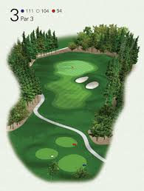
and give a realistic chance of birdie. The longer the hole, the more conservative the play and the mindset in general. A player relaxes by not pressing too hard here and will make more birdies by default as a result. A good solid game-plan will yield more birdies as the player is more process focused and in control.
“It is possible to make a score with any game that you have, no matter how you are hitting it.”-JY
Lastly, the PGA stats back up the fact that not many birdies are made with a long iron in hand. The proximity to the hole makes it more difficult as the distance reduces accuracy. The best on the PGA Tour from 200-225 hit it on average 33 feet away and often miss the green. The best make less than 5% of putts from that range. So clearly not many birdies are made from long distance. Again, a more relaxed mindset with a middle of the green mentality can reduce risk and yield more birdies and solid pars. Again, this creates improvement over the field average.

A, B, C and D games:
Understanding that golf is a difficult game and accepting that you are not always at your best is the key to becoming a good player. Indeed, most tour players only play really well for six weeks a year. Outside of that they are often playing ugly golf and crafting their ball round using resilience and heart.

Obviously, there are days when a player is in the zone and lighting things up, which we can call their “A” Game. They can take dead aim at most things and it comes off. These days are more the exception than the rule, but a player strives to find them often. But if a player uses intelligent course management and golf IQ, they will play more solid rounds more often with or without their “A” game.

Having a reactive game plan is very important. At any given time, a player can have their “A” game and suddenly have their “C” game, so they need a plan to work with it. For my course management system, I have four categories of a player’s game:

- “A” Game- Attack: These are the rare days that a player is in the zone! They can pretty much take everything on as they have a high degree of ball control.
- “B” Game- Blend: This is when the player has some high ball control but the course may be tricky or they have a slight doubt or flaw in their game here and there. So, they attack and play conservatively. This is the most prudent course management style of all four in my view.
- “C” Game- Conservative: The player has inconsistent ball control and has to play unattacking golf.
- “D” Game- Defensive: The player has no control or confidence at all. They may be hitting a hybrid or three wood off the tee all the way around. They play total defensive golf aiming for the middle of the greens and fairway finding.

In all four categories, it is possible to make a score. It just requires a modicum of golf IQ and intelligence to use a reactive game plan.
A vital element of the art of scoring, for it is an ‘art’, is to have a system for the pins during a round. For example:
Red light pin: This is a pin that is a sucker pin. Cut tight and if you miss position your ball, then you can get into trouble. It should be played away from.
Yellow light pin: This is a pin that can be attacked if the player feels good about their game but can be played away from if they do not. It varies with distance of the shot.
Green light pin: This is a pin that should be attacked. Little or no risk and much reward
The proximity and distance to the hole is a big factor on the traffic light pin the player thinks is ahead of them, as is how the player is feeling about their game.

“Your swing needs to be good enough to control the ball, that’s all. Your short game does the scoring and your mind glues it all together.” - JY

IJGA Swing Ideals:
Although we do not teach a method at IJGA, we do have some ideals, which we like to remain close to. It is important to be well versed in all types of swing styles and lesson types in order to be a well-rounded coach.

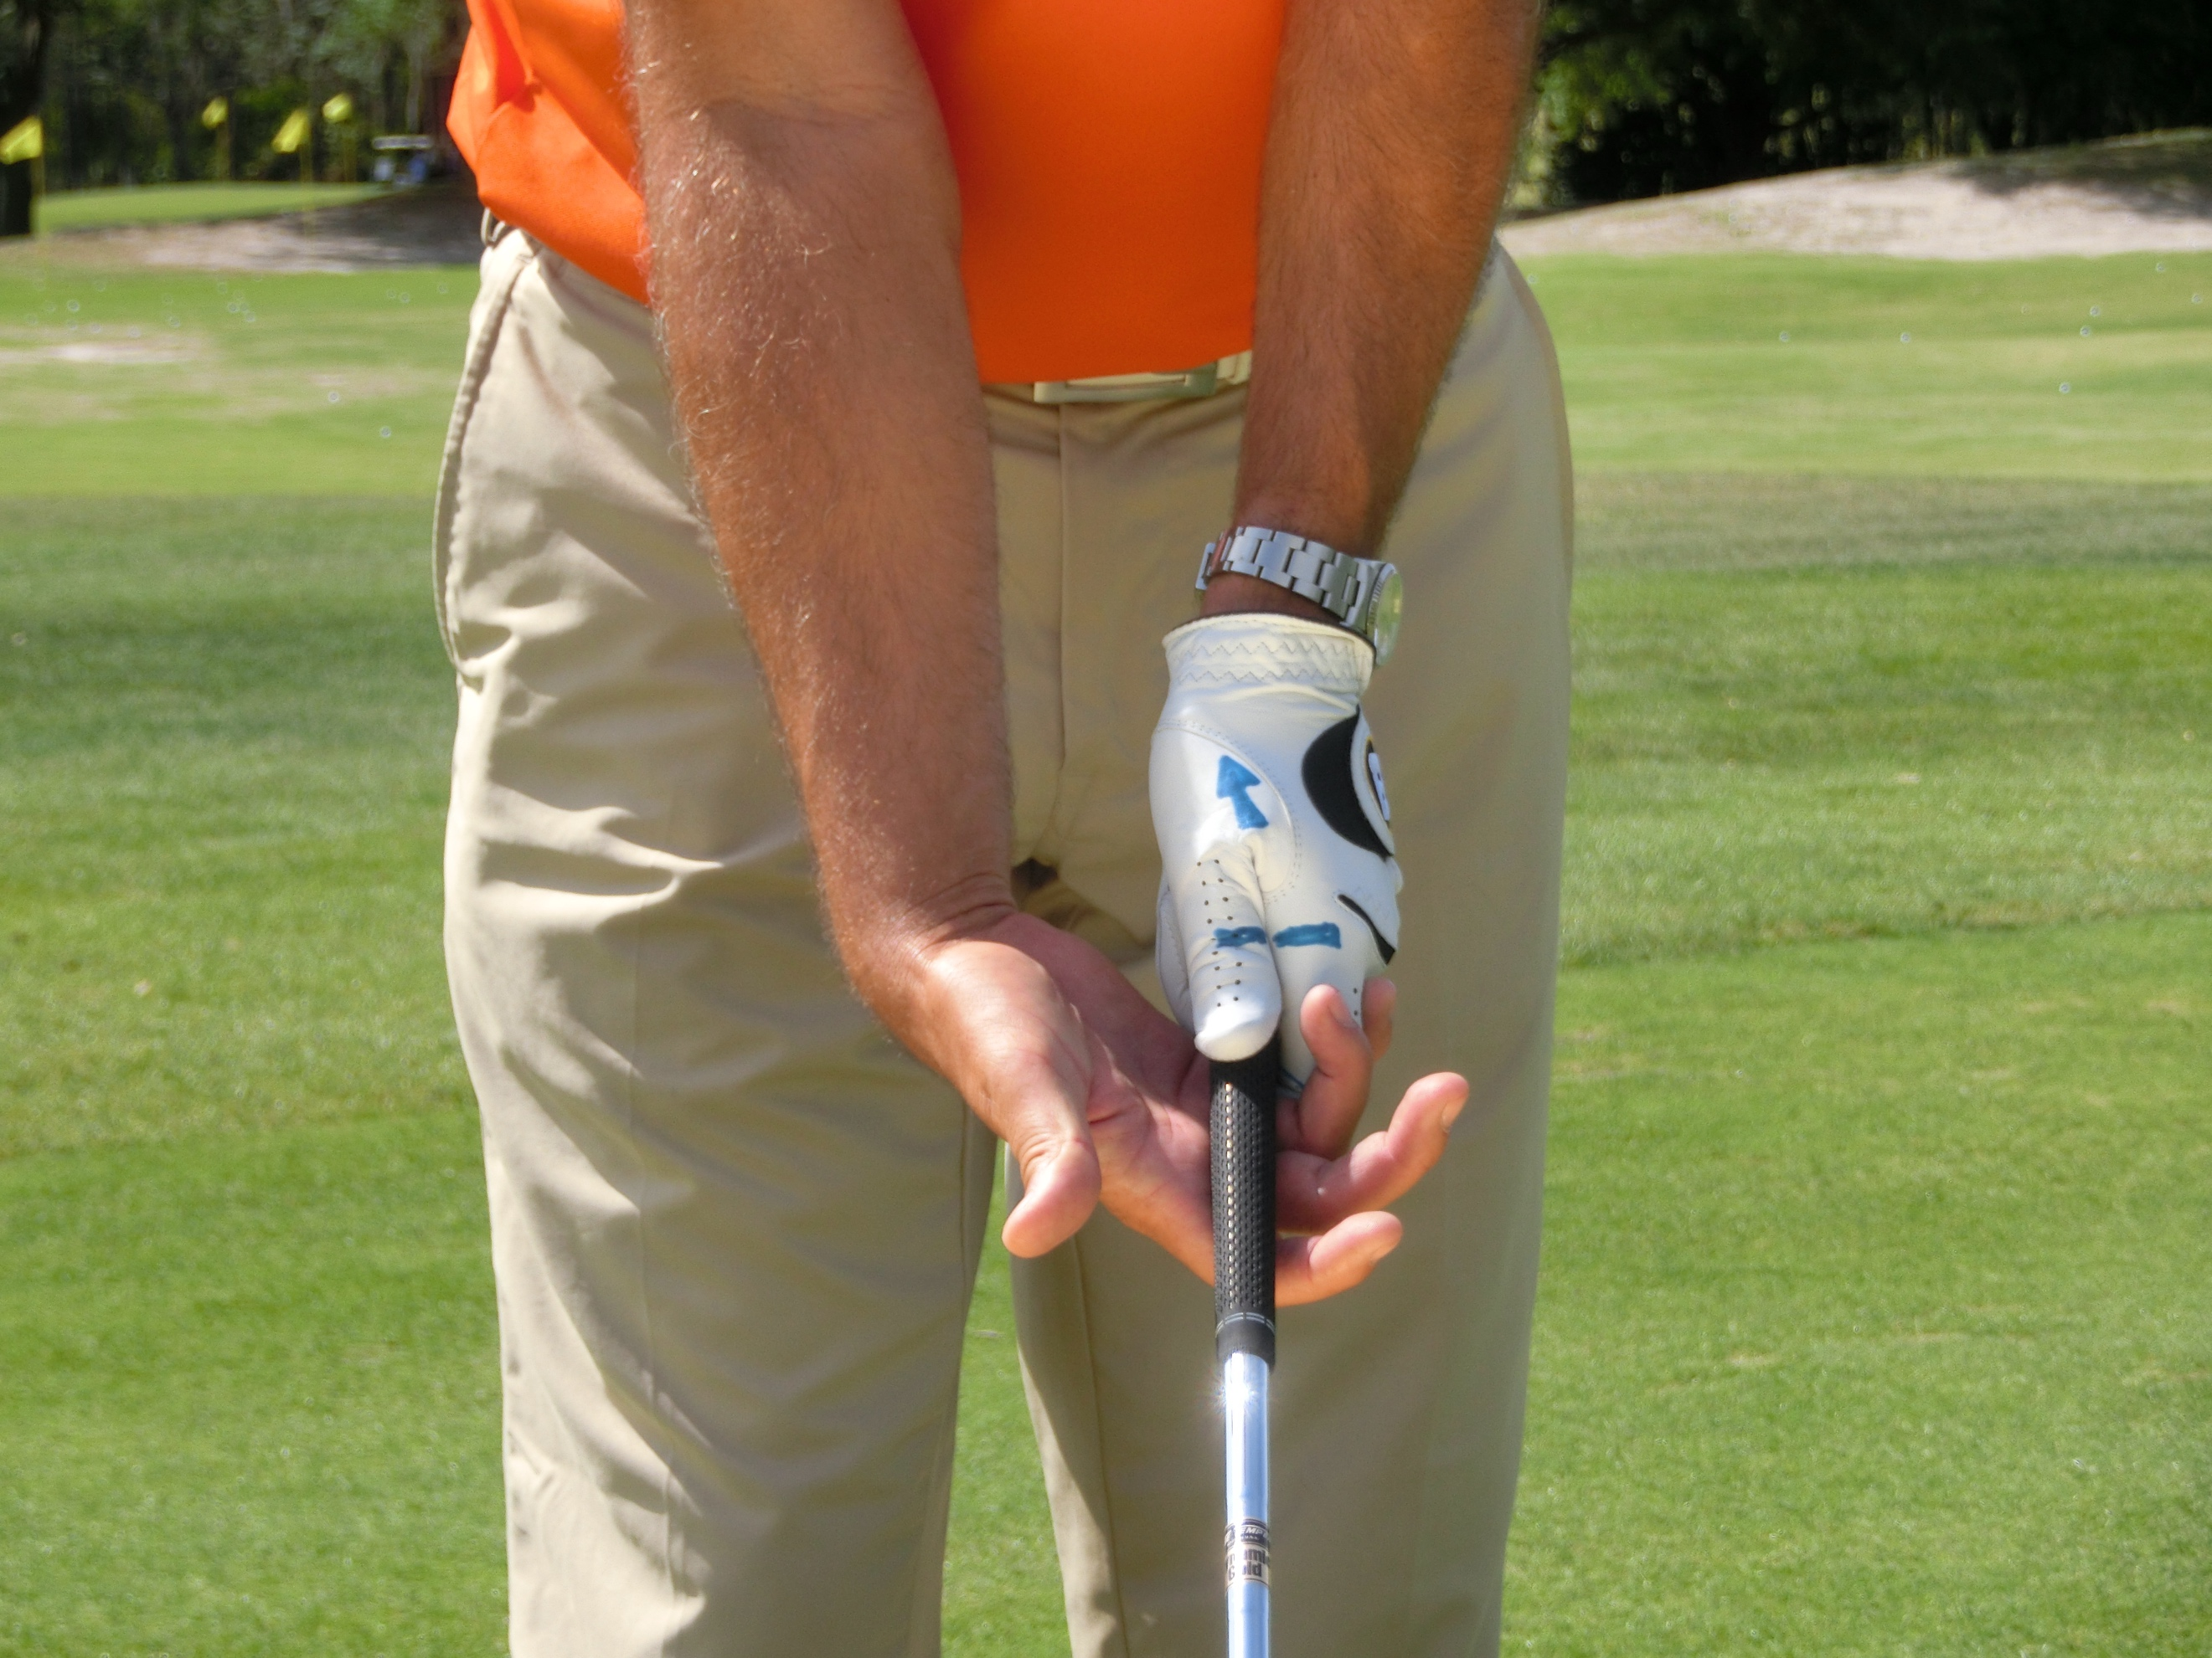
Some ideals would be:
- Grip- This should be in the fingers of the left hand not in the palm. The thumb of the left hand should fit into the lifeline of the right hand when they come together. The right thumb and forefinger should form a trigger with the right thumb across the grip. It is vital to match the forearms to this hand position. The V of the left hand should point towards the right ear. The V of the right hand should point between the ear and shoulder. Grip pressure should be not too loose or too tight.
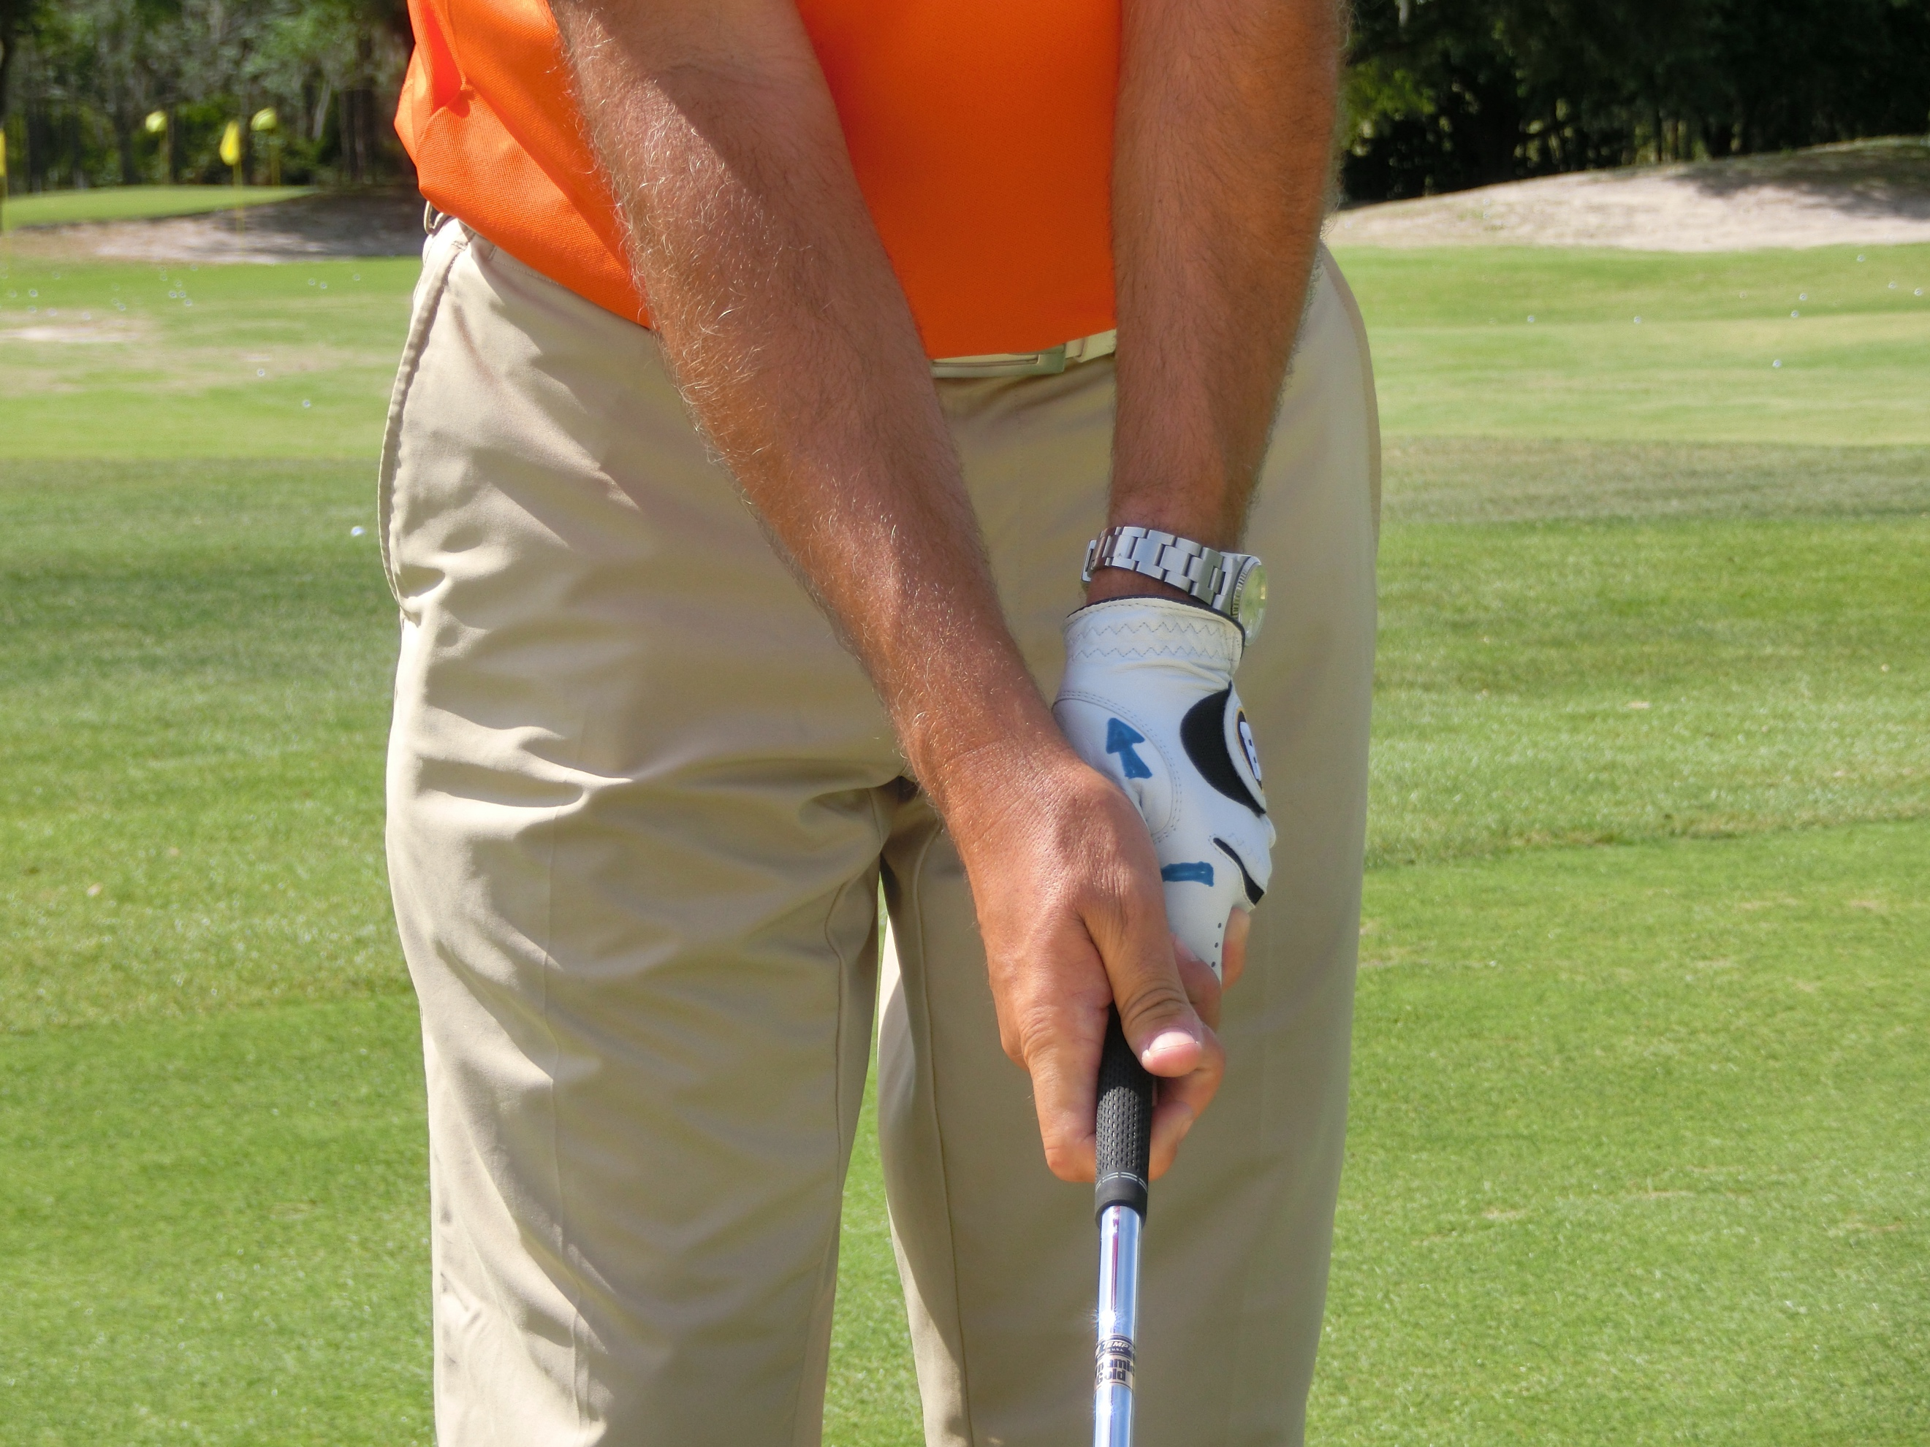
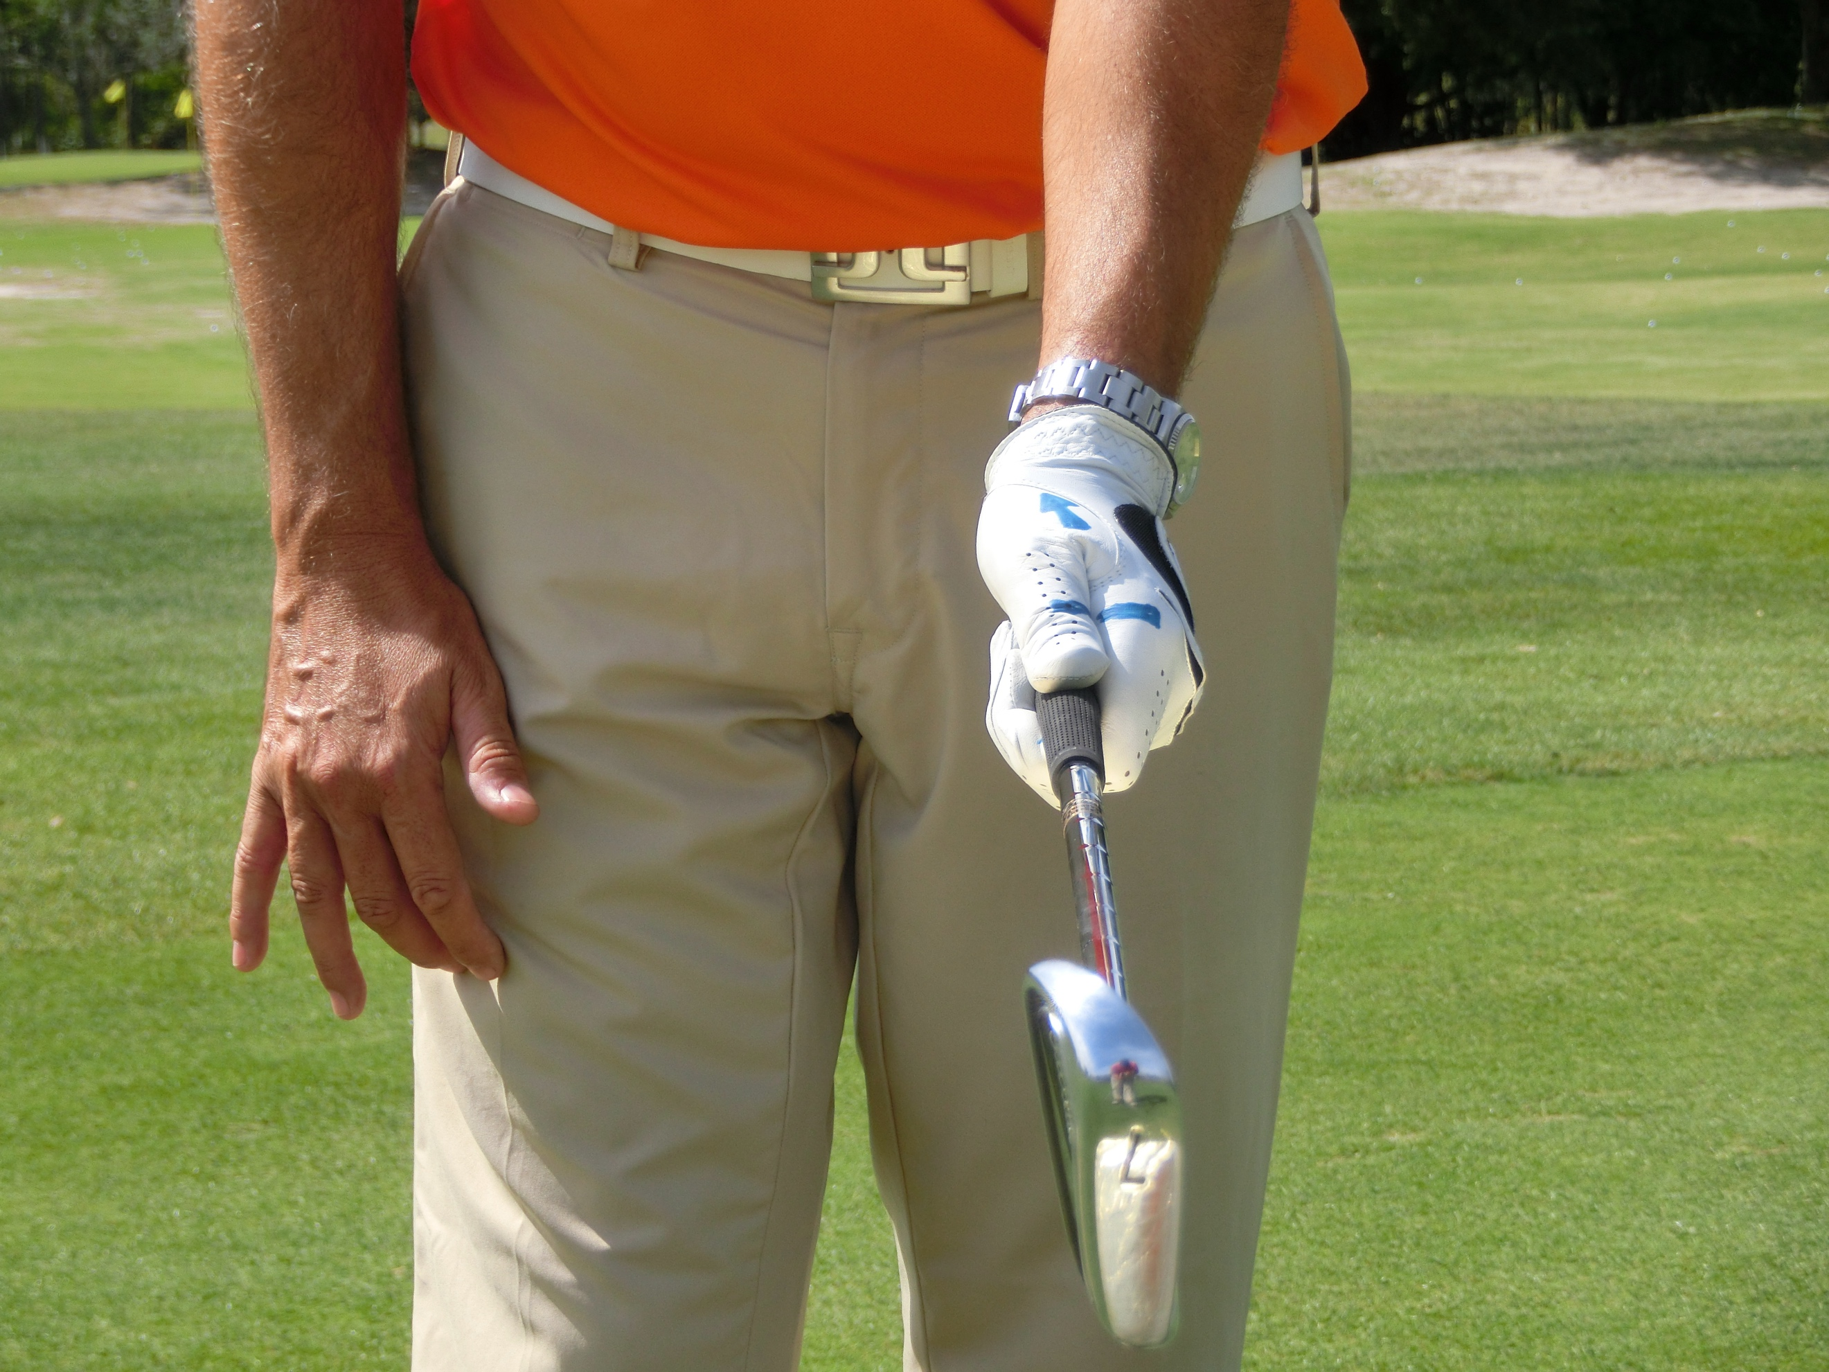
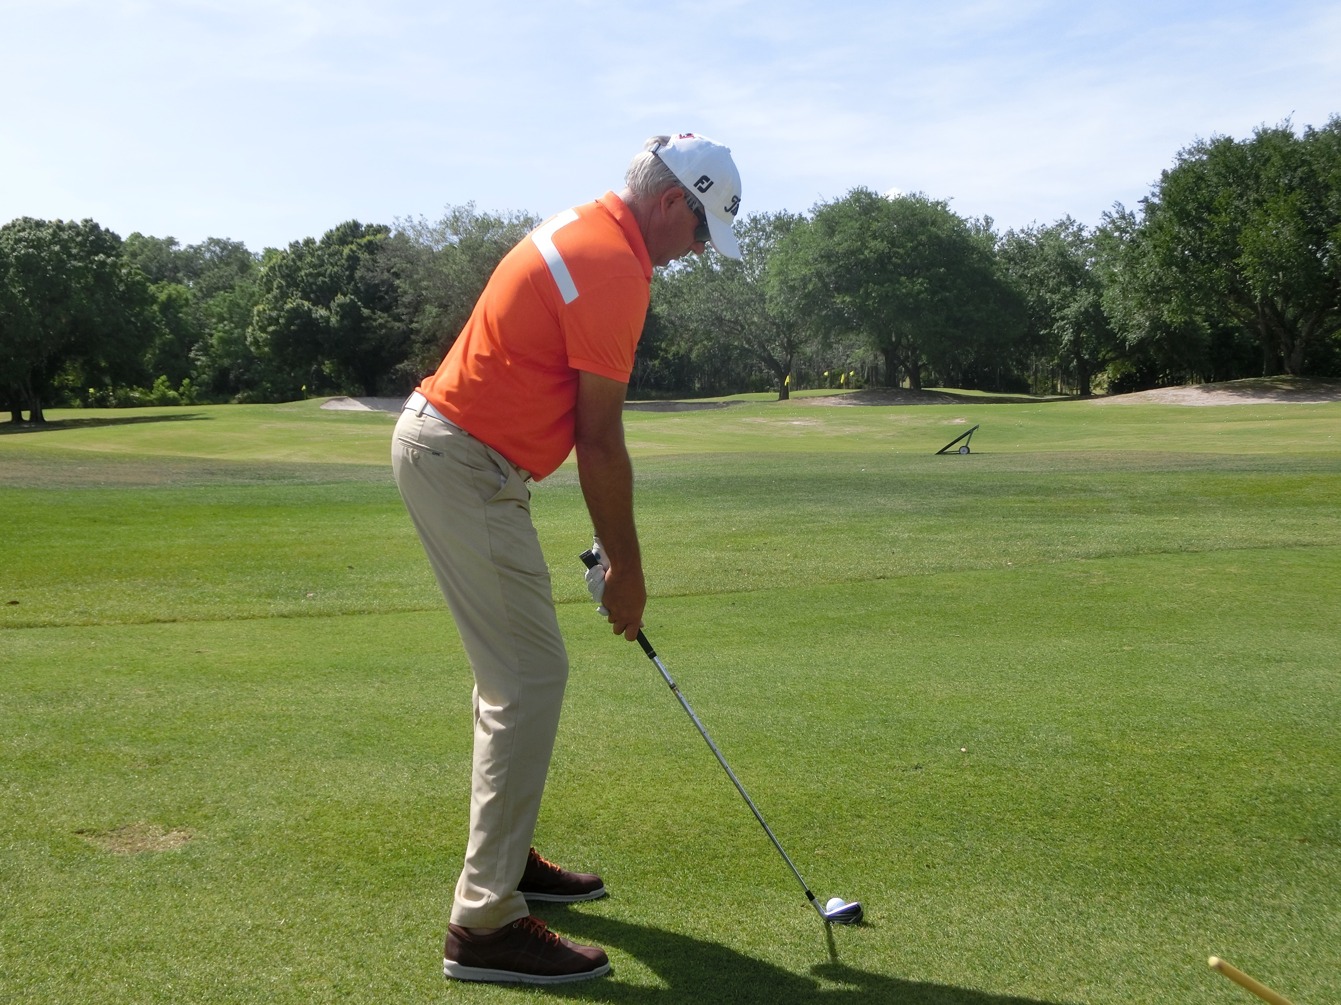
Posture- Like the grip, this is non-negotiable. The posture needs to be athletic and balanced and ready for movement. A player has no chance of creating an athletic swing from an unathletic starting position. So, the width of the stance should be around shoulder width. The knees slightly flexed, the back straight in the lumbar spine and gently curved in the thoracic, with the arms naturally hanging down from the shoulders. The balance is crucial, not too far on the heels or not too far on the toes. If a player were to hang a club from the right shoulder socket, the shaft should fall down on the tricep and the tip of the knee with the line running down into the ball of the foot. Internally, the body should be switched on and activated including elements of the quads, glutes and abs.
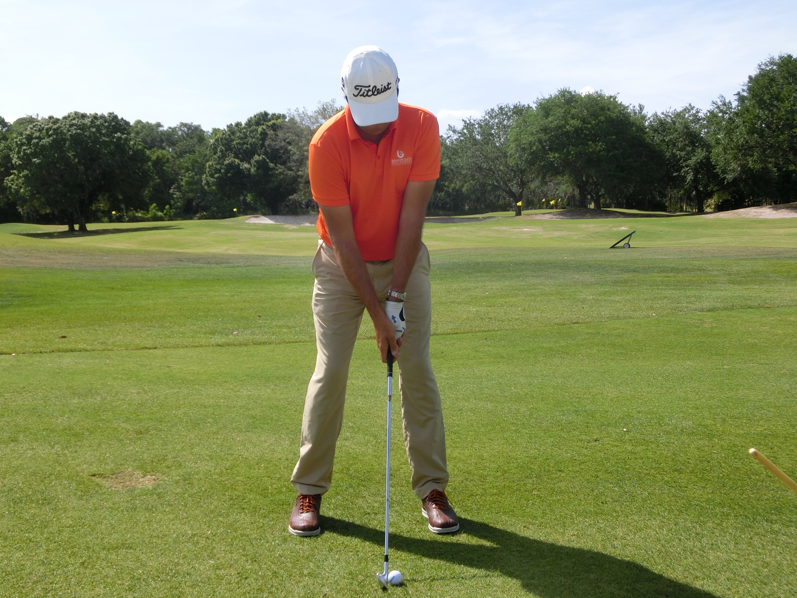
Alignment and ball position- Naturally a player should be parallel to the ball to target line with their feet, hips and shoulders. The ball should be positioned in a graduated ball position with the short irons in the middle of the stance, moving gradually left as the club length increases and culminating in the driver off the left heel.

- Pelvis- The pelvis position is very important and best viewed from the rear. The beltline should look relatively level with the spine tilted gently away from the target.

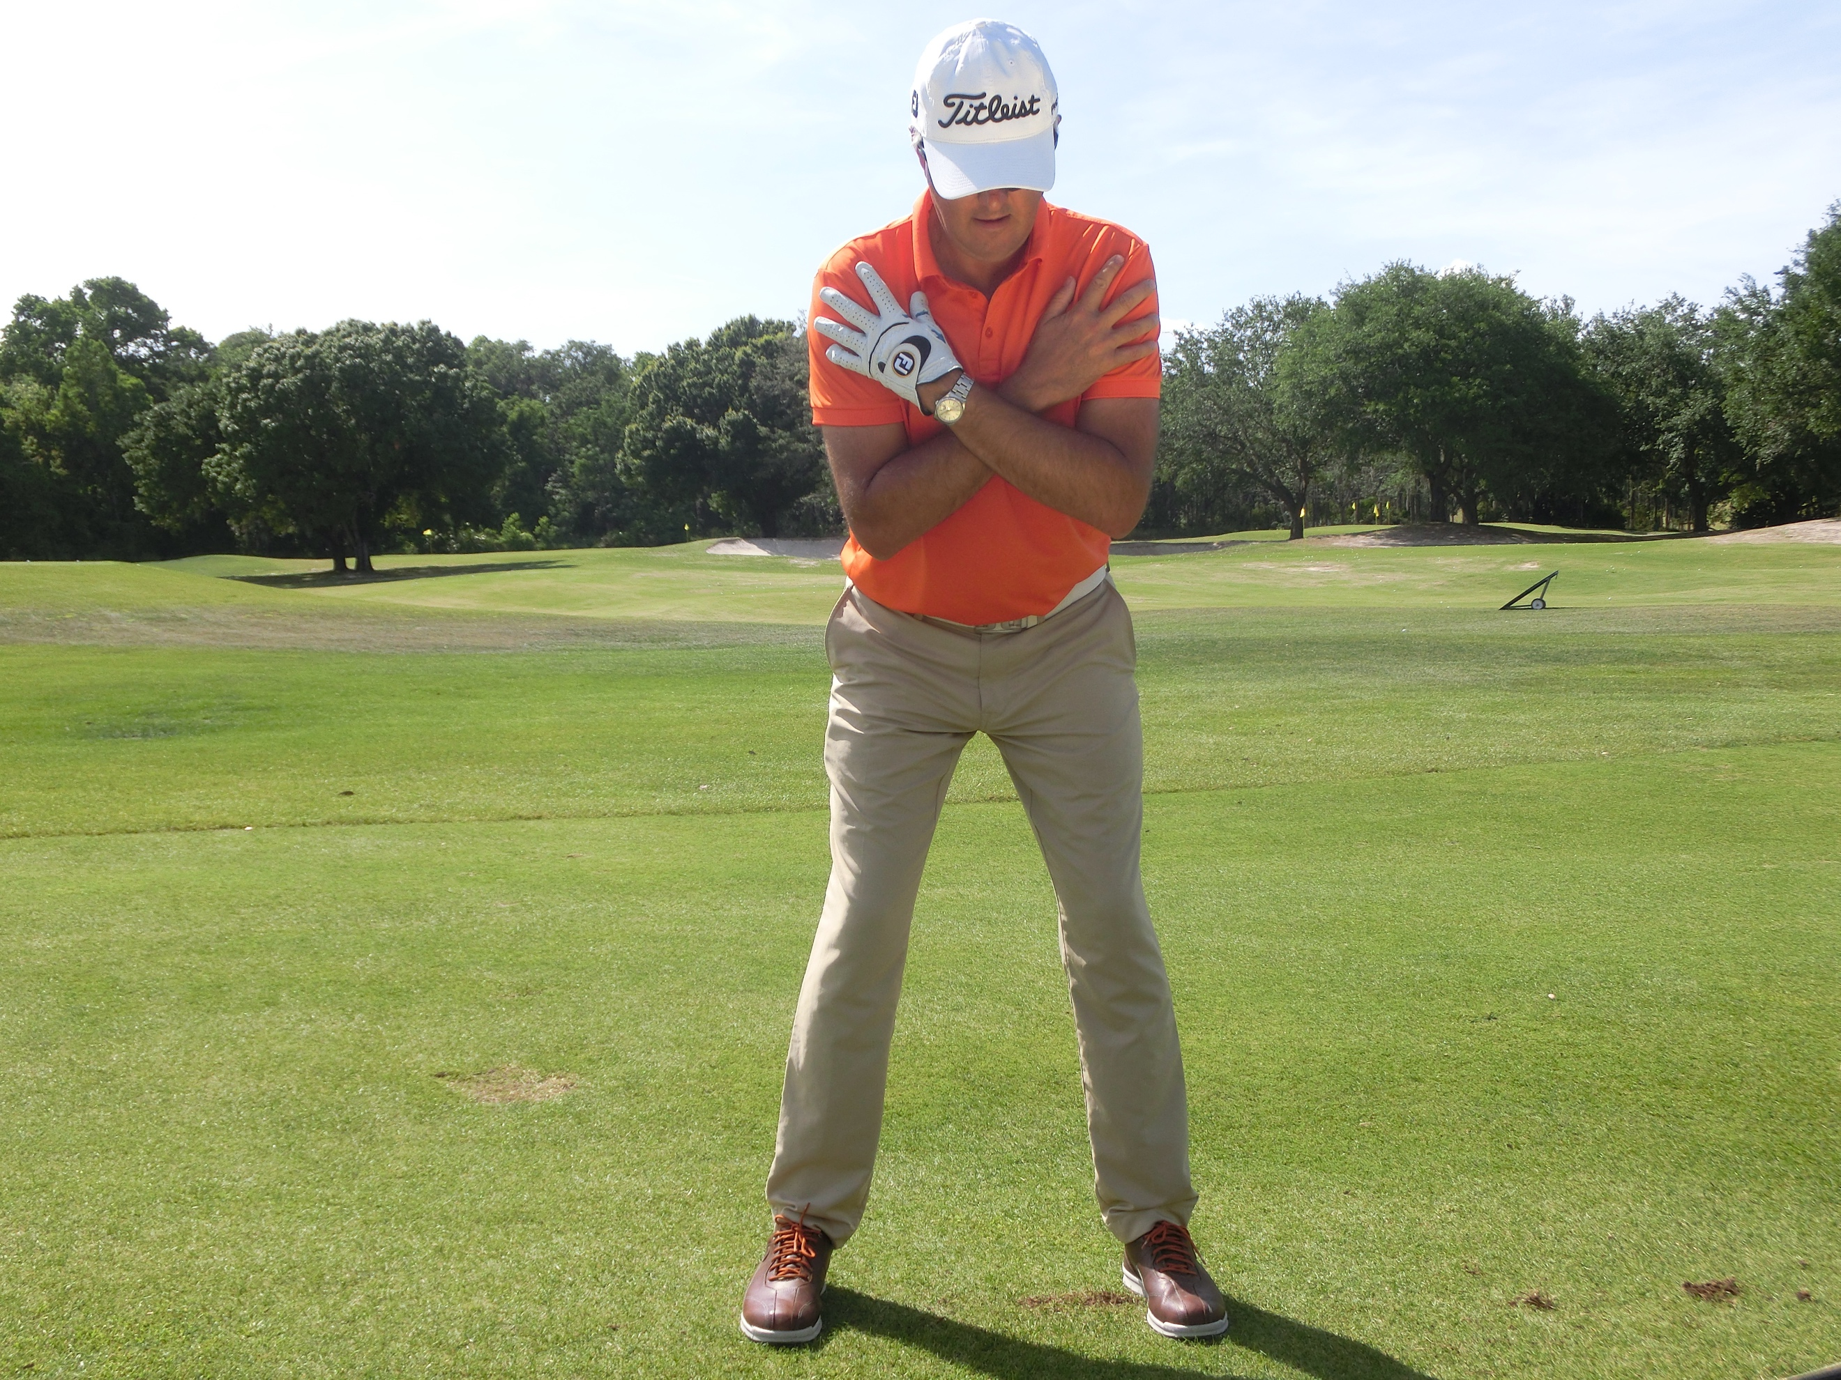
- Body Motion- Big picture would be to create a tight, well sequenced and wound coil as opposed to a loose ‘turn’. Use of the ground to generate energy and power, torqueing the muscles and sequencing the arms and club in harmony with this. The transition should increase the ground pressure as the lower body separates from the upper and moves diagonally towards the left toe. The legs then stabilize to allow the upper body and club to catch up. The weight then moves into the left heel as the left leg ‘posts’ allowing the right side to fire through the shot, resulting in the body being open to the target at impact with the arms in sequence to that. The resultant balanced finish is a bi-product of this harmony.
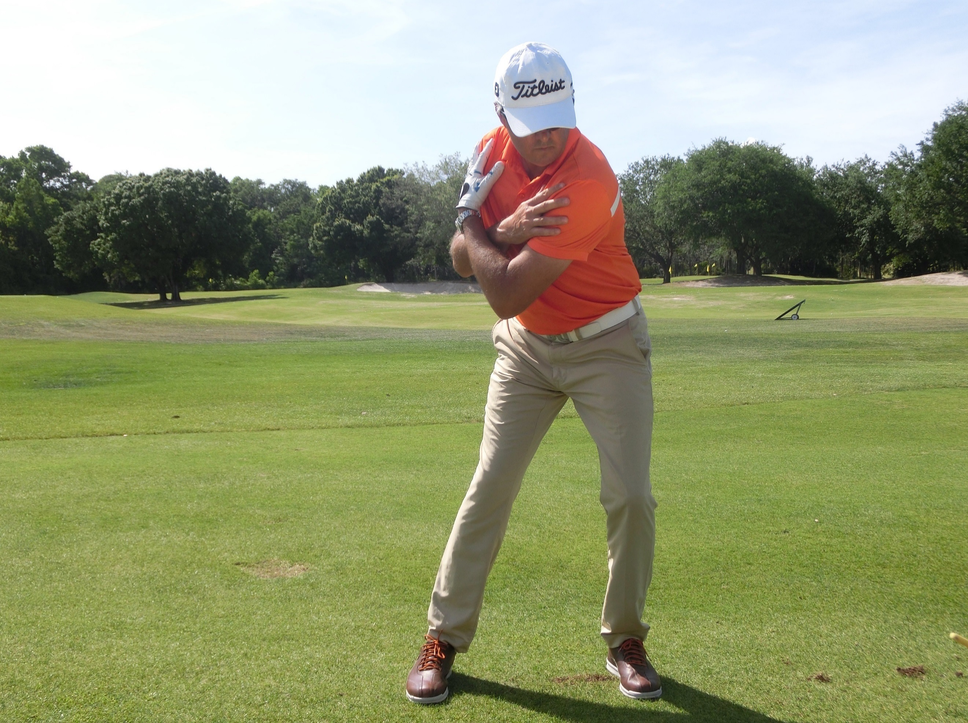
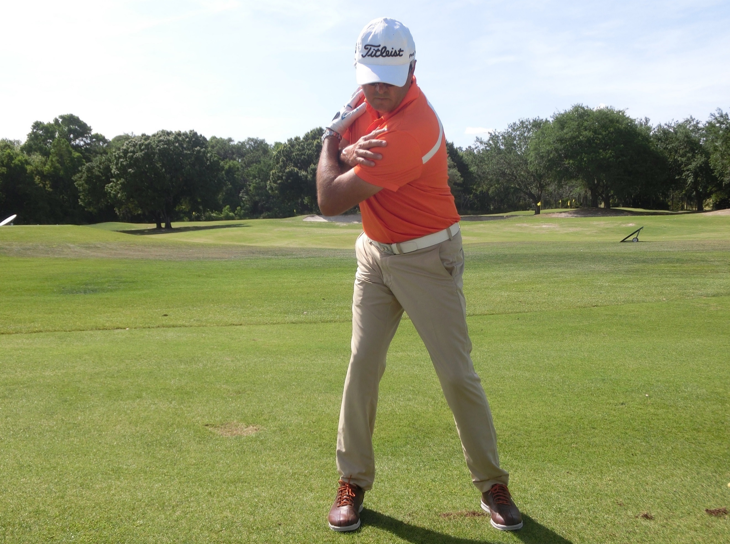

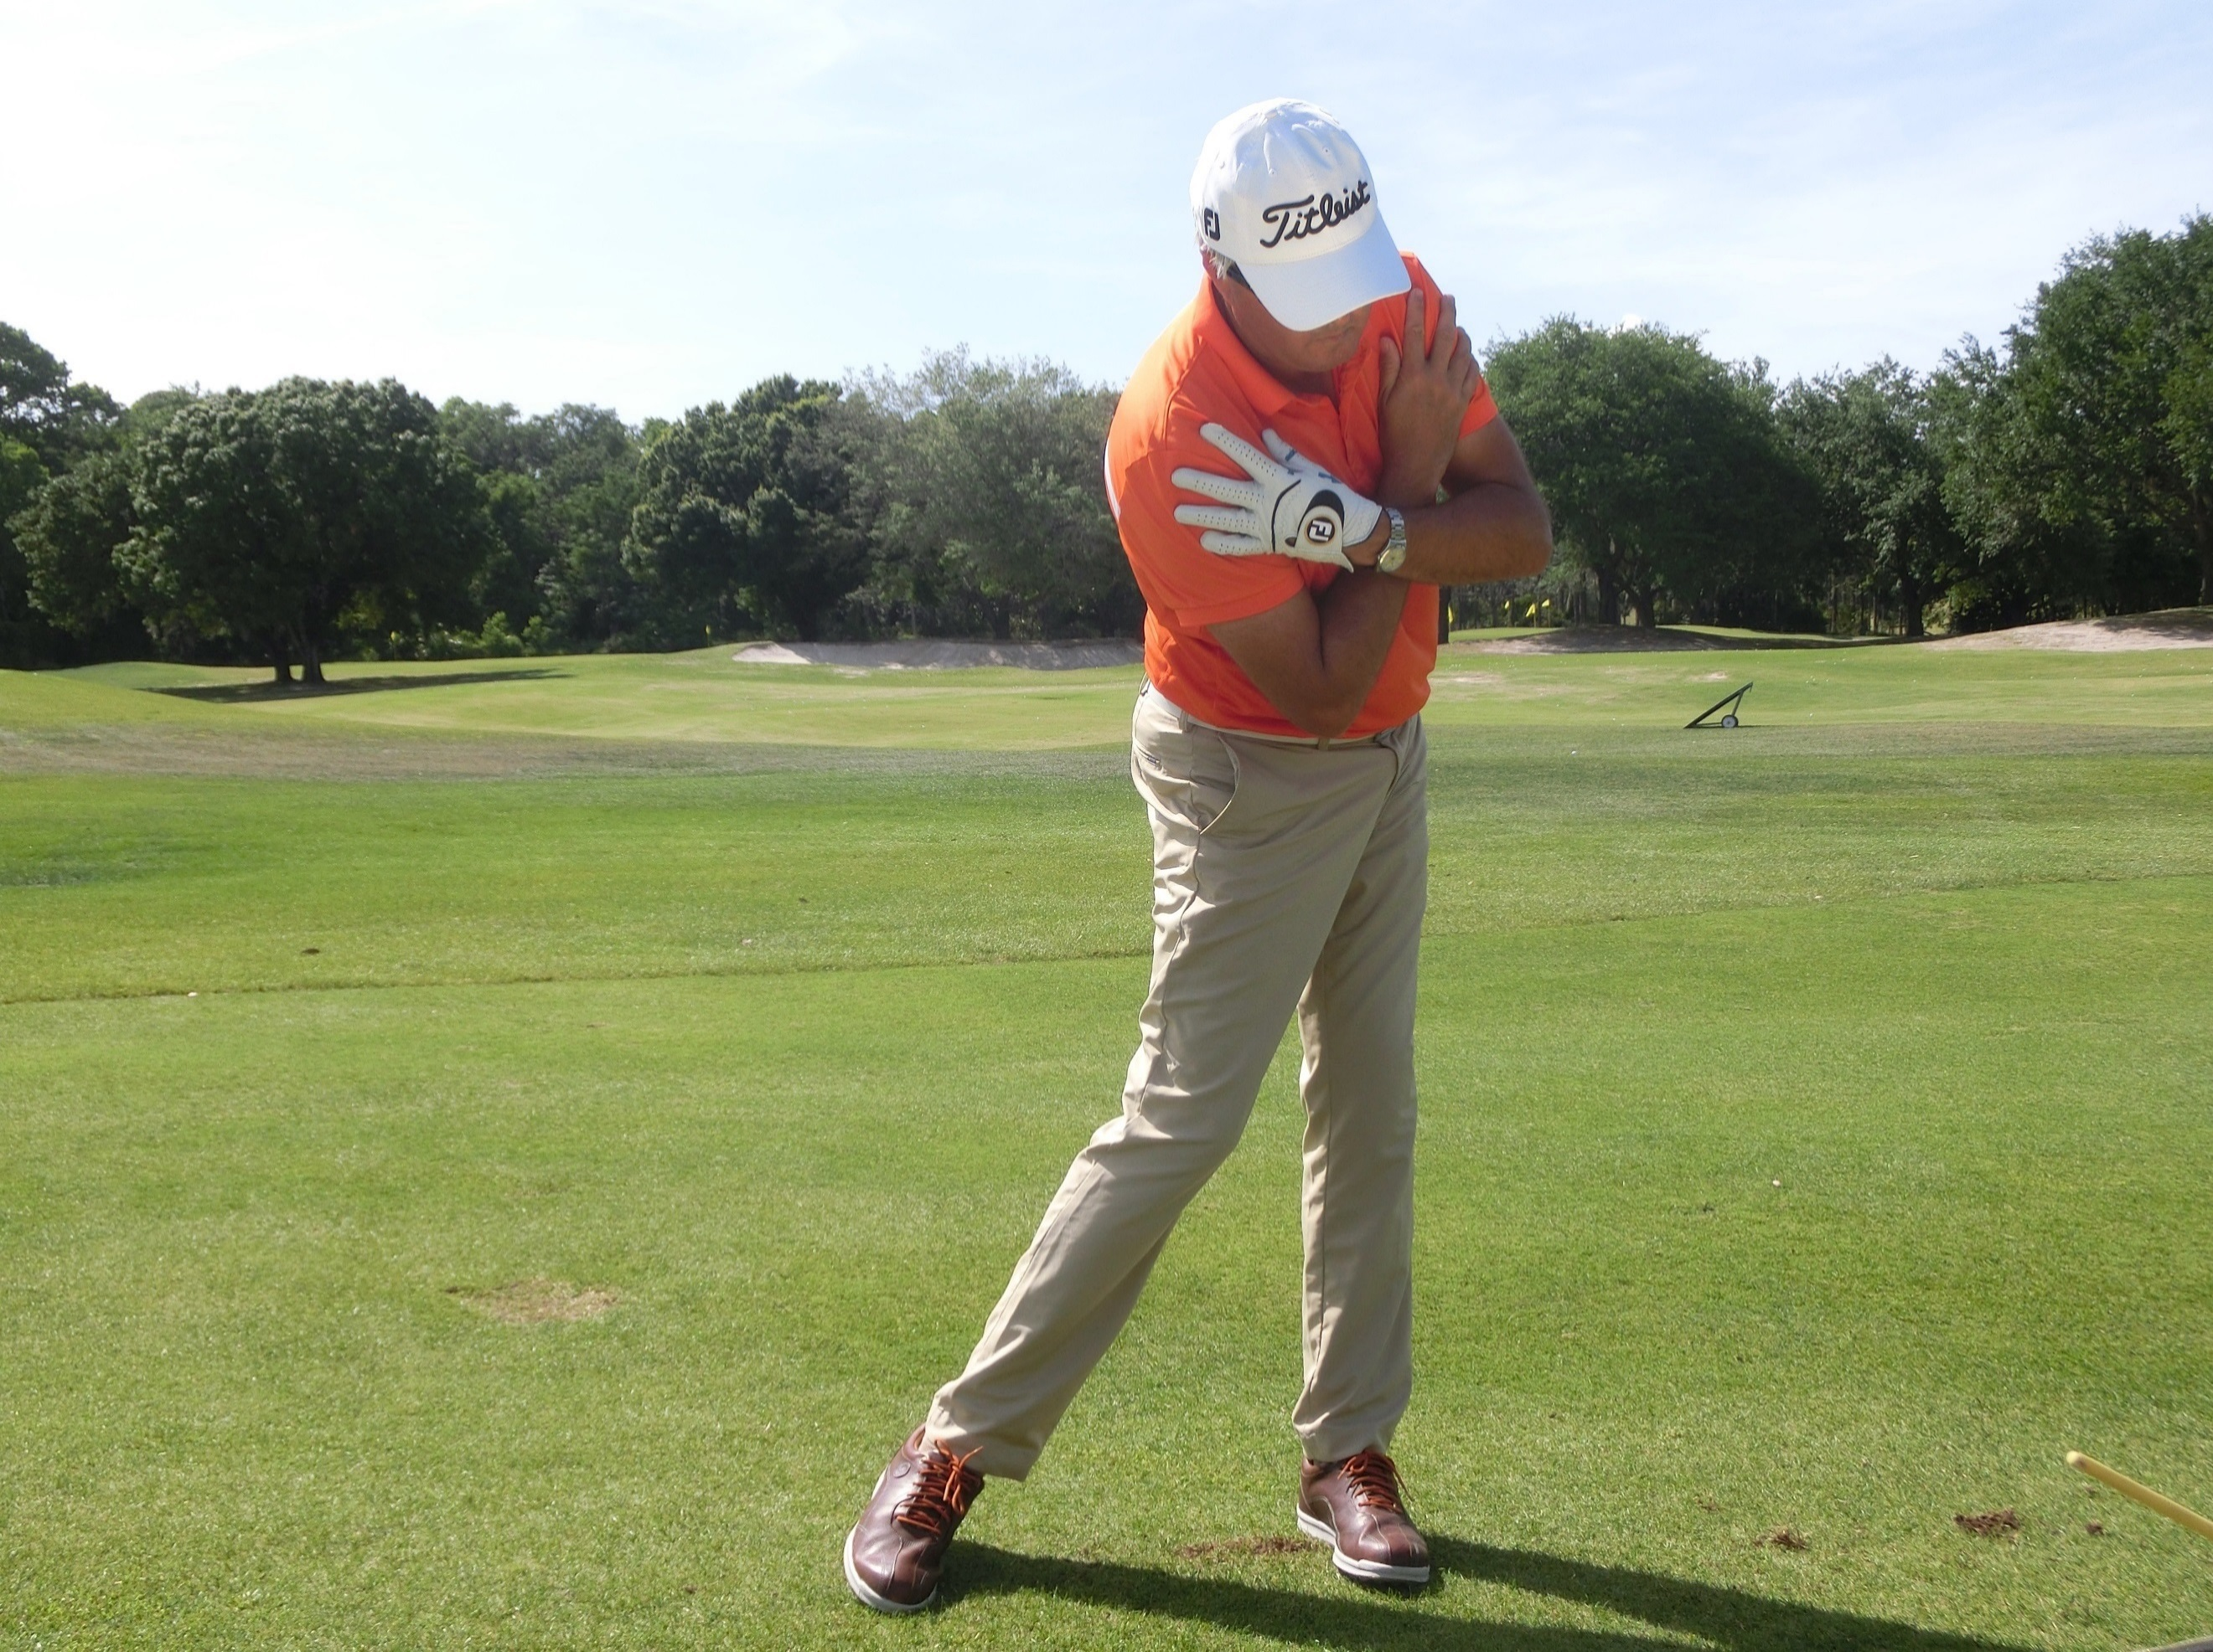
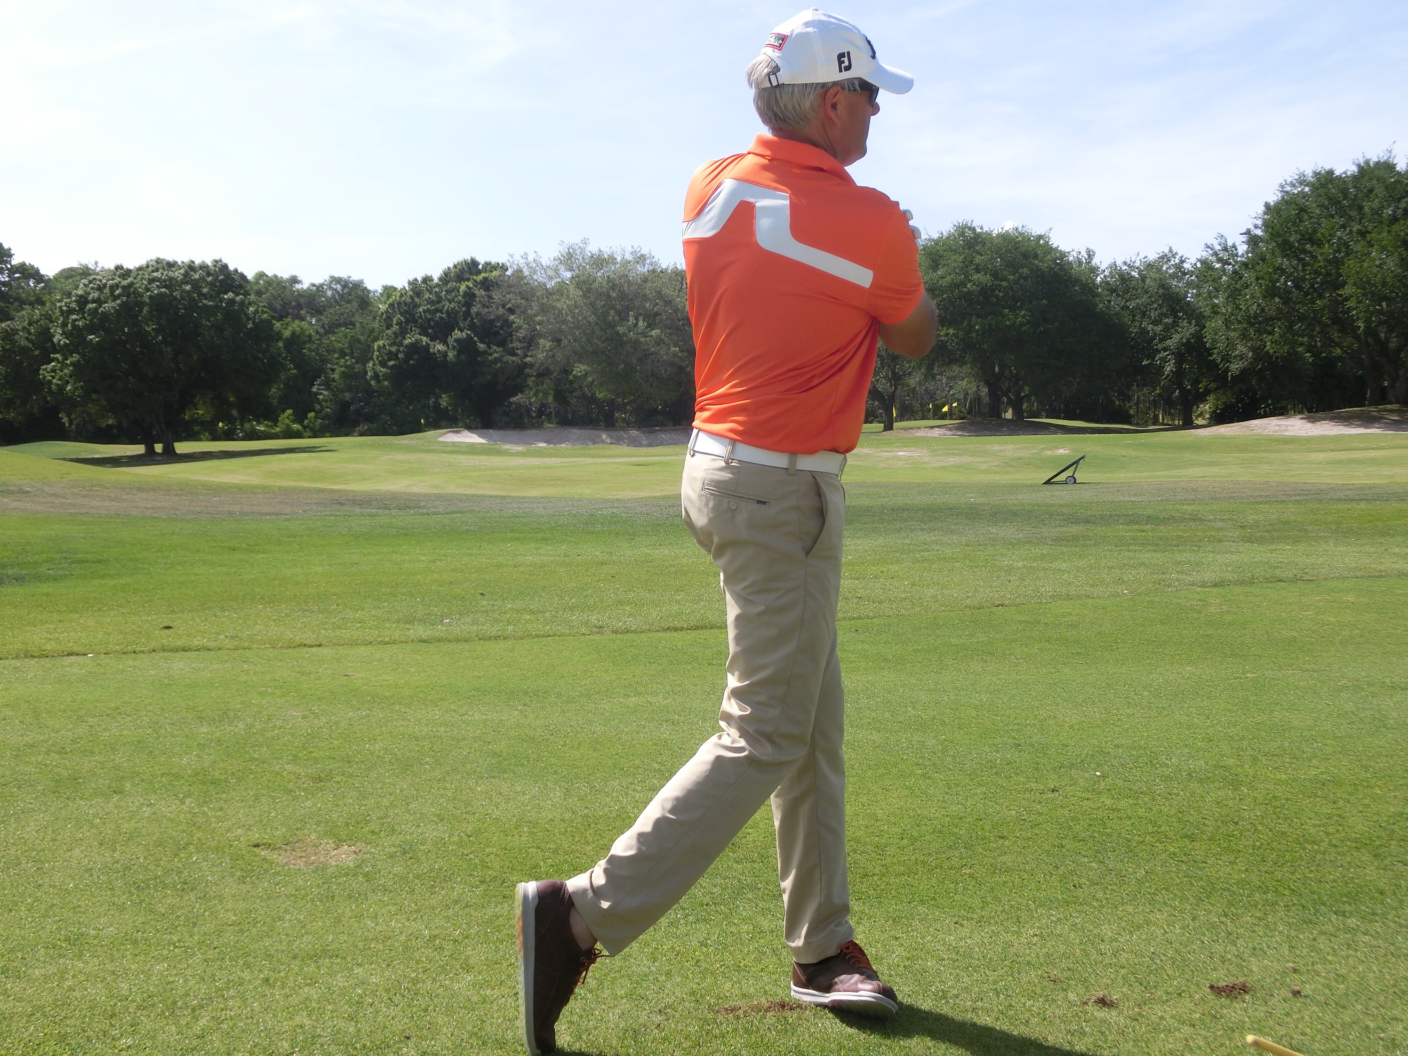

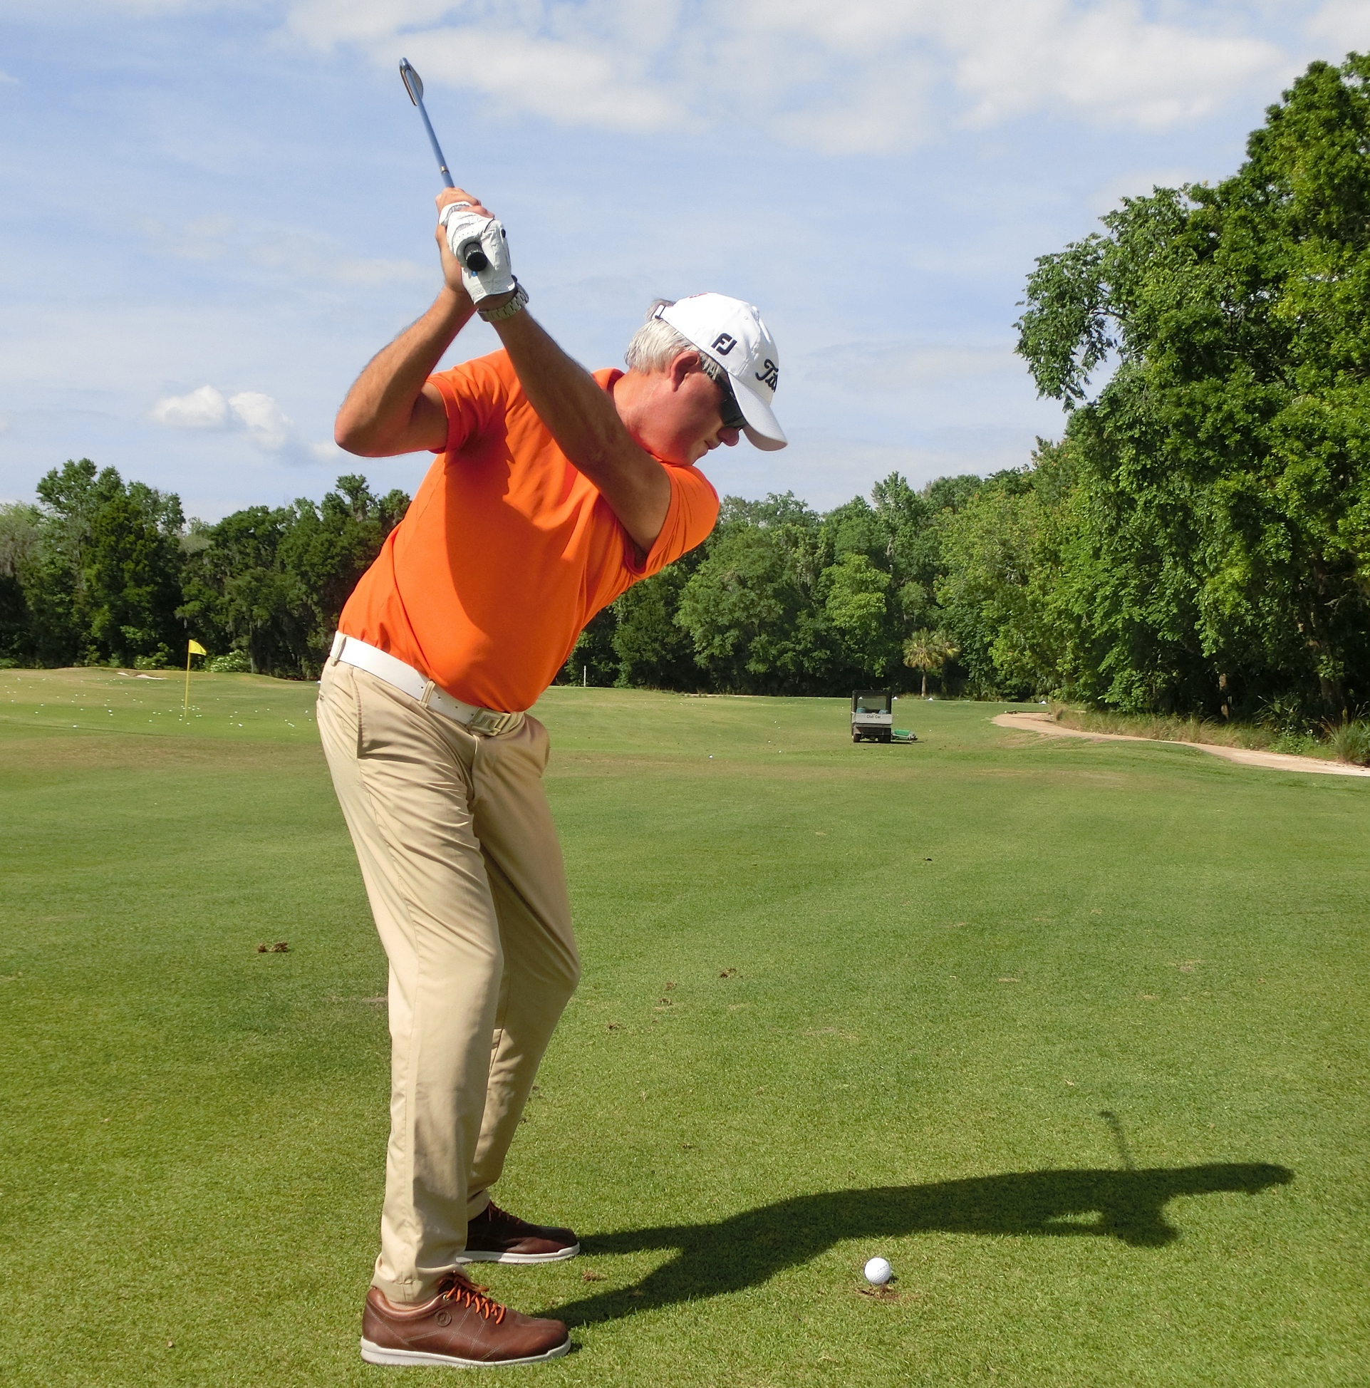
- Positionally- Plane: The most efficient way to swing a club is on one plane. With most players, a more ‘up and down’ single plane is more desirable although a rounded plane can be acceptable so long as the arms do not get too deep and track-out on the way down. The club should be un-manipulated early on and stay outside the hands. It should then gently hinge upwards and get in balance with the hands in the middle of the chest halfway back and the club bisecting the back of the shoulder. The body should then carry the arms rather than the arms independently lifting.

- Coming down, the plane of the club and left arm should be marginally shallower than the backswing but not much. Check points may be the left arm on the chest with the hands in the middle of the body but slightly deeper than the backswing checkpoint due to transitional dynamics. The shaft should appear below the right shoulder. The club then gets outside the hands-on approach as the body turns. The shaft getting back to a similar angle to the starting angle at impact. The right arm and body then turn through the shot together with the shaft plane through the shot matching the backswing plane. Again, finishing in perfect balance at the end with the club behind the neck.
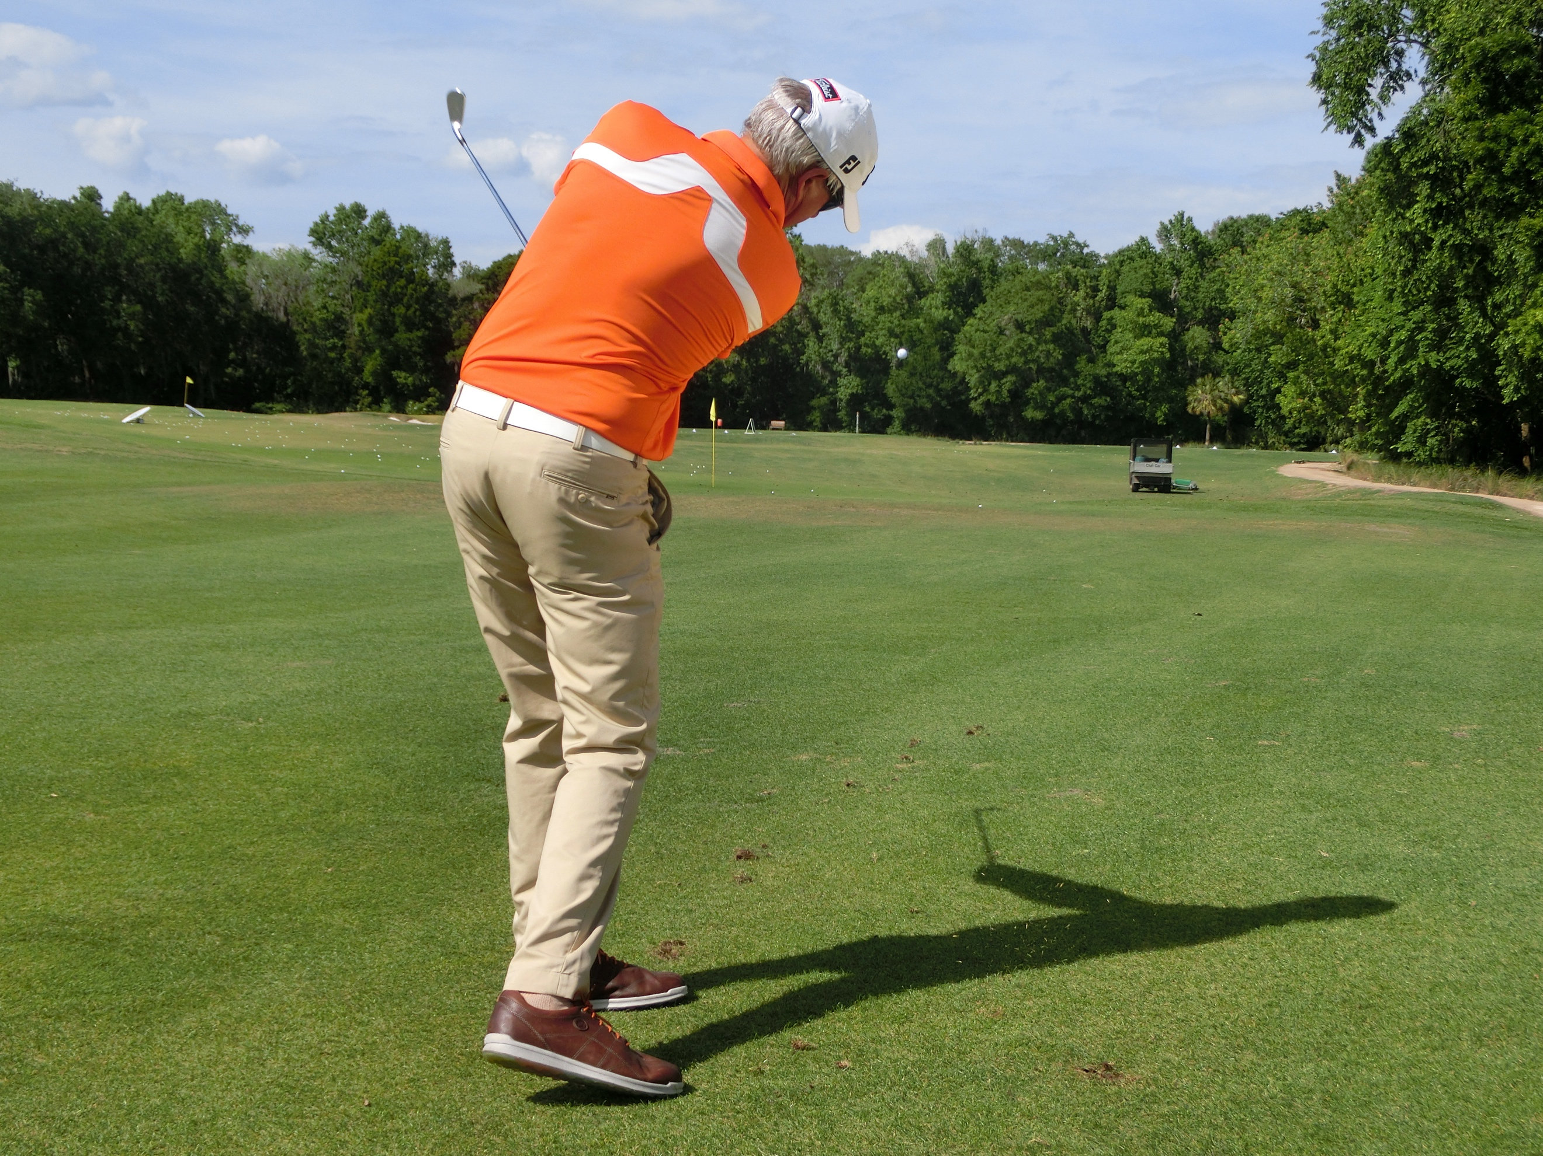
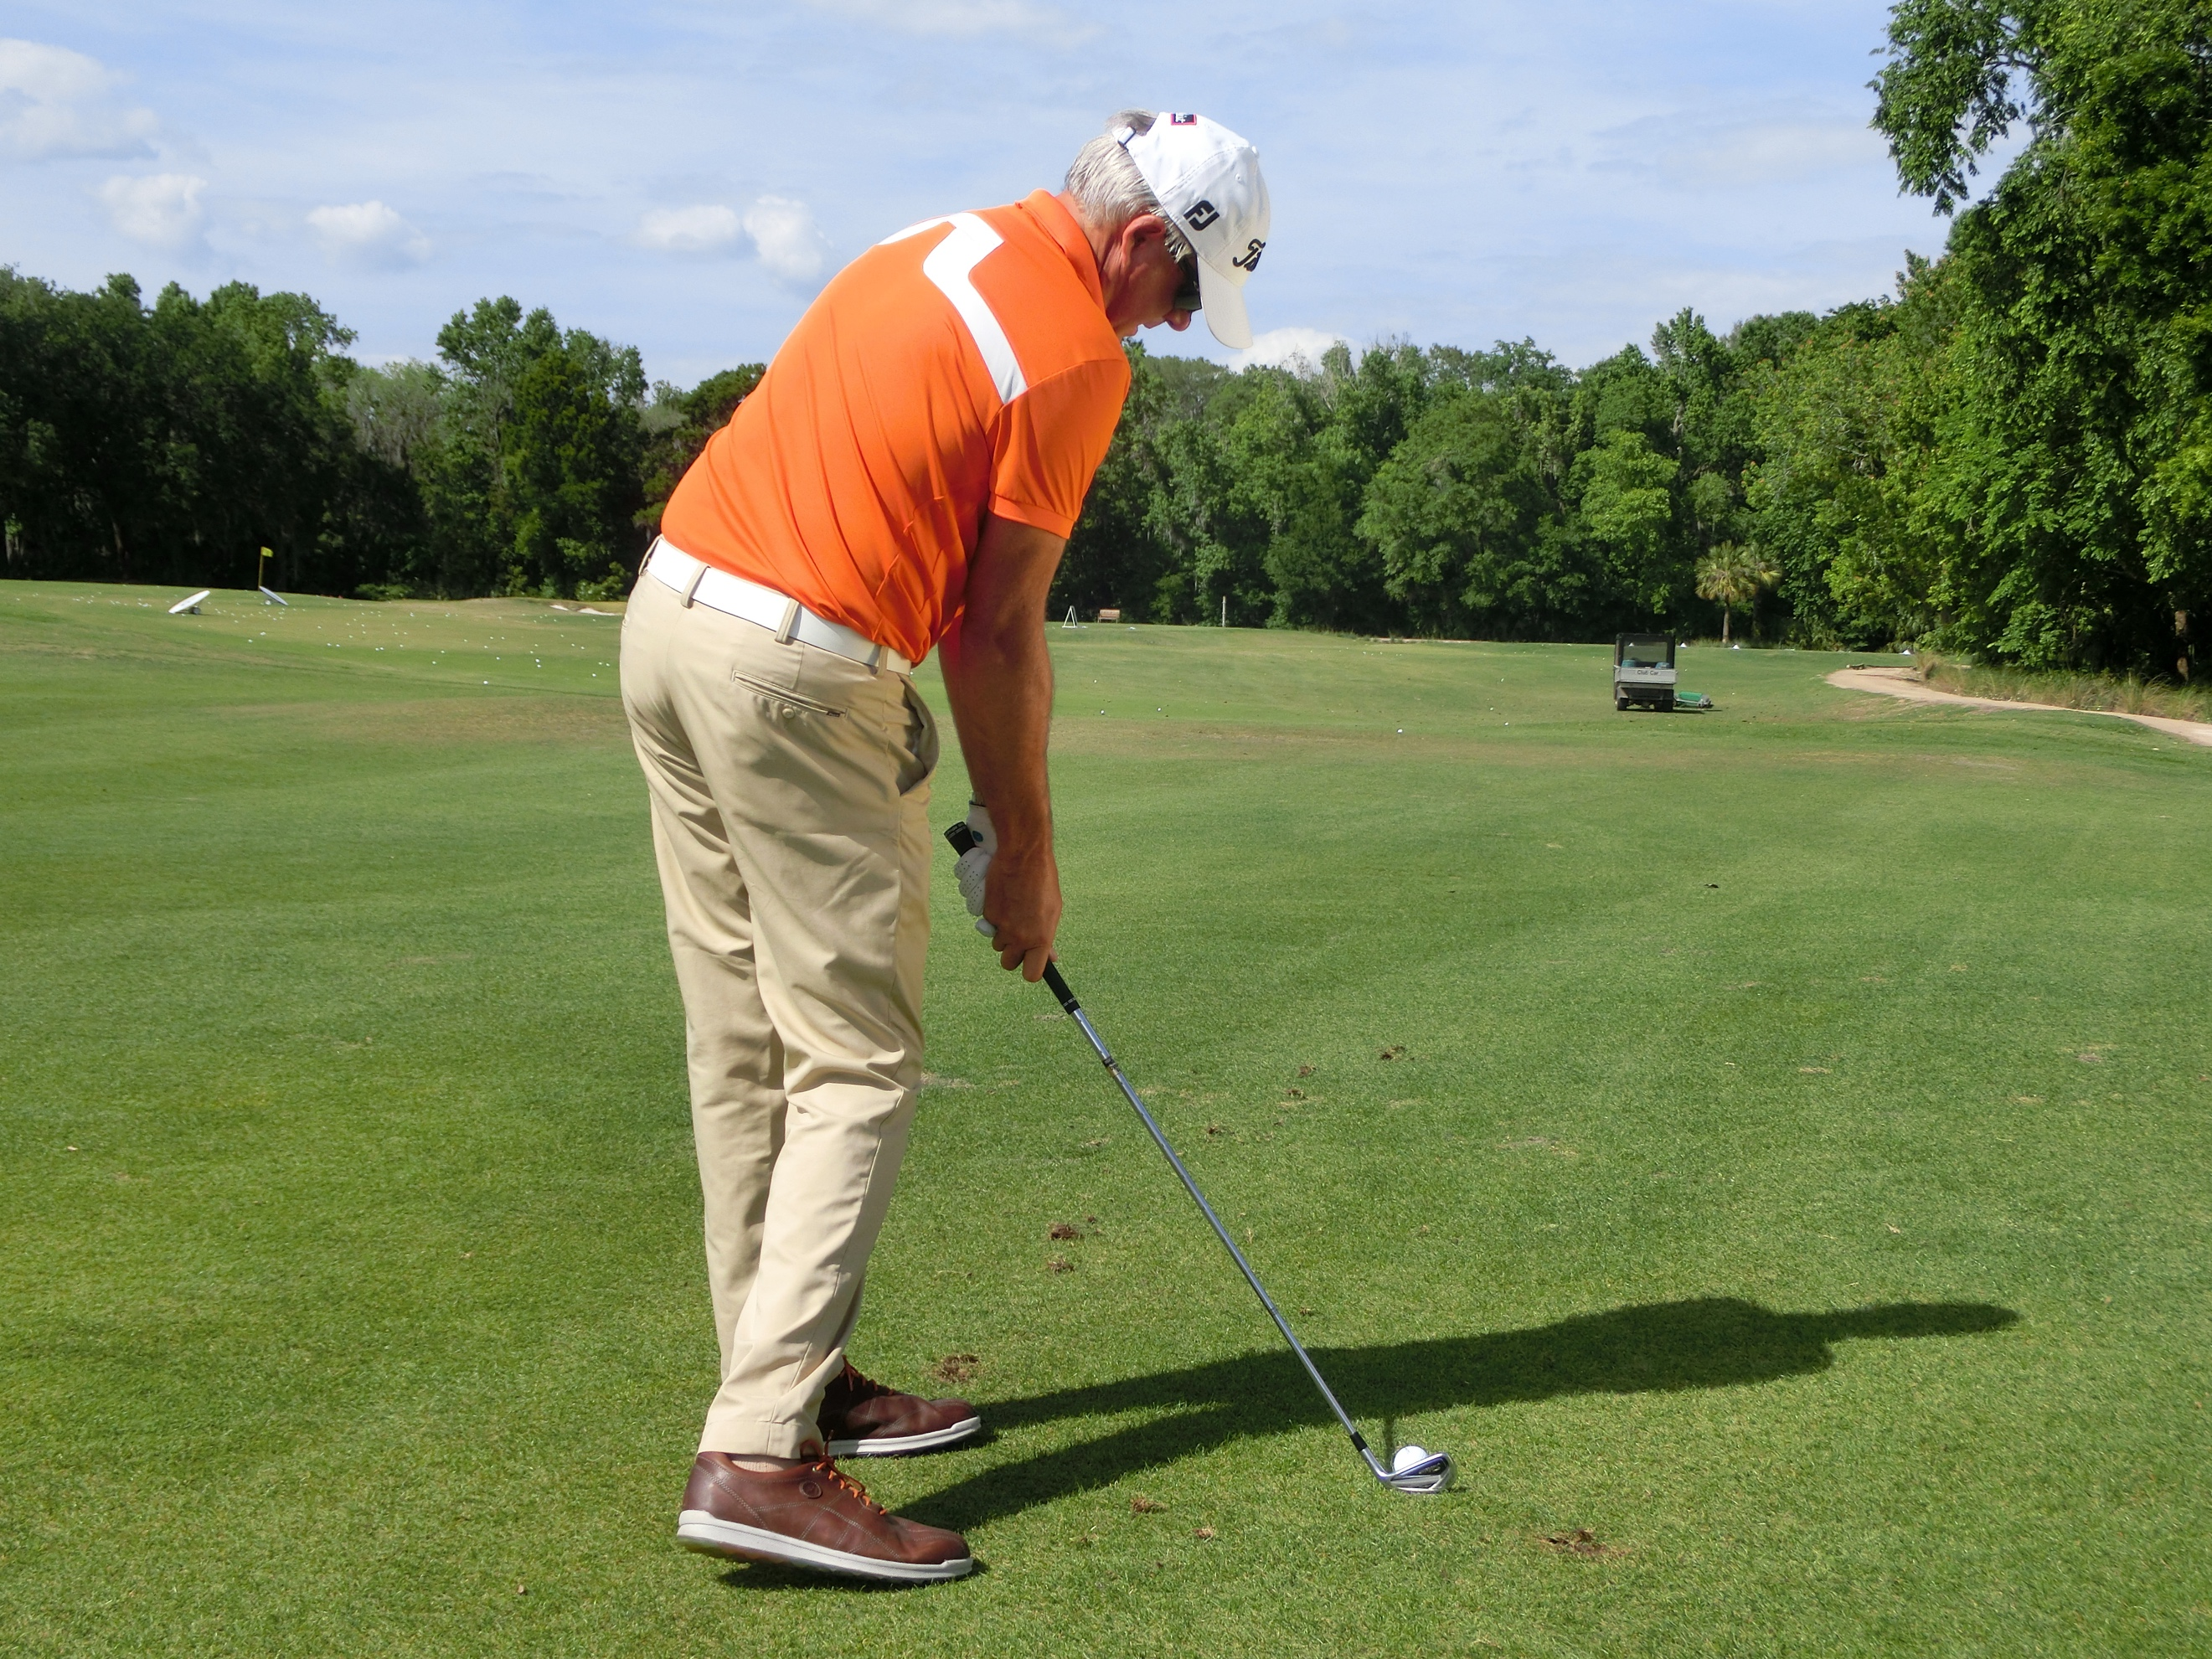

Tour Short Game

Putting:
Often called a game within the game, putting is devilishly simple but can become incredibly complicated. There really is no reason why anyone cannot become a good player. The stroke requires no strength or special coordination. The head of the putter travels about eight to ten inches back and through on a gentle arc relative to the shaft angle at address and the putter head design.

The Set-up:
The set up with most things in golf is important, and in putting it is 95% of the stroke and a vital element. The geometry and aiming which is created at address will help to create the simplicity of the stroke. So, get it right. You can see below some keys:

Grip:
- It is vital to get the grip in the life line of both hands. This immobilizes the wrists and discourages face manipulation.
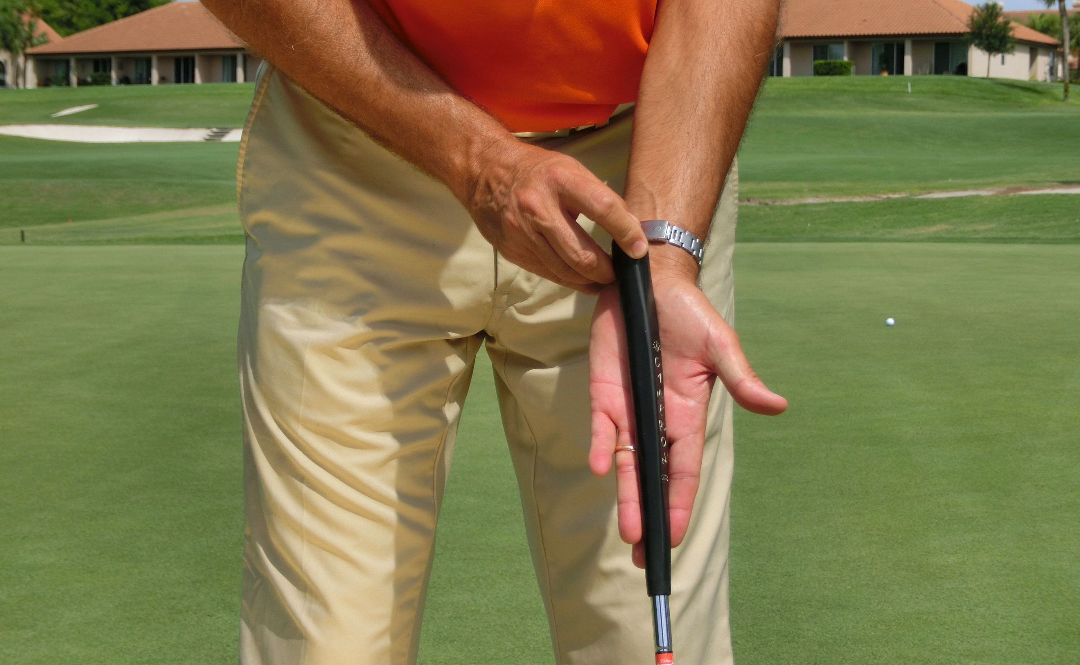
- The right hand moves up to the left and under compared to a full shot grip.
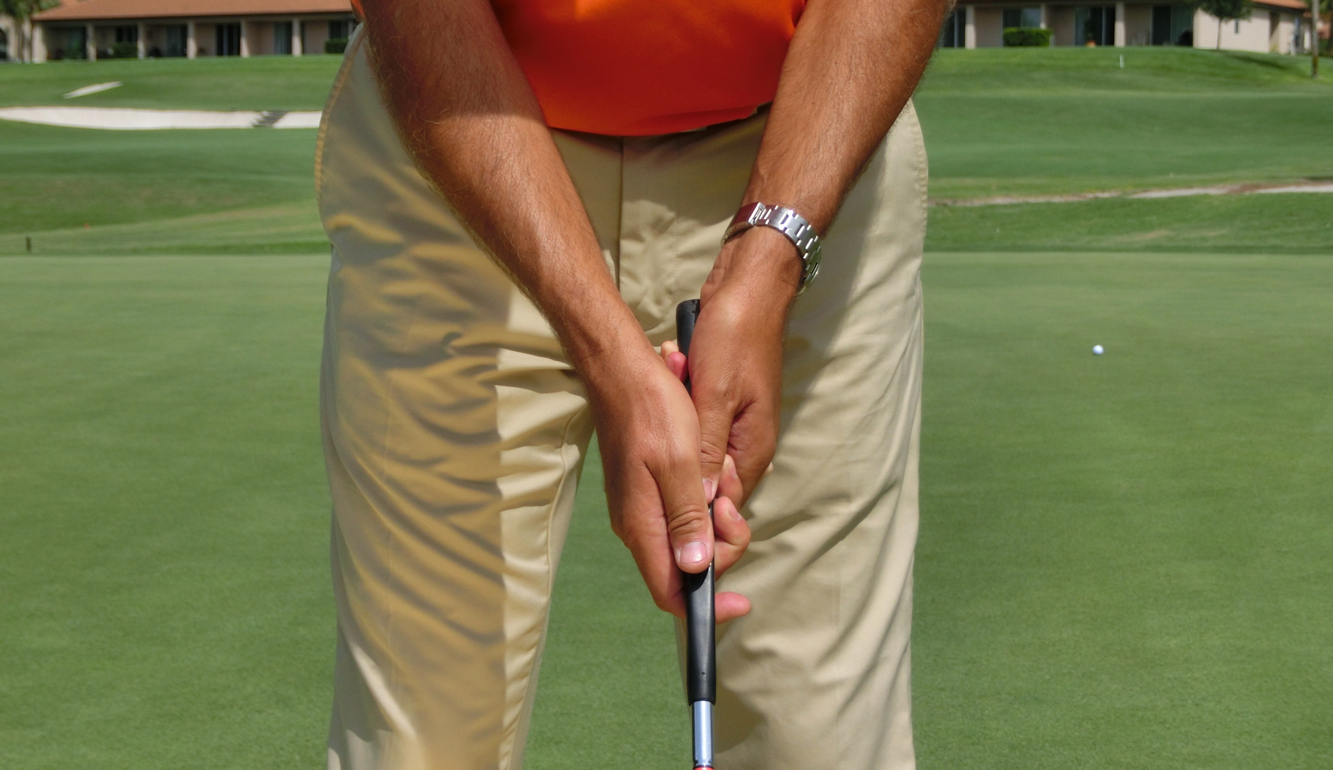
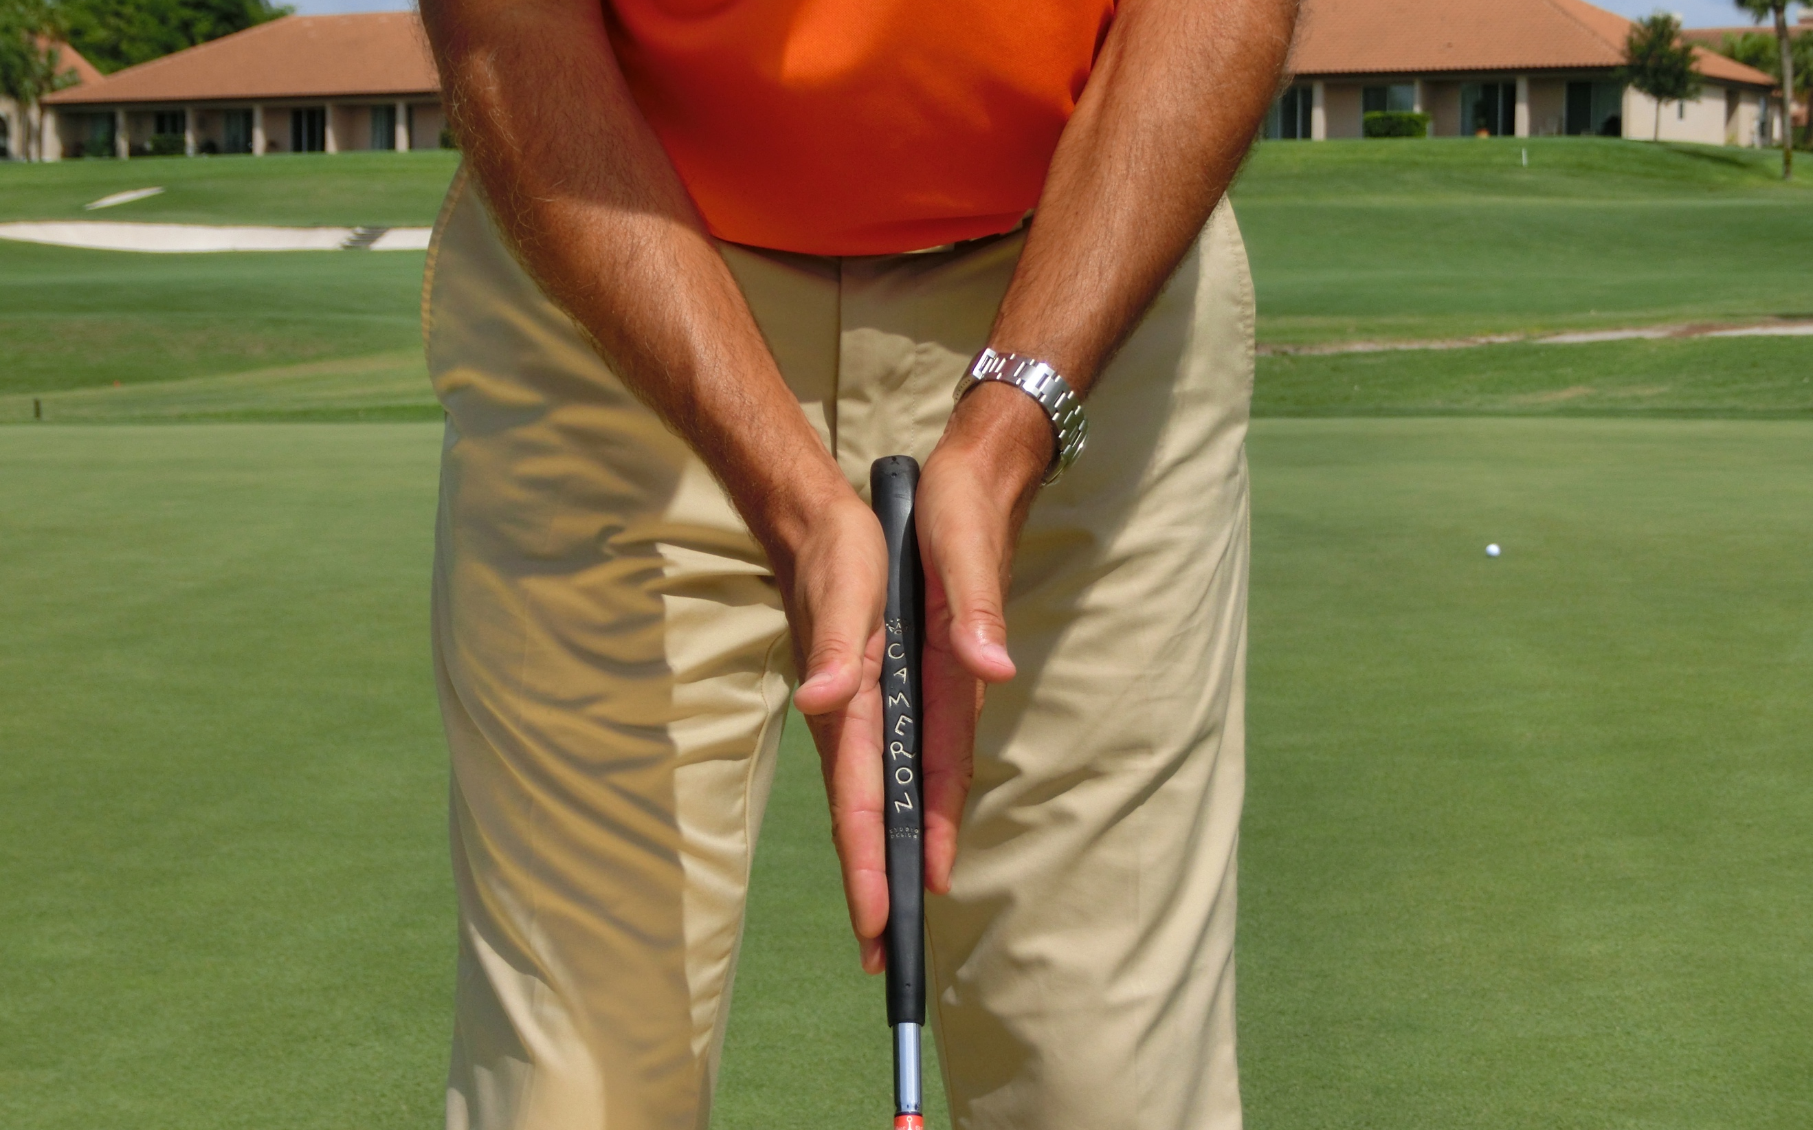
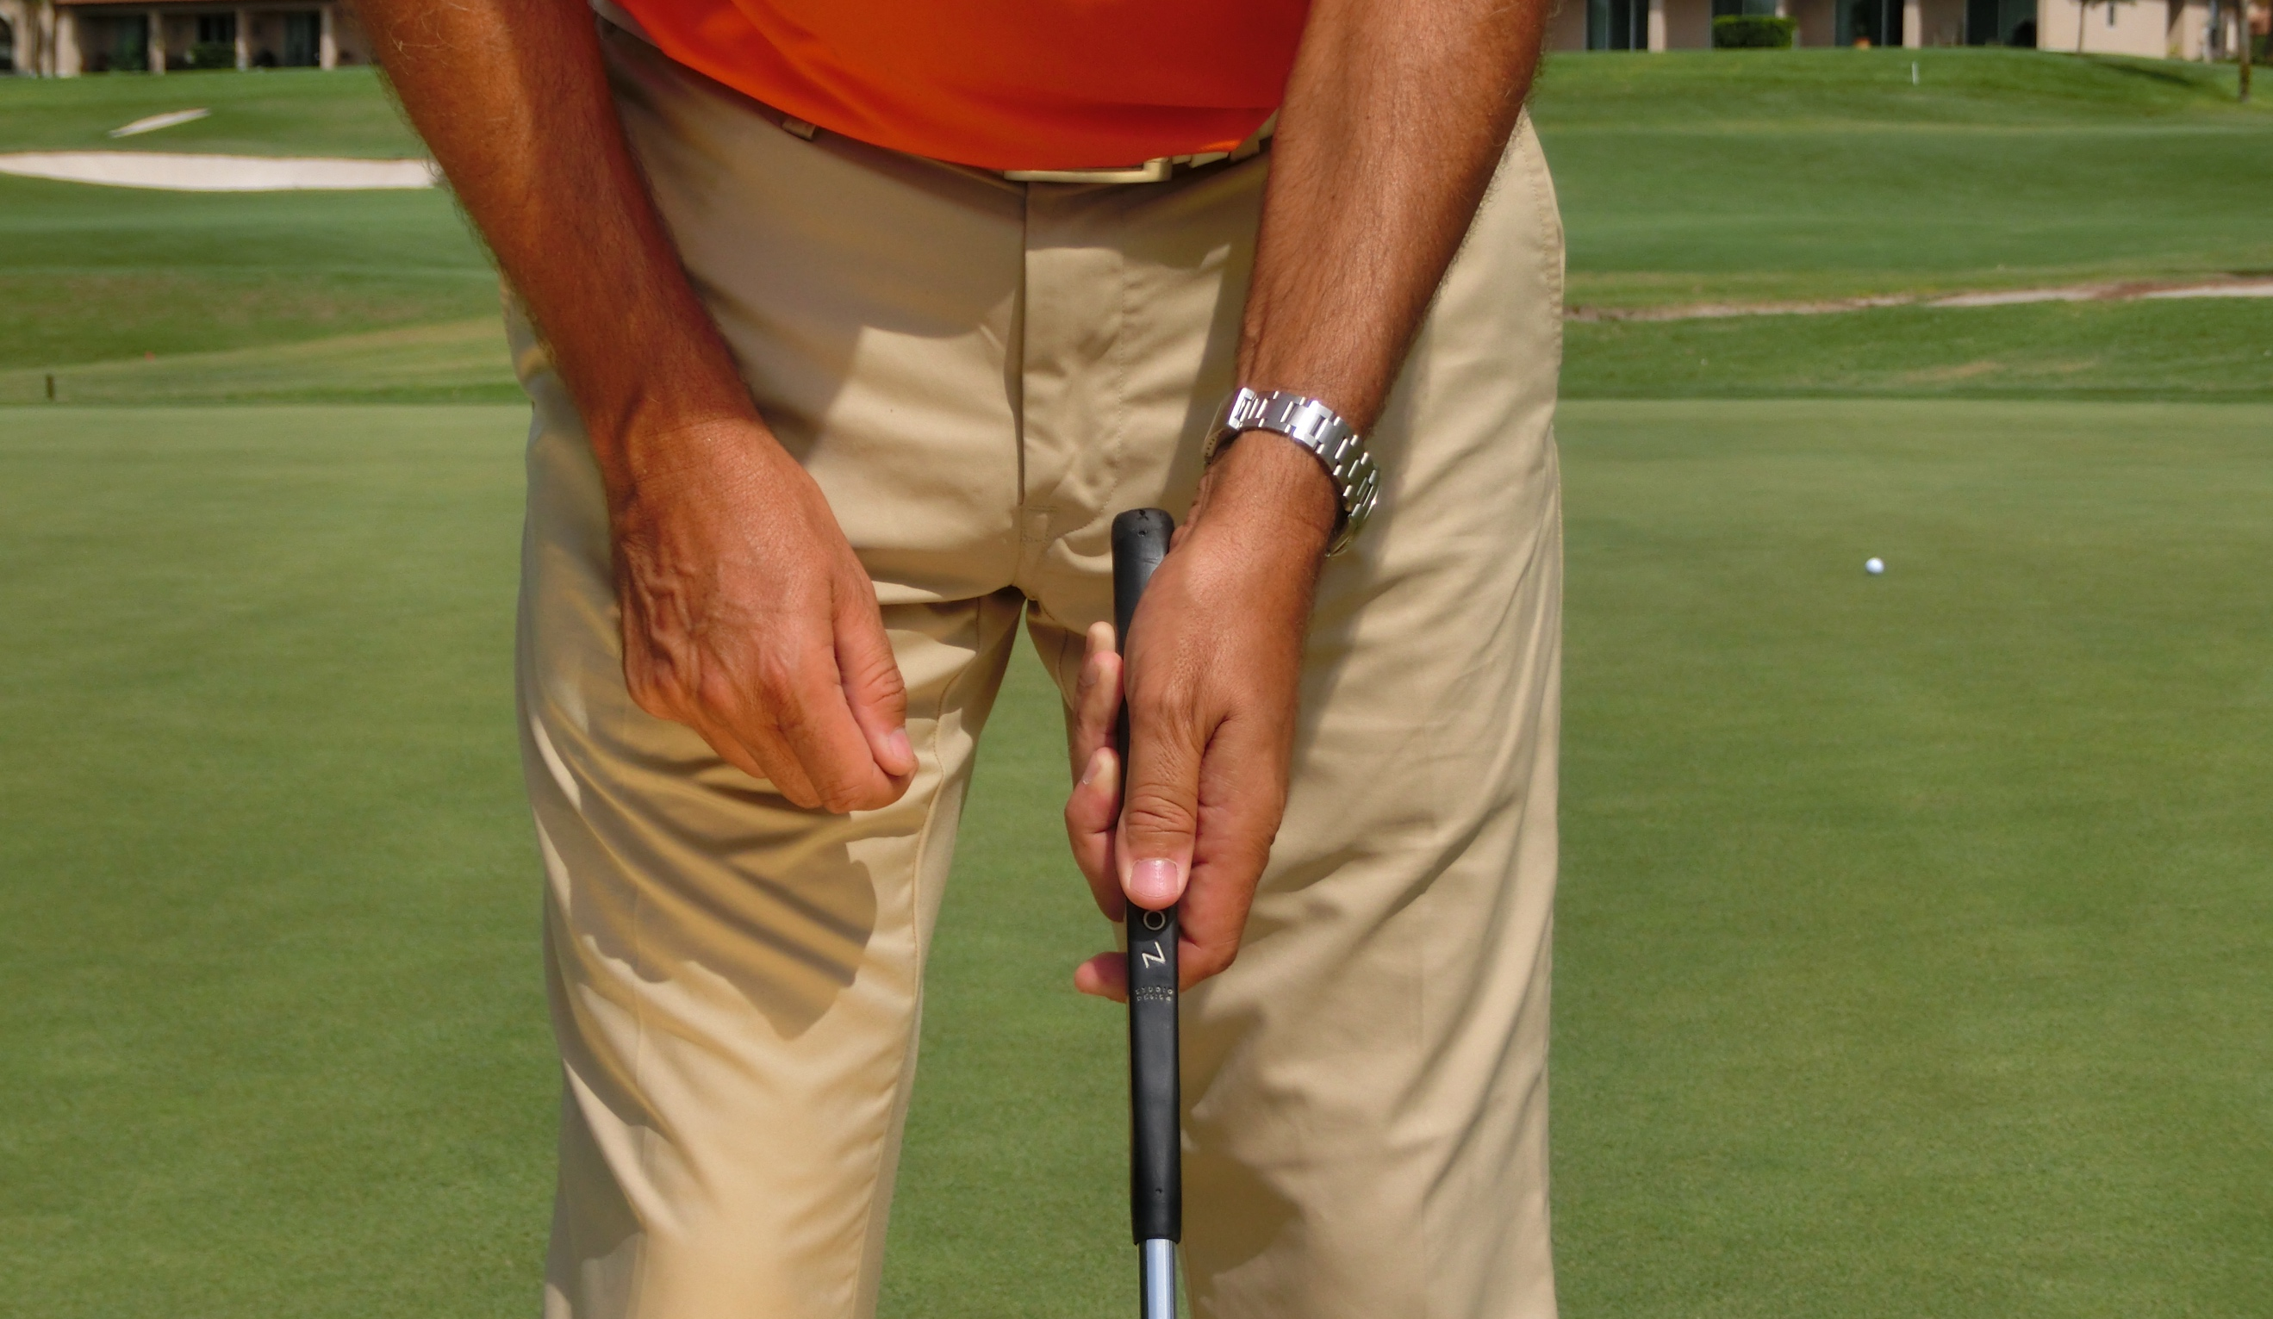
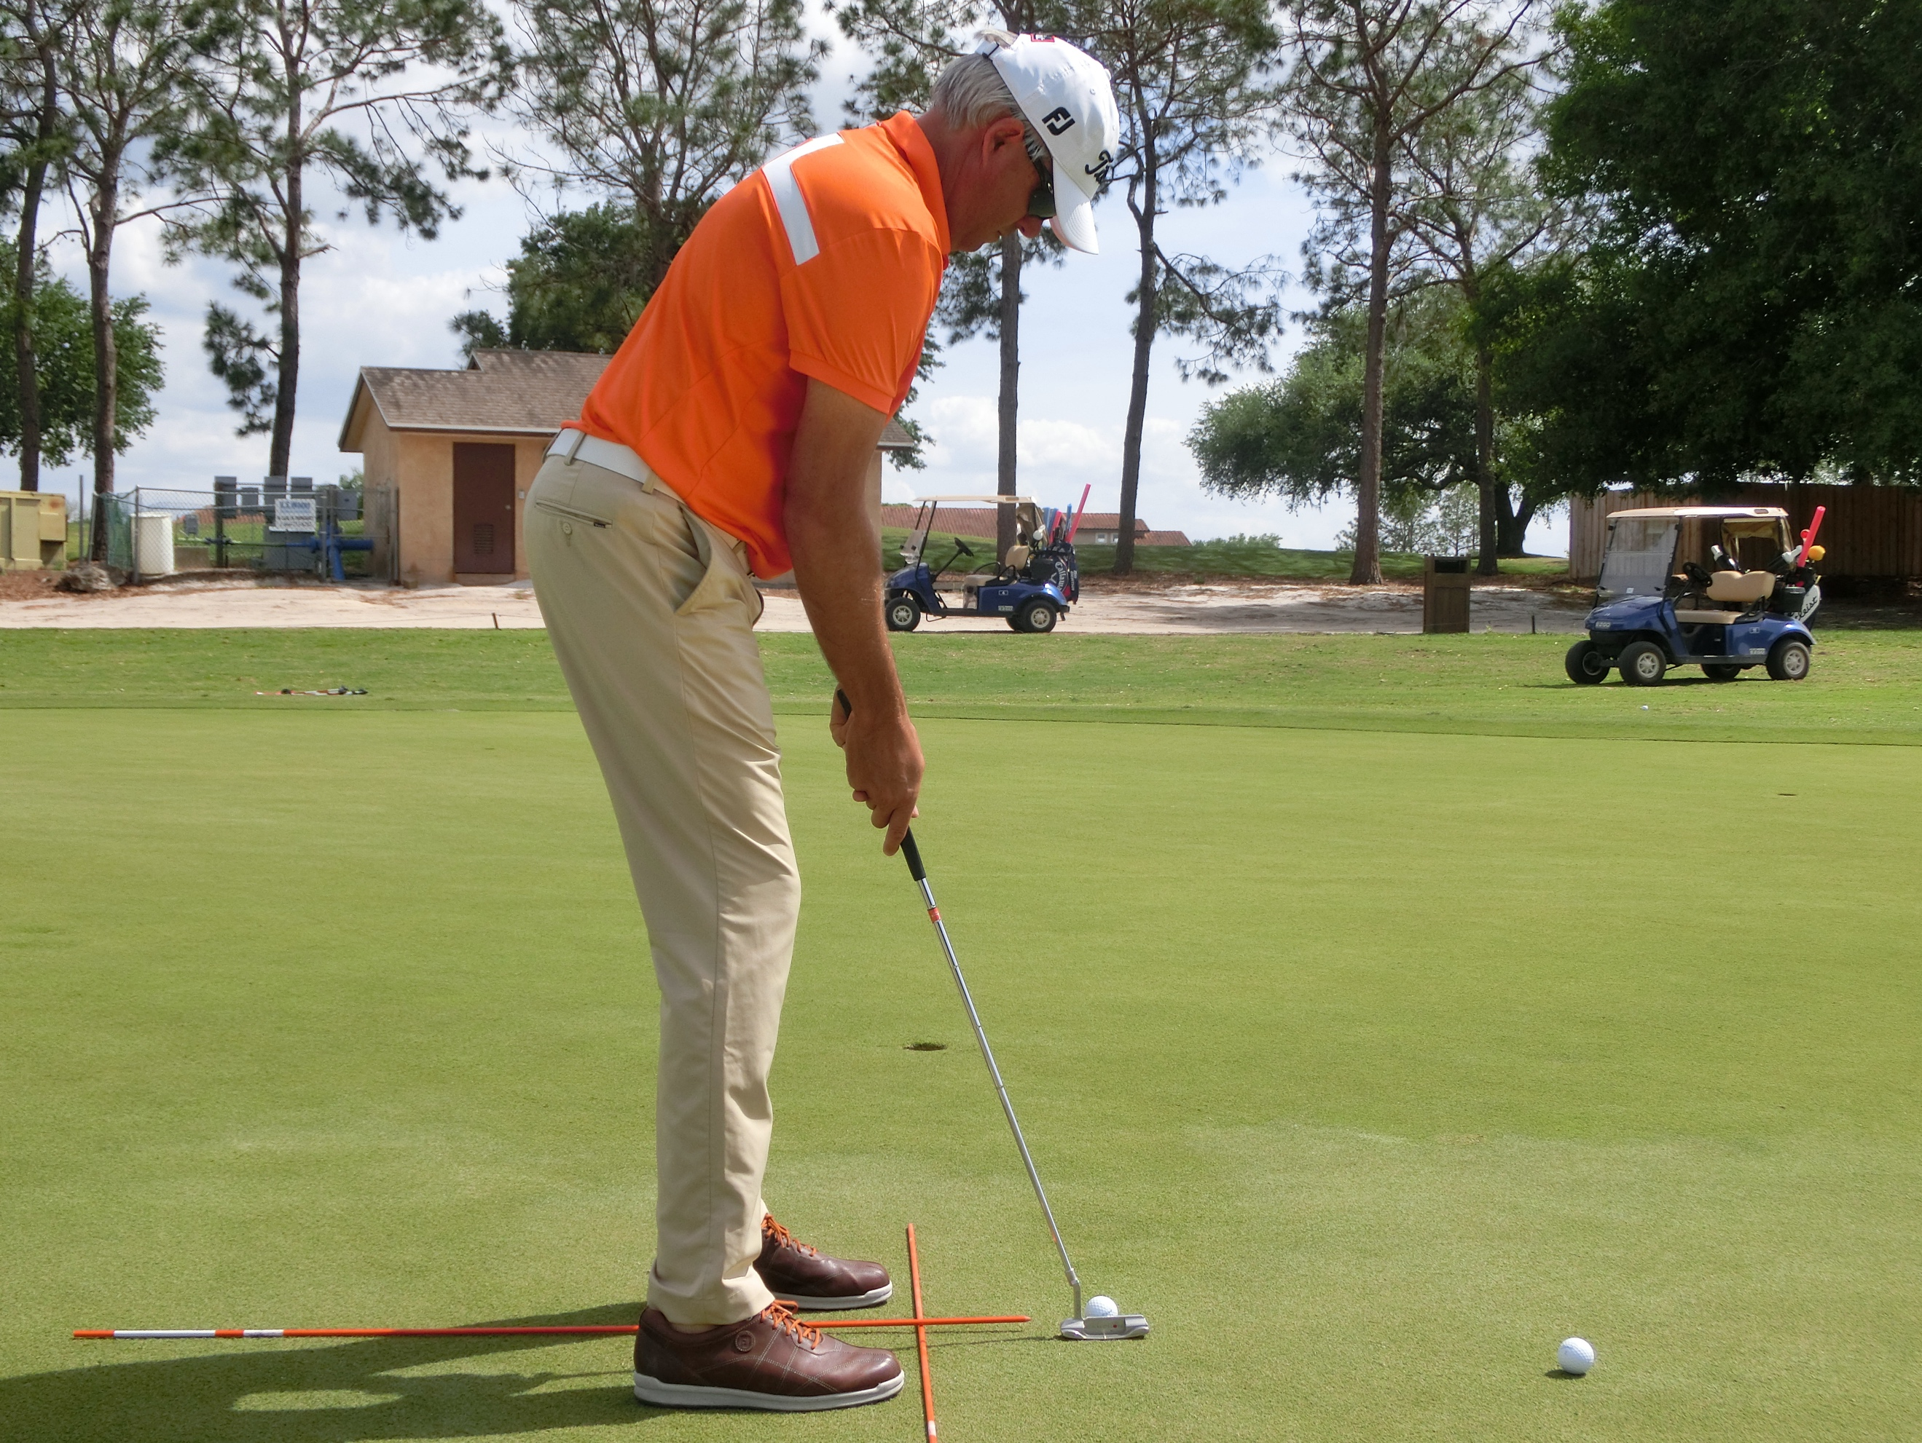

Down the line:
- Eyes marginally inside the ball for most players
- Forearms and shaft inline at address and on same plane
- Knees bent and upper body relatively tall
- Body square

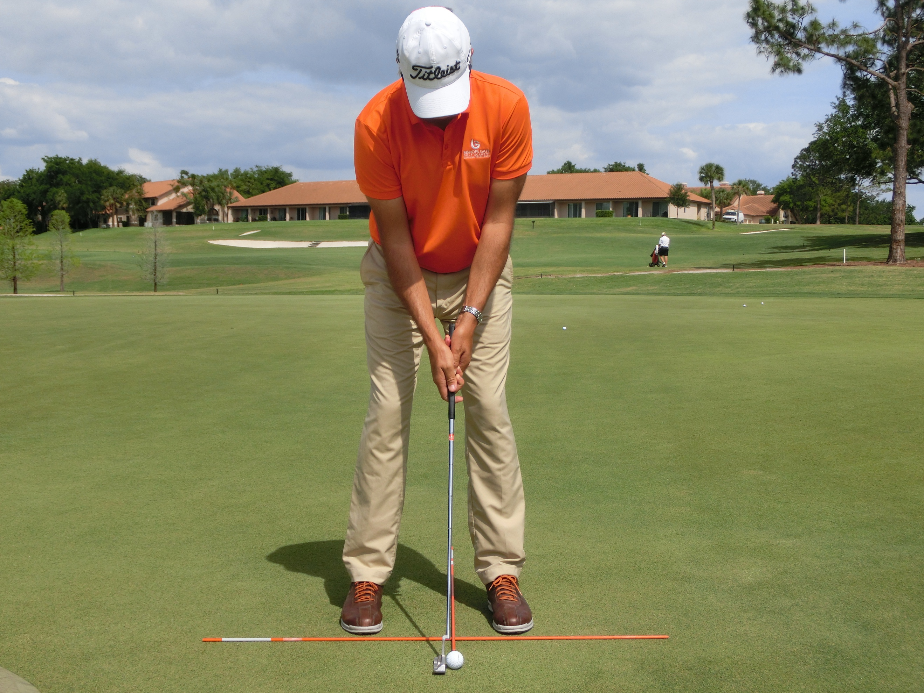

Face on:
- Ball marginally ahead of center so the putter mass and center of call meet a slight rise angle.
- A symmetrical look with shoulders and forearms relatively level.
- Shaft at 90 degrees.

The motion:
- The shoulder frame moves the forearm triangle with the wrists staying firm.
- The legs are still.
- The head is still.
- The backswing and follow through match in length.
- The tempo should be 2:1.
- The club should form a gentle arc according to shaft angle. The face should rotate gently relative to that arc.

Chipping:
Objective: To create a bullet proof strike that creates a consistent spin, trajectory and has scope for art and creativity without compromising the strike elements.

Set Up:
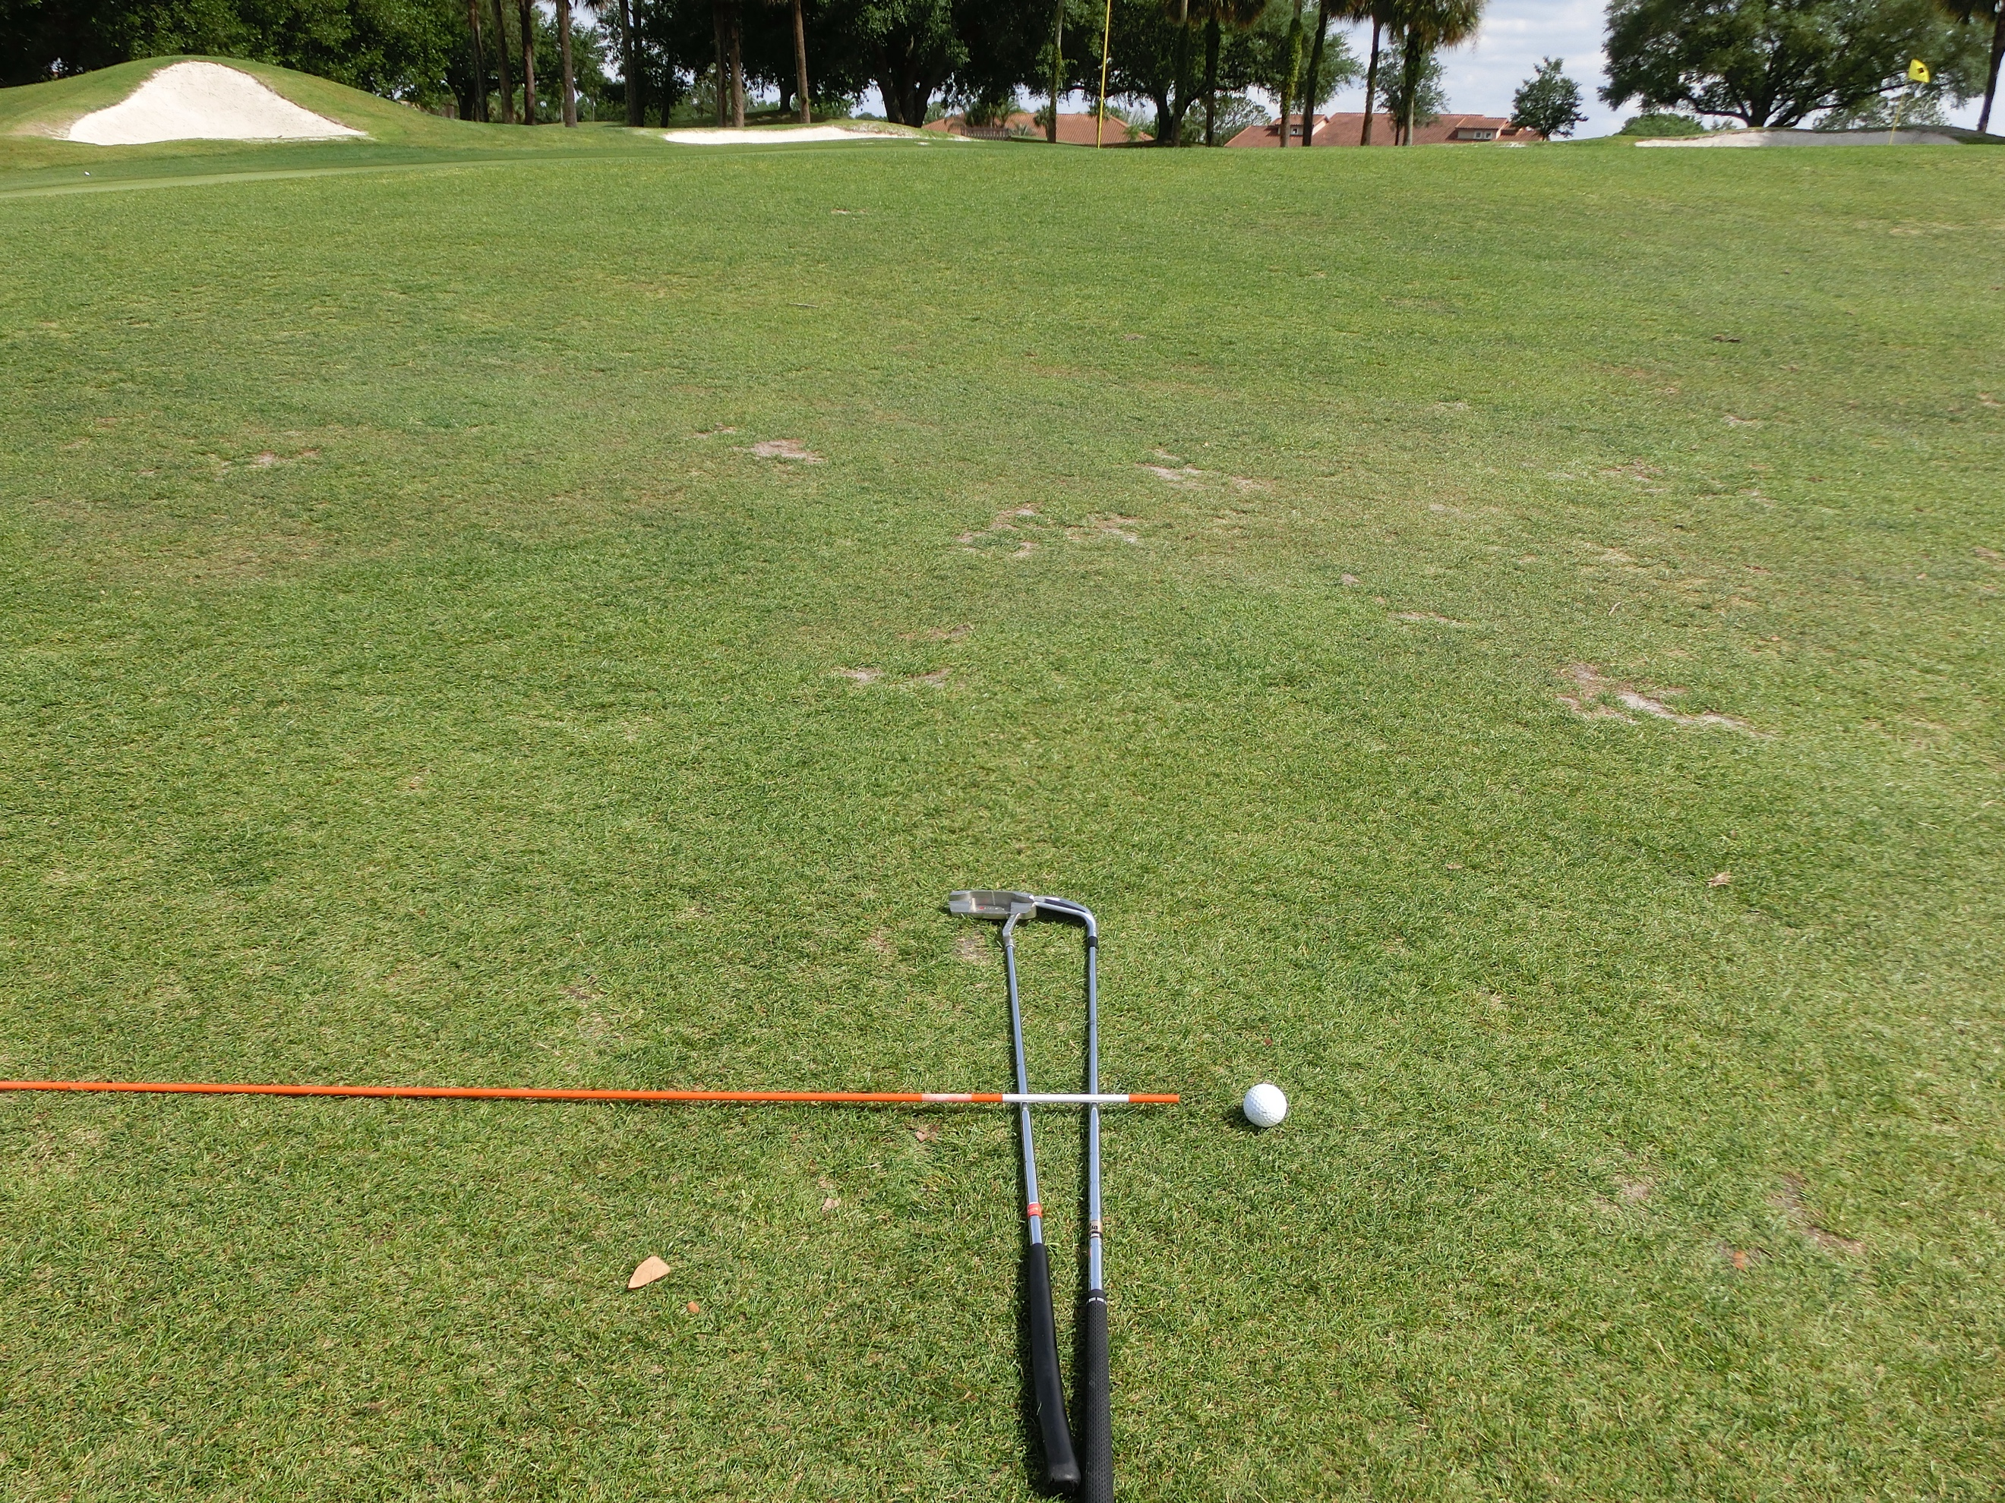
- If the target is 12 o’clock, the feet, knees, hips and shoulders aim at 11.
- The feet are close together and the toes point ahead of the ball. The knees lean into one another slightly.
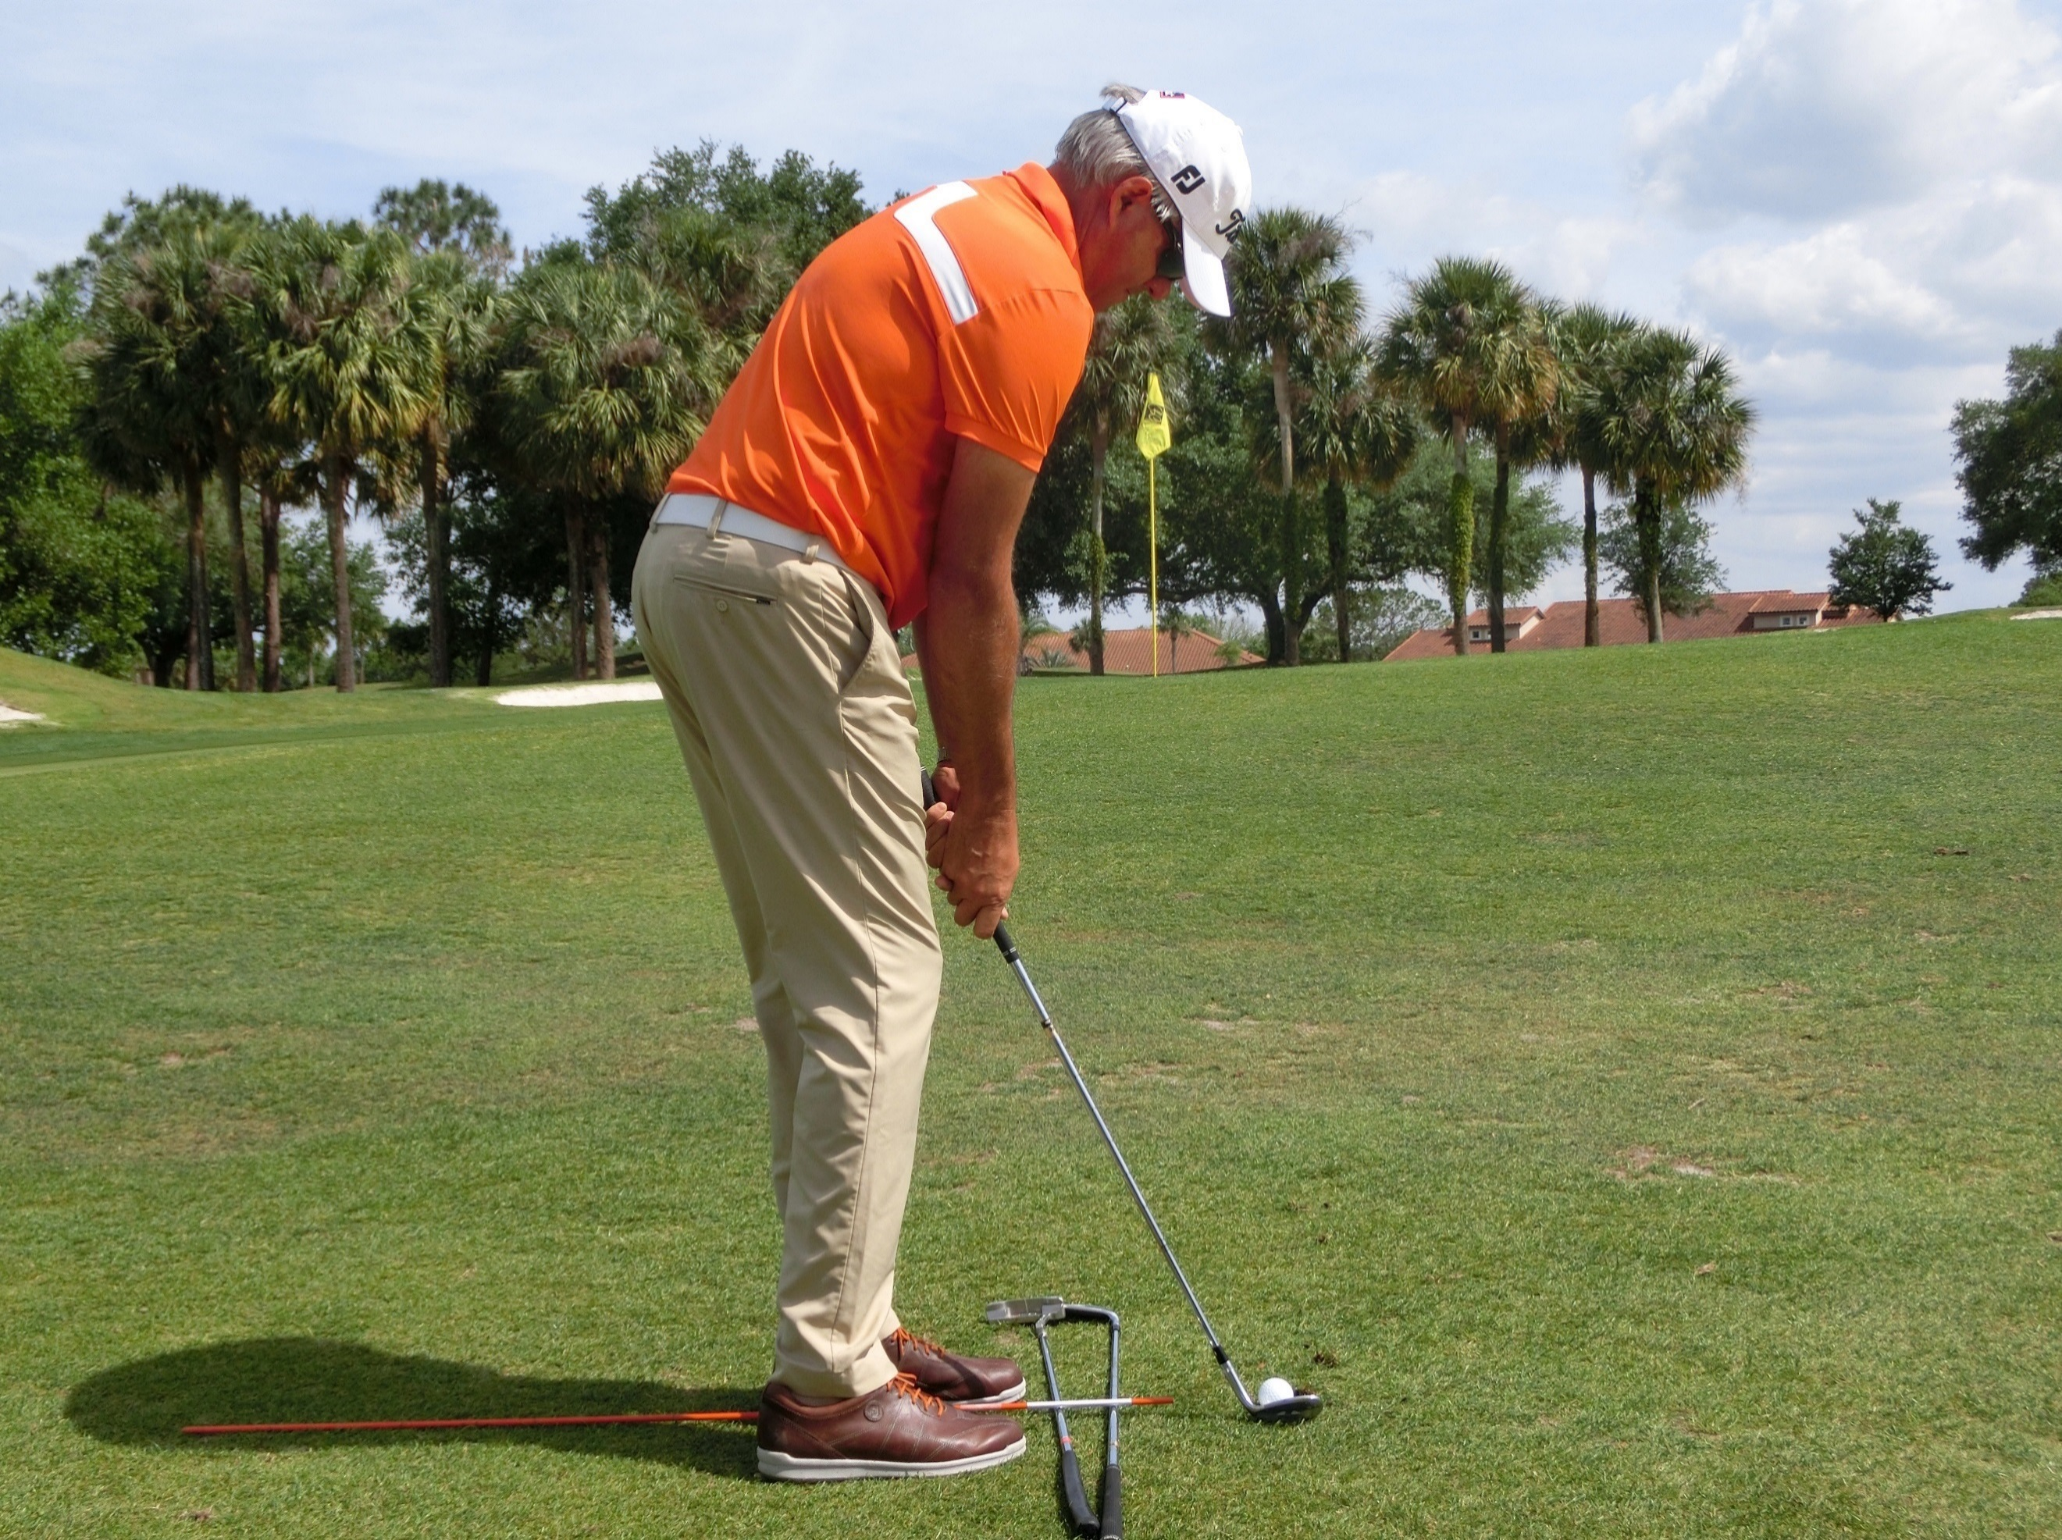
- The upper body weight leans towards the target, lower body is neutrally distributed. Traditional doctrine states that the player should get the weight forward, but the lower body weight shifts forward moving the upper body back and therefore the sternum and flat-area. CPI tour-quality chipping involves getting the upper body weight forward, less so with the lower, encouraging the sternum to get into position ahead of the ball.
- The sternum should be ahead of the ball.
- The hands are marginally left of the zipper and marginally ahead of the ball.
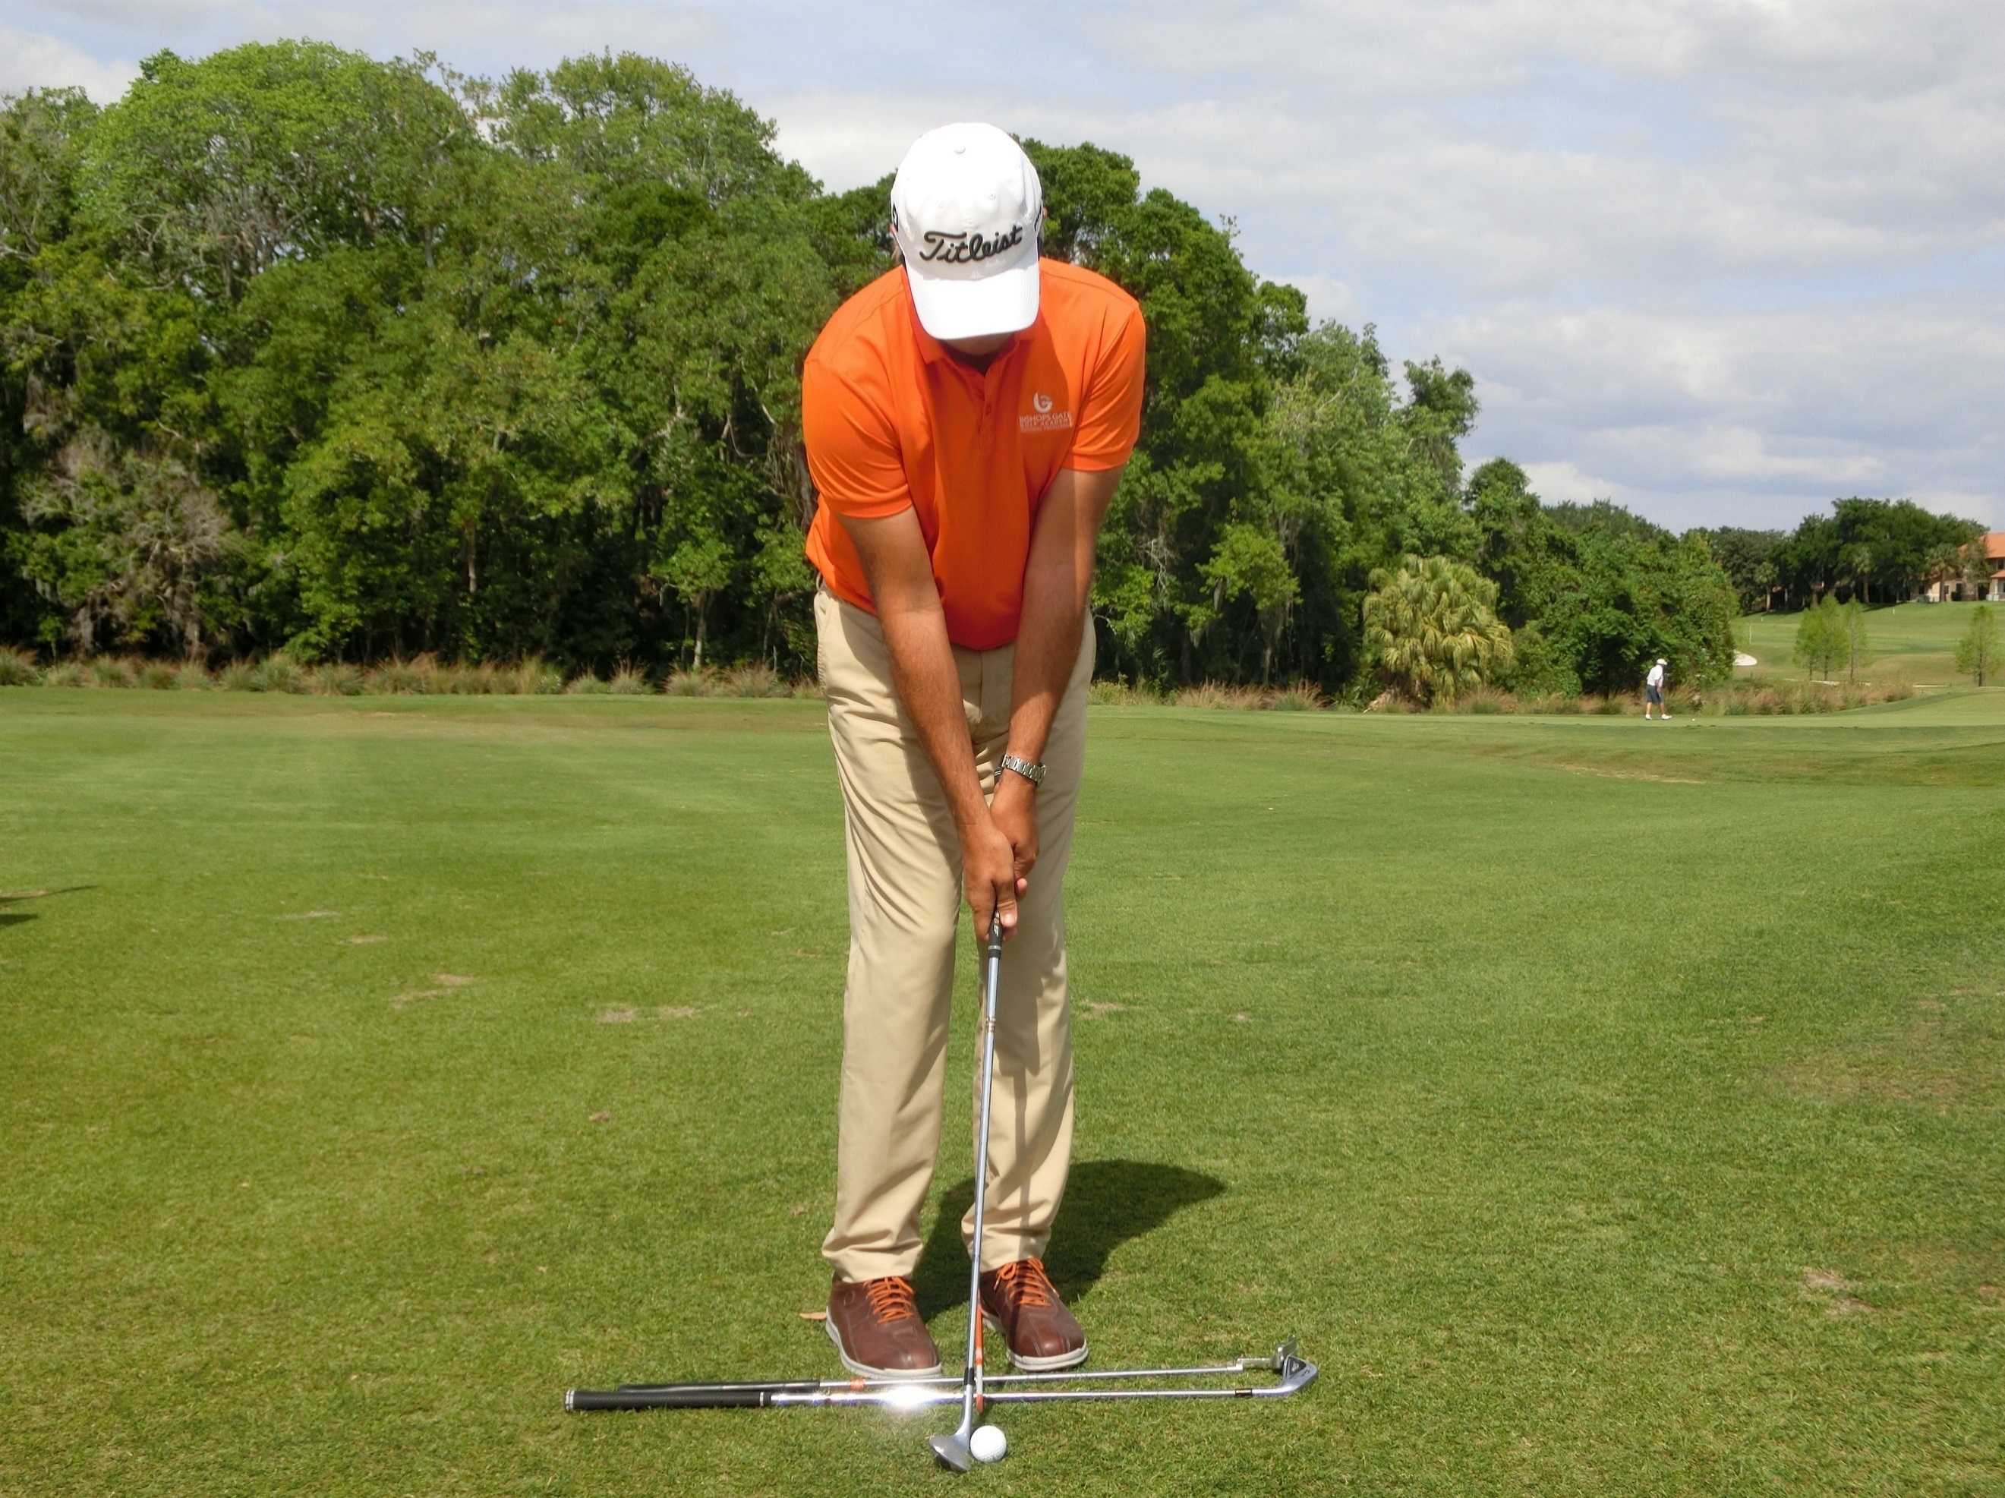
- The ball is in the middle of the stance.
- The player should be close to the ball, gripping down on the club with the triceps linked to the ribcage.
- The right side should look marginally high at address.
- This is called the mock-impact position.

The Motion:
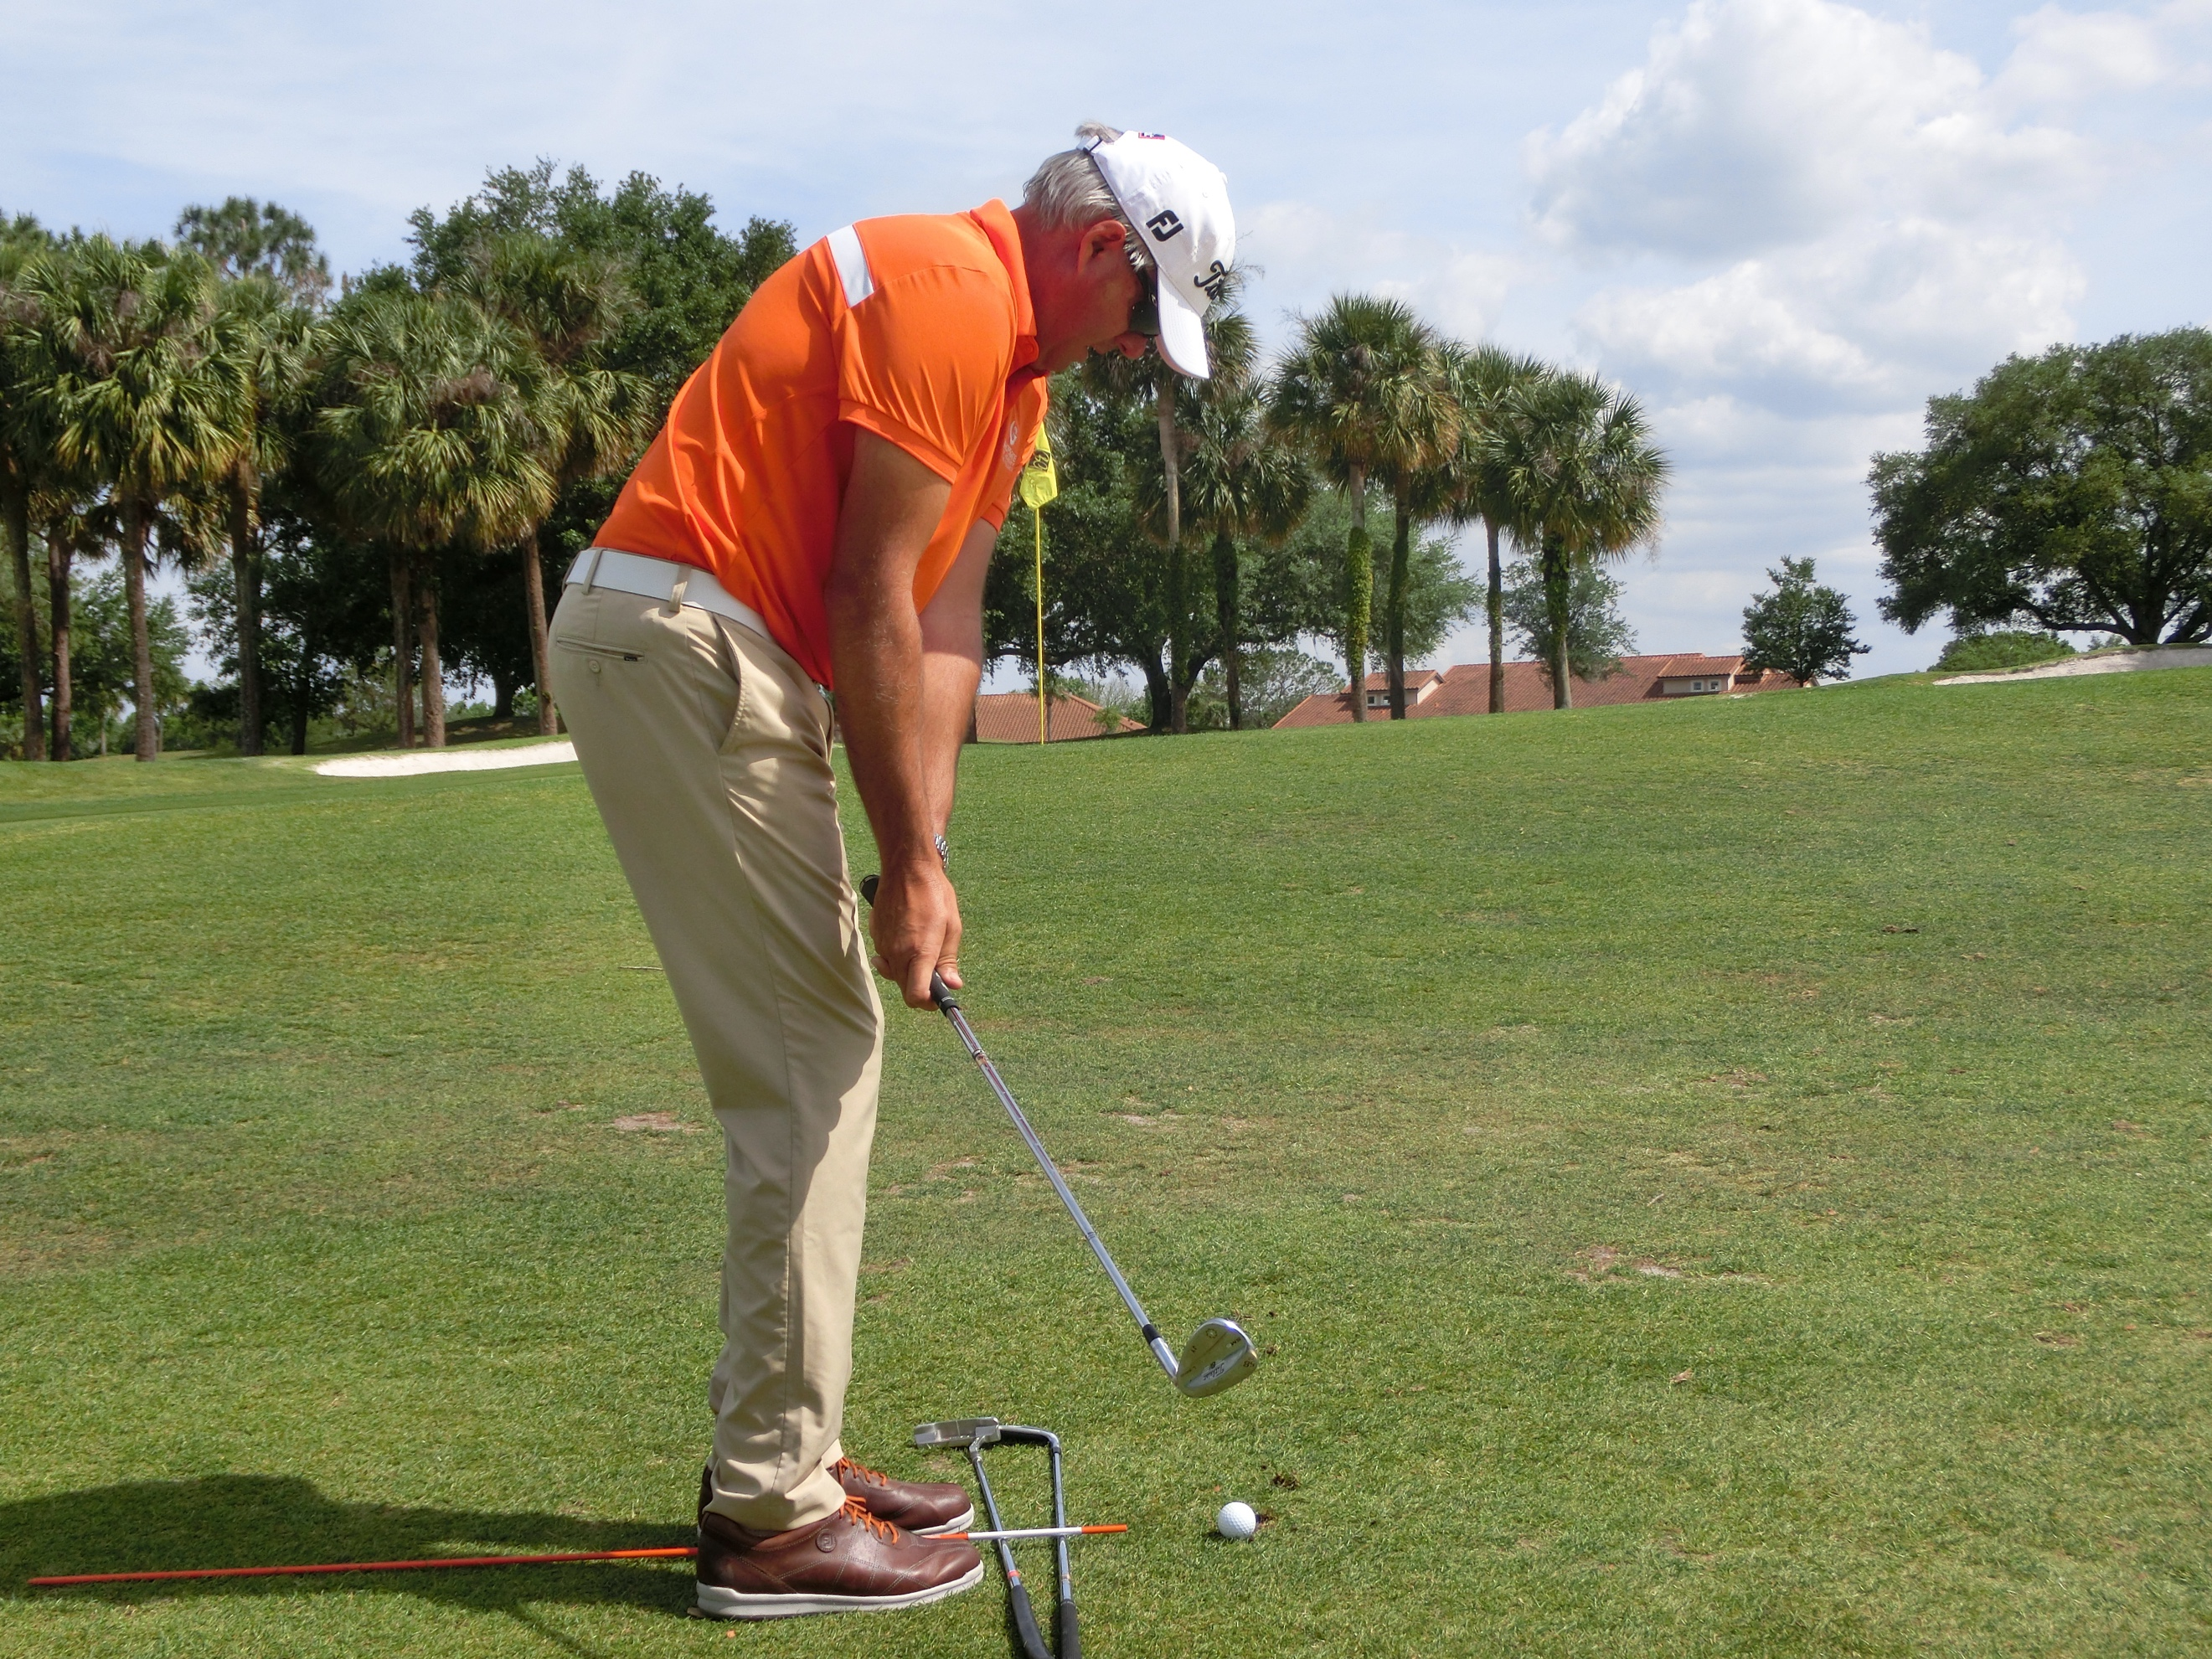
- The body is the motor or the engine of the stroke. The thighs, knees and hips gently turn back and through to provide momentum.
- The arms hang on for the ride.
- The right hand creates the differing speeds and spins.
- You are trying to eliminate lead in the handle and lean in the shaft which encourage the flat area to bottom out behind the ball.
- This is a neutral chip, which creates a neutral shot. From here a player can move the ball/handle forward or back to create lower or higher shots and shots with more and less spin.
- Ideal strike is a slight bruising and pinching of the turf.

Assignment:
- Film your chipping presentation.
- Show a ‘before and after’ of a student’s chipping improvements (2 minutes long)
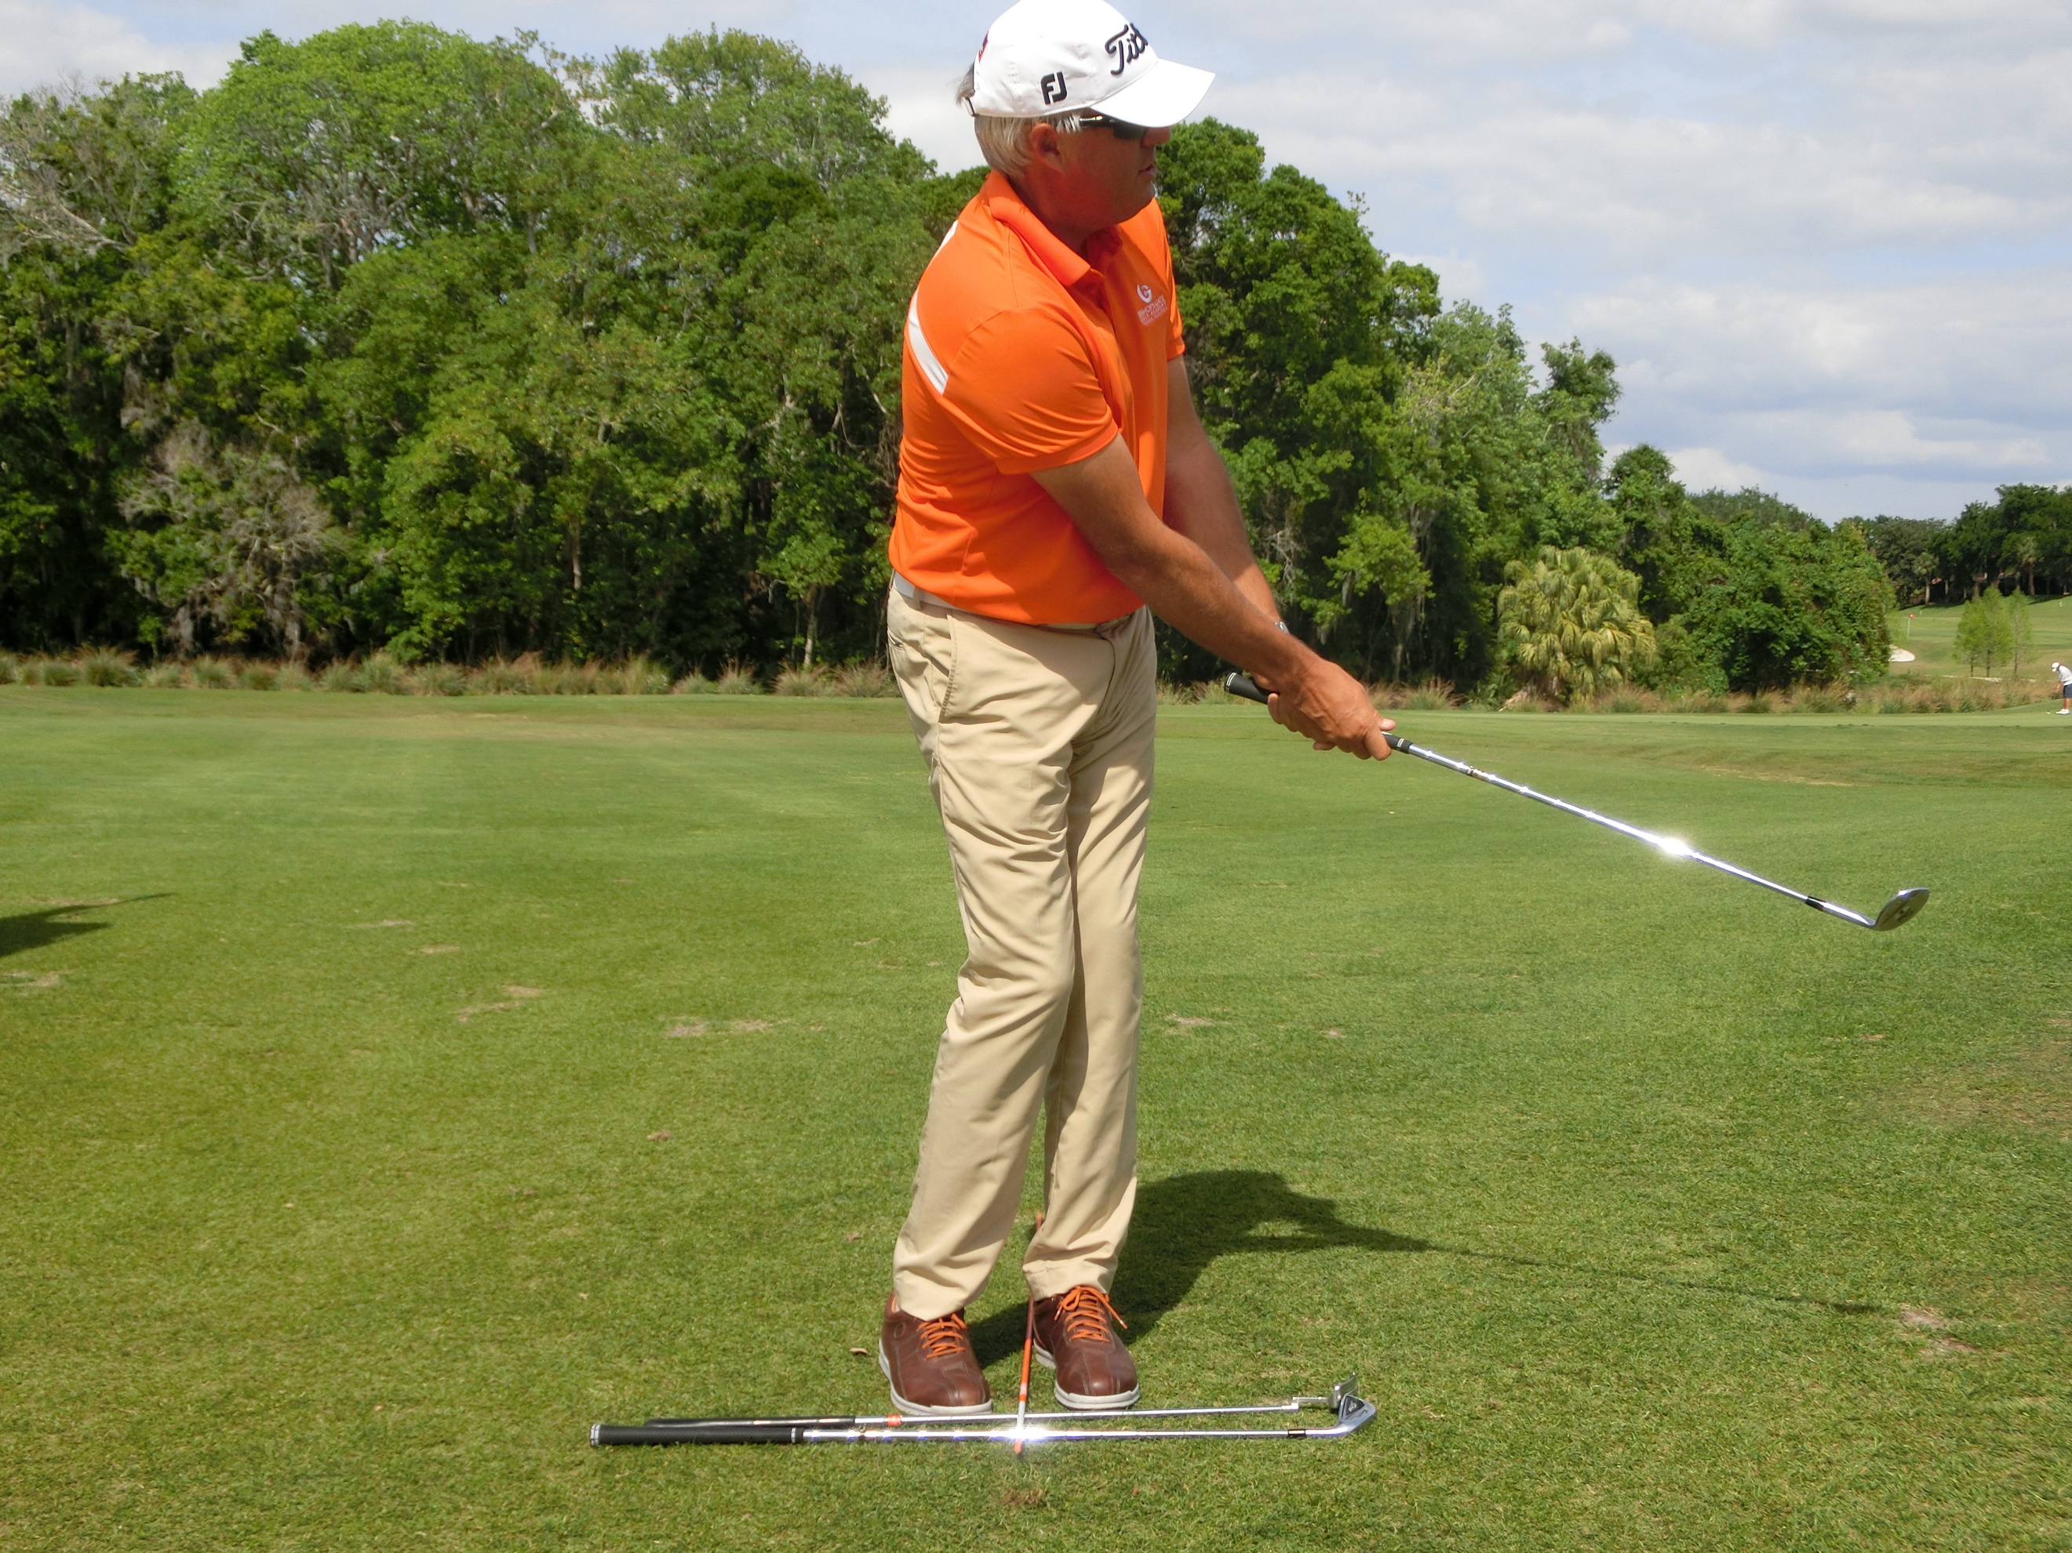
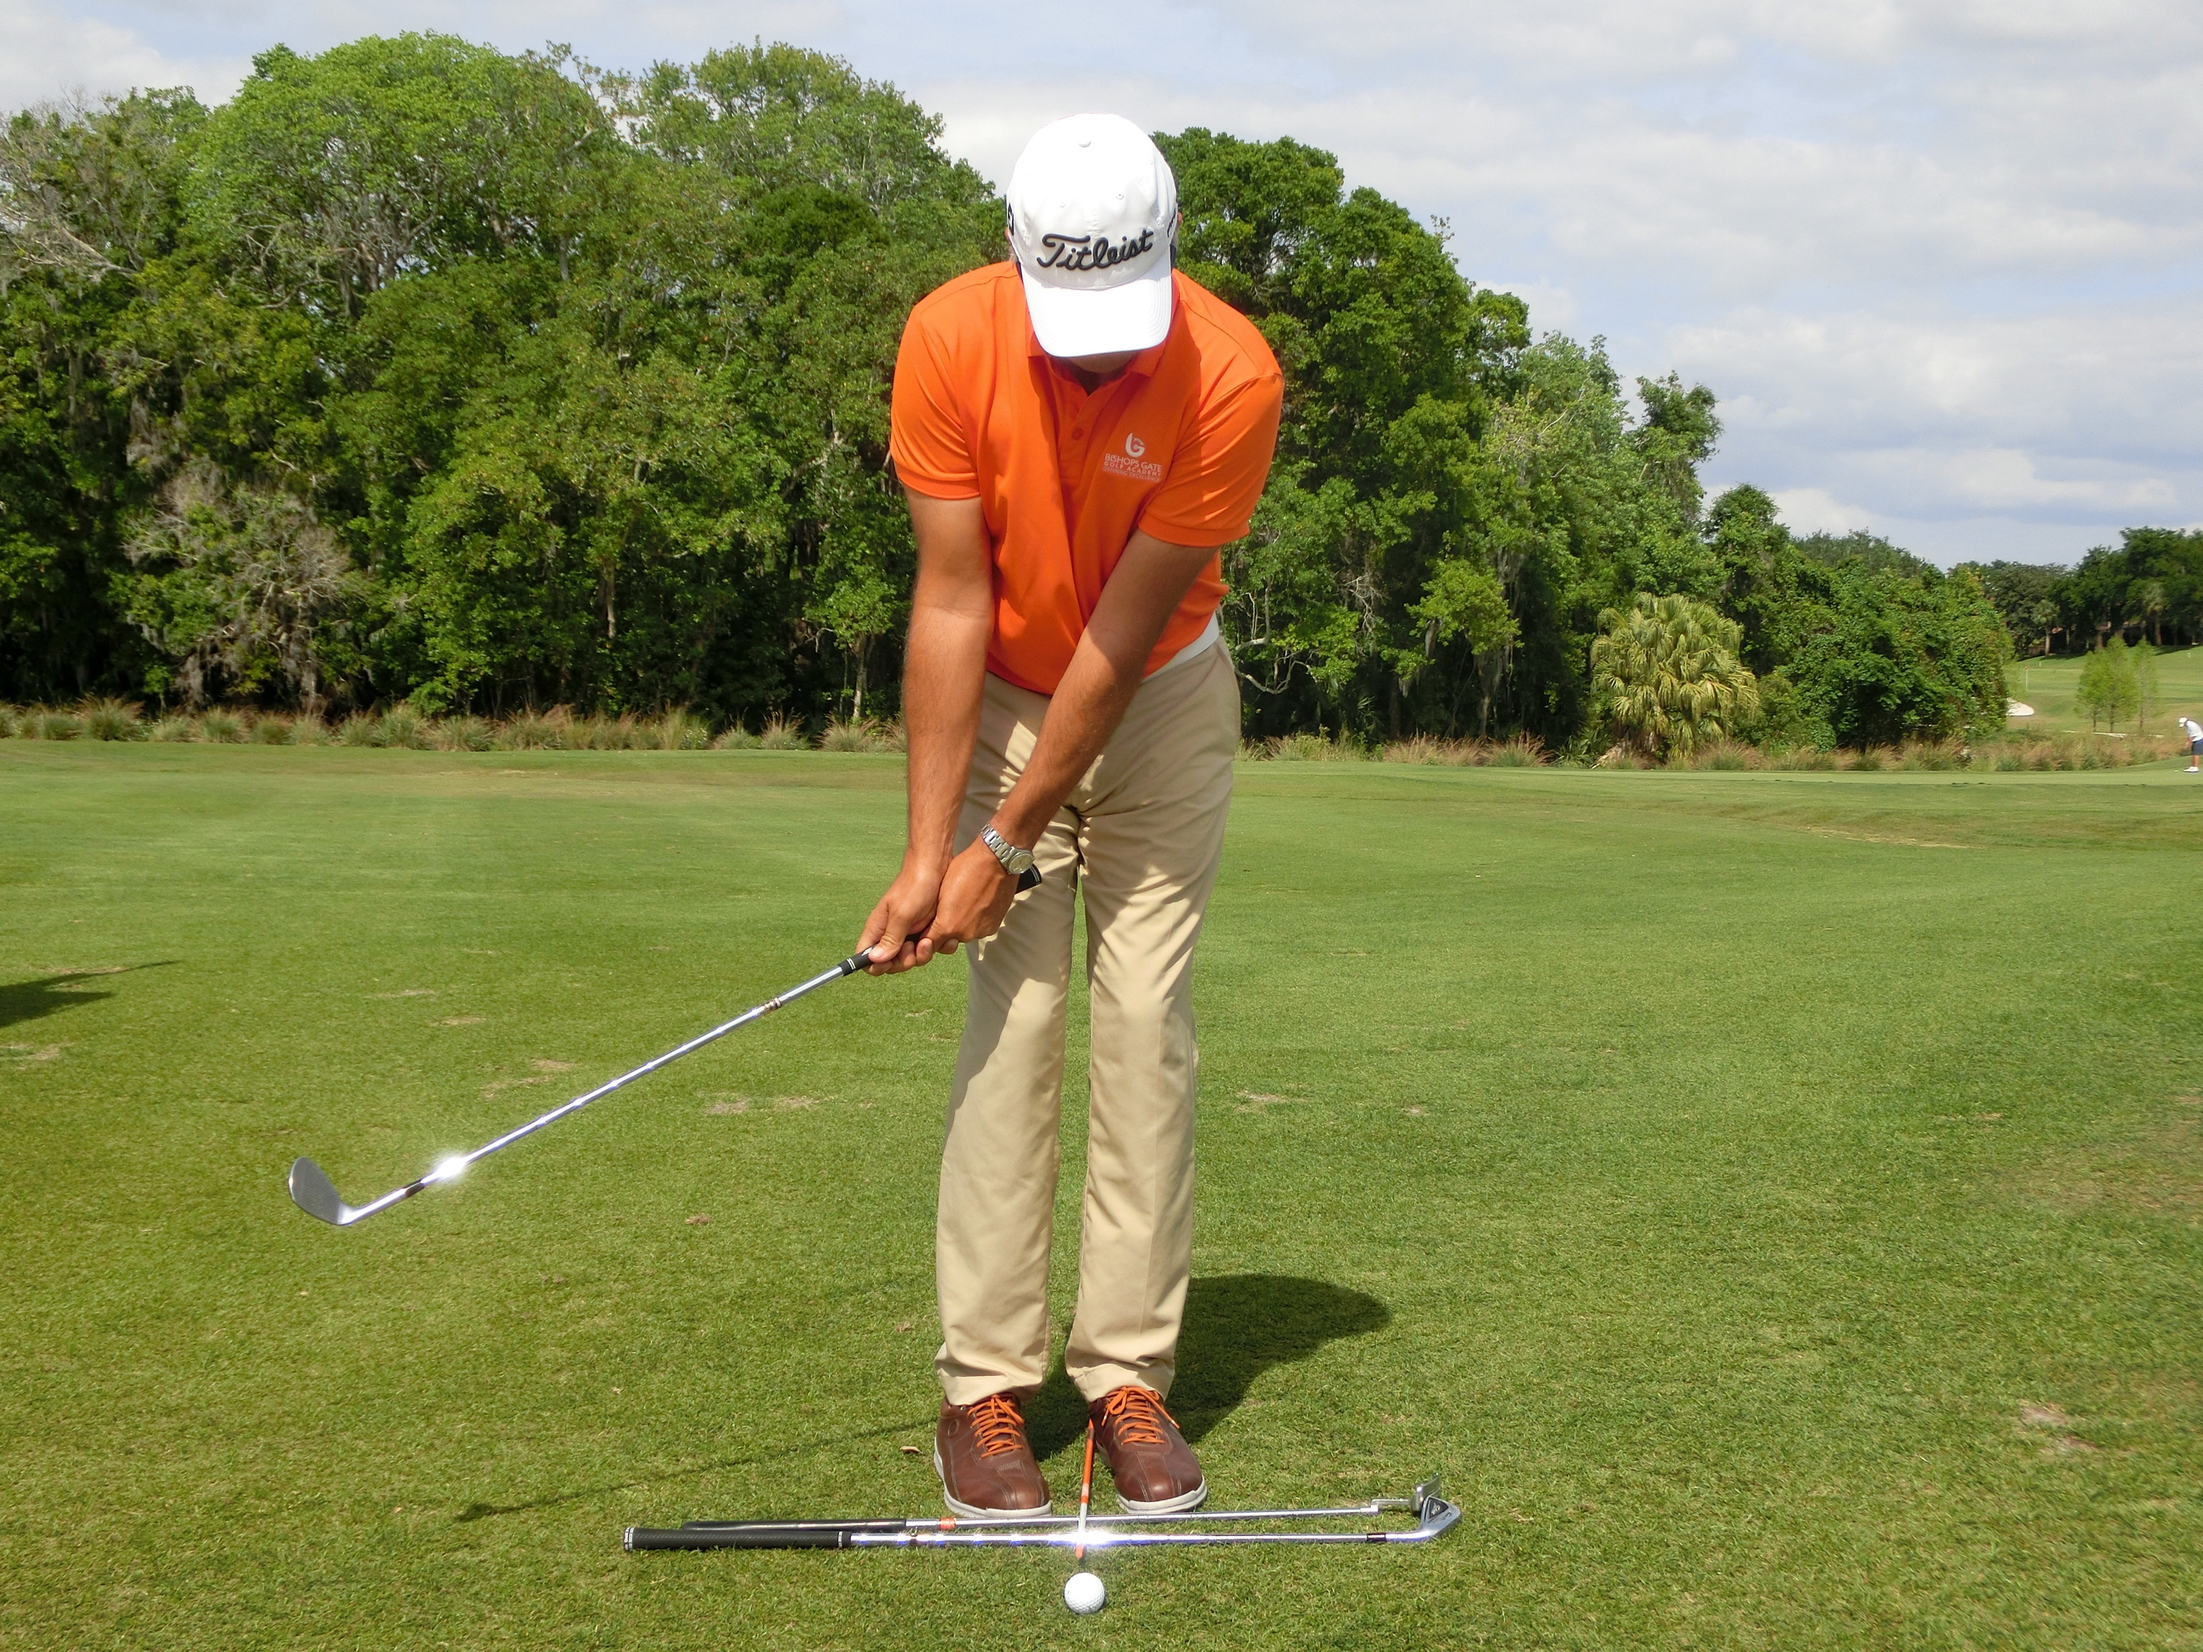

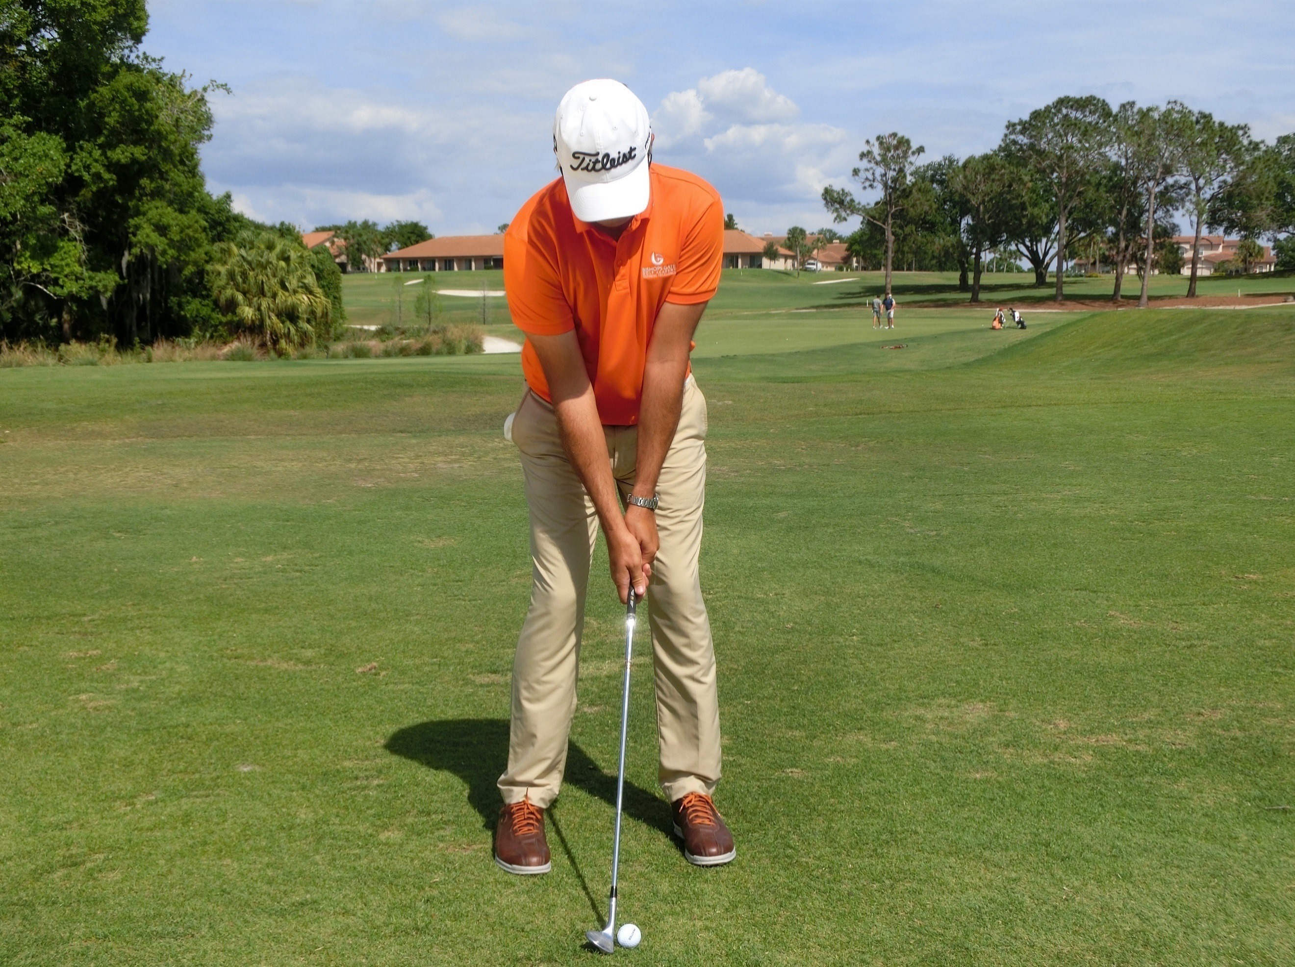
Pitching:
Objective: Create a technique that controls the spin rate, strike and trajectory making distance control easy.

Set up:
- Feet at 11 O’clock.
- Knees, hips and shoulders square.
- Width of stance is between the full swing and chip.
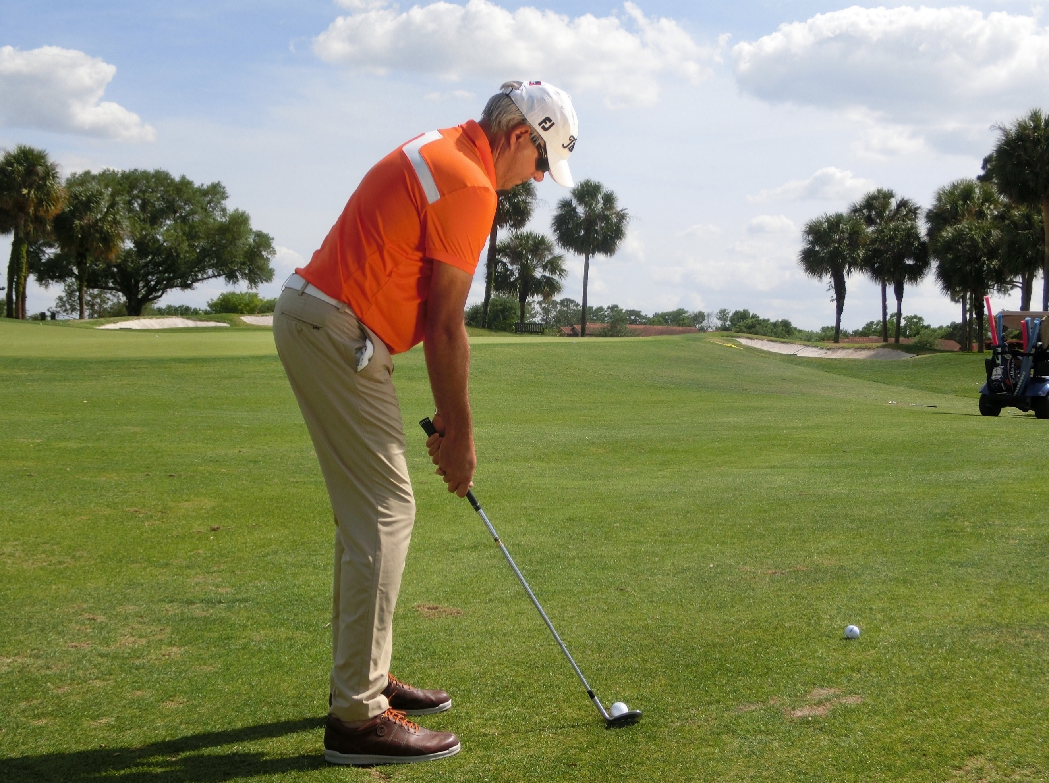
- Distance from the ball is between the full swing and chip.
- Weight leans 60% left (including lower body)
- Ball positioned in the middle.

Motion:
- Key is to allow the turning motion of the trunk to create the energy.
- The arms stay at the same speed as the trunk.
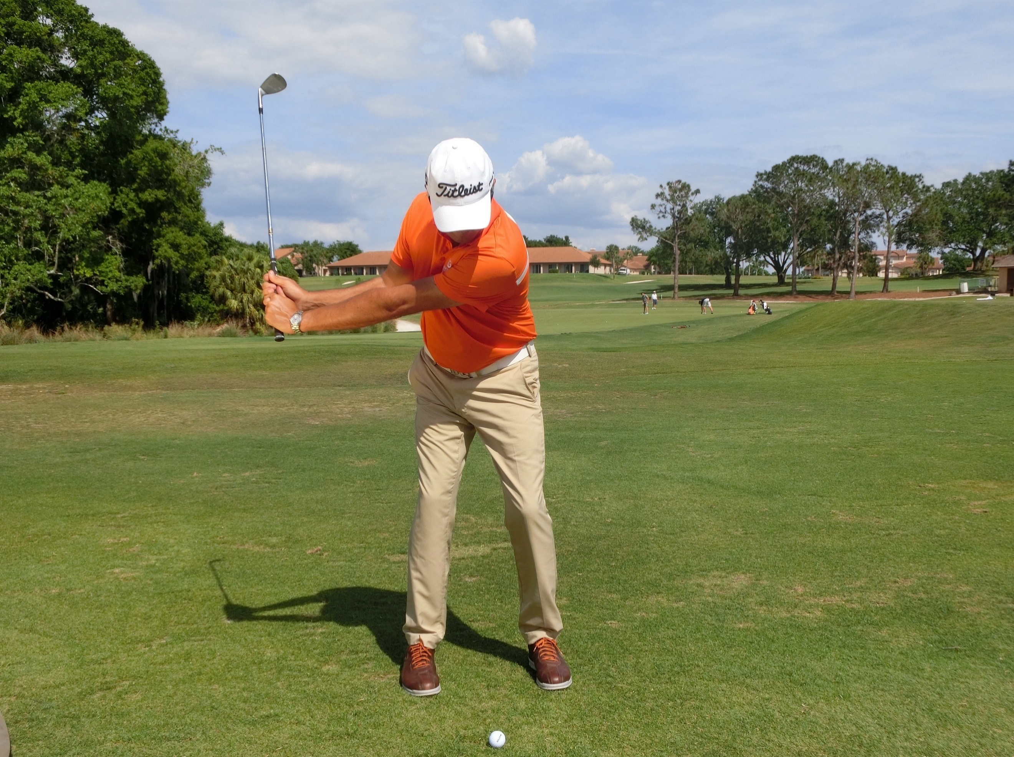
- The swing is a wide, U shaped swing with the club creating a flat area at the bottom of the swing, which allows the club to skid, not a V shaped, steep action, which digs.

Assignment:
- Film your pitching presentation.
- Find the best tour player technique you can and do a voice over of why it works so well.

- Demonstrate a ‘before and after’ of someone’s pitching improvements.

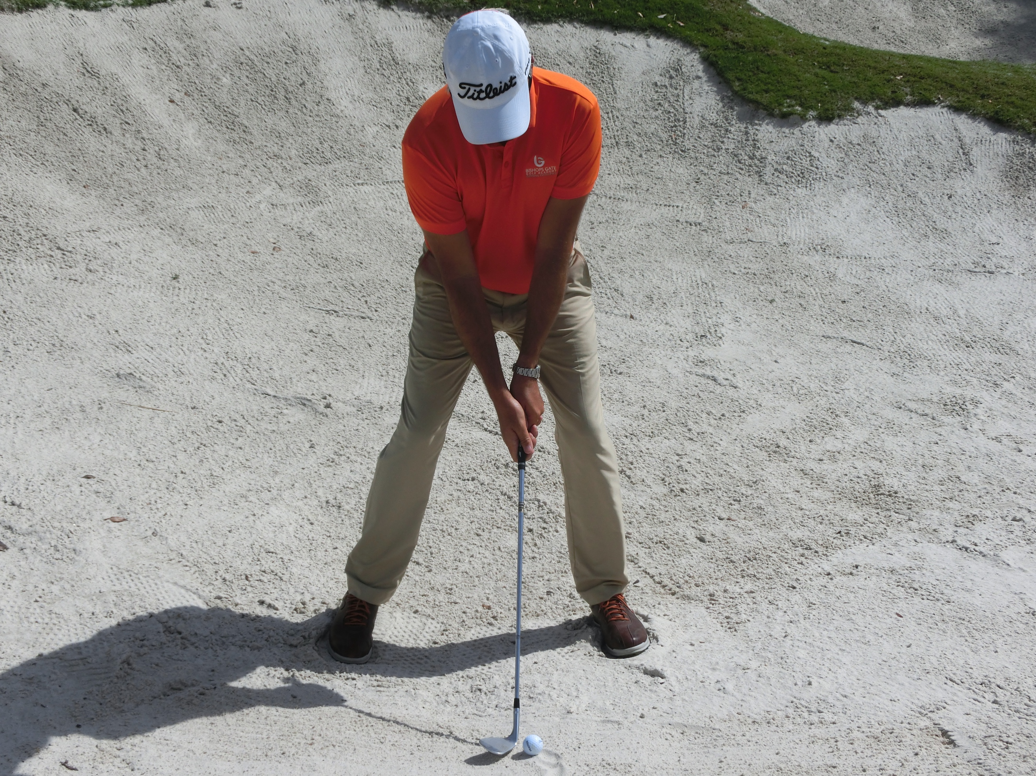
Standard Bunker Shot:
Objective: To create a motion allowing the club to skid, producing high, spinny and controlled bunker shots.

Set-up:
- Body at 11 O’clock.
- Club at 12.30, then grip it.
- Wide stance with low center of gravity.
- Ball forward, hands back and low.

The Motion:
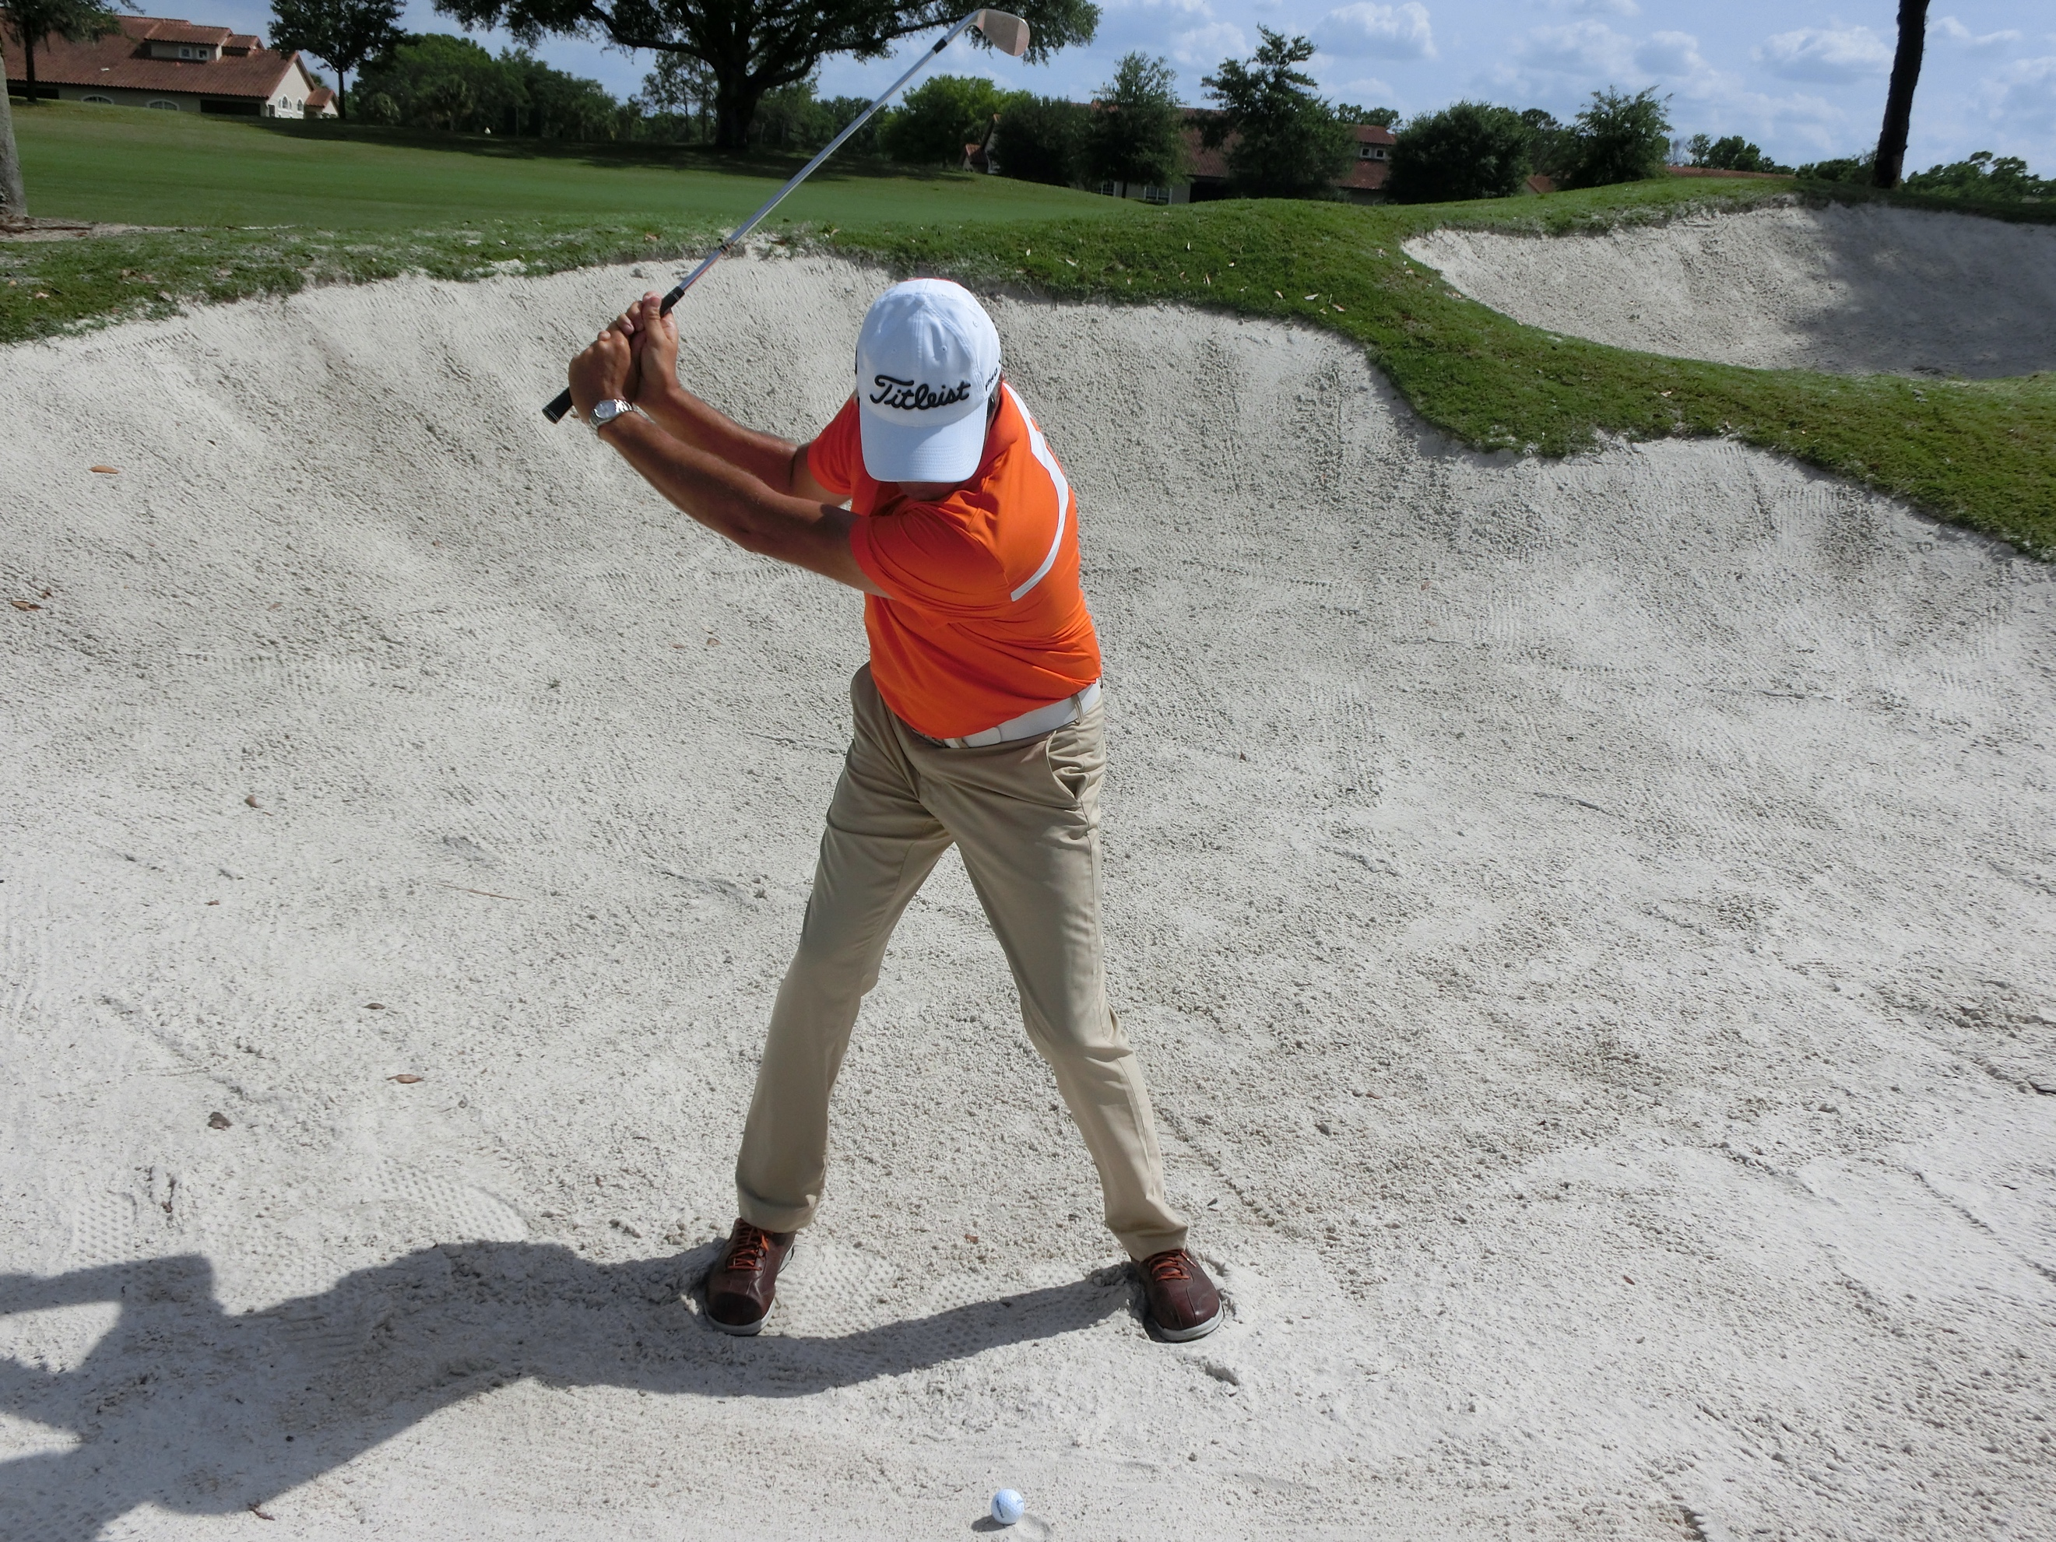
- Turn the trunk.
- Feel the weight of the club.
- Allow the club to swing and get the toe hanging at the top.
- The downswing should be shallow, not steep.
- The handle slows down as the right-hand releases hard under the right.
- The left arm folds on the way through to a complete finish.
- Feet planted and still.
- Rhythm is a key component.
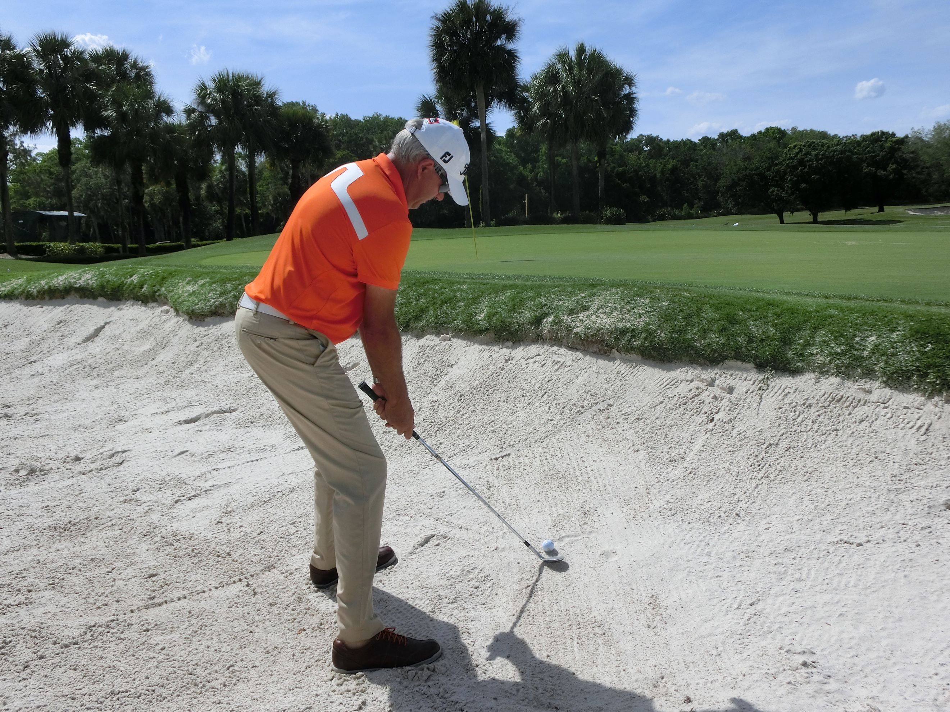
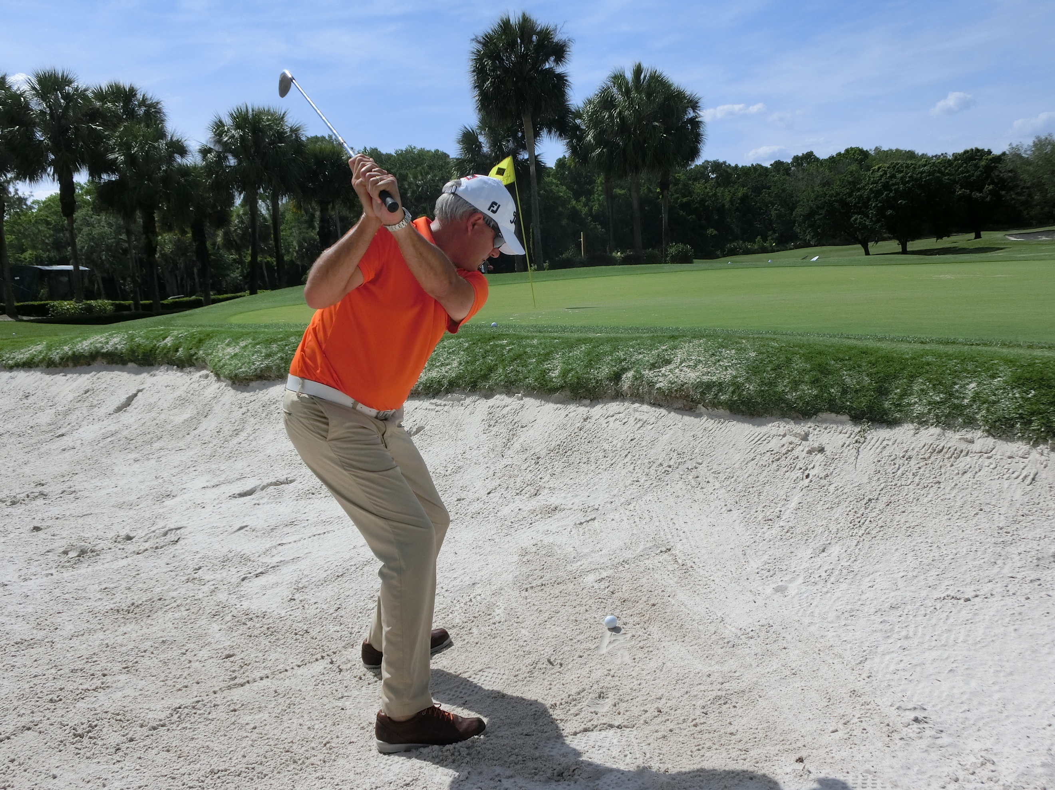

Assignment:
- Film your bunker presentation.
- Demonstrate a ‘before and after’ of a player’s bunker improvements.
- Do a piece-to-camera on the bounce of the club and how it works.

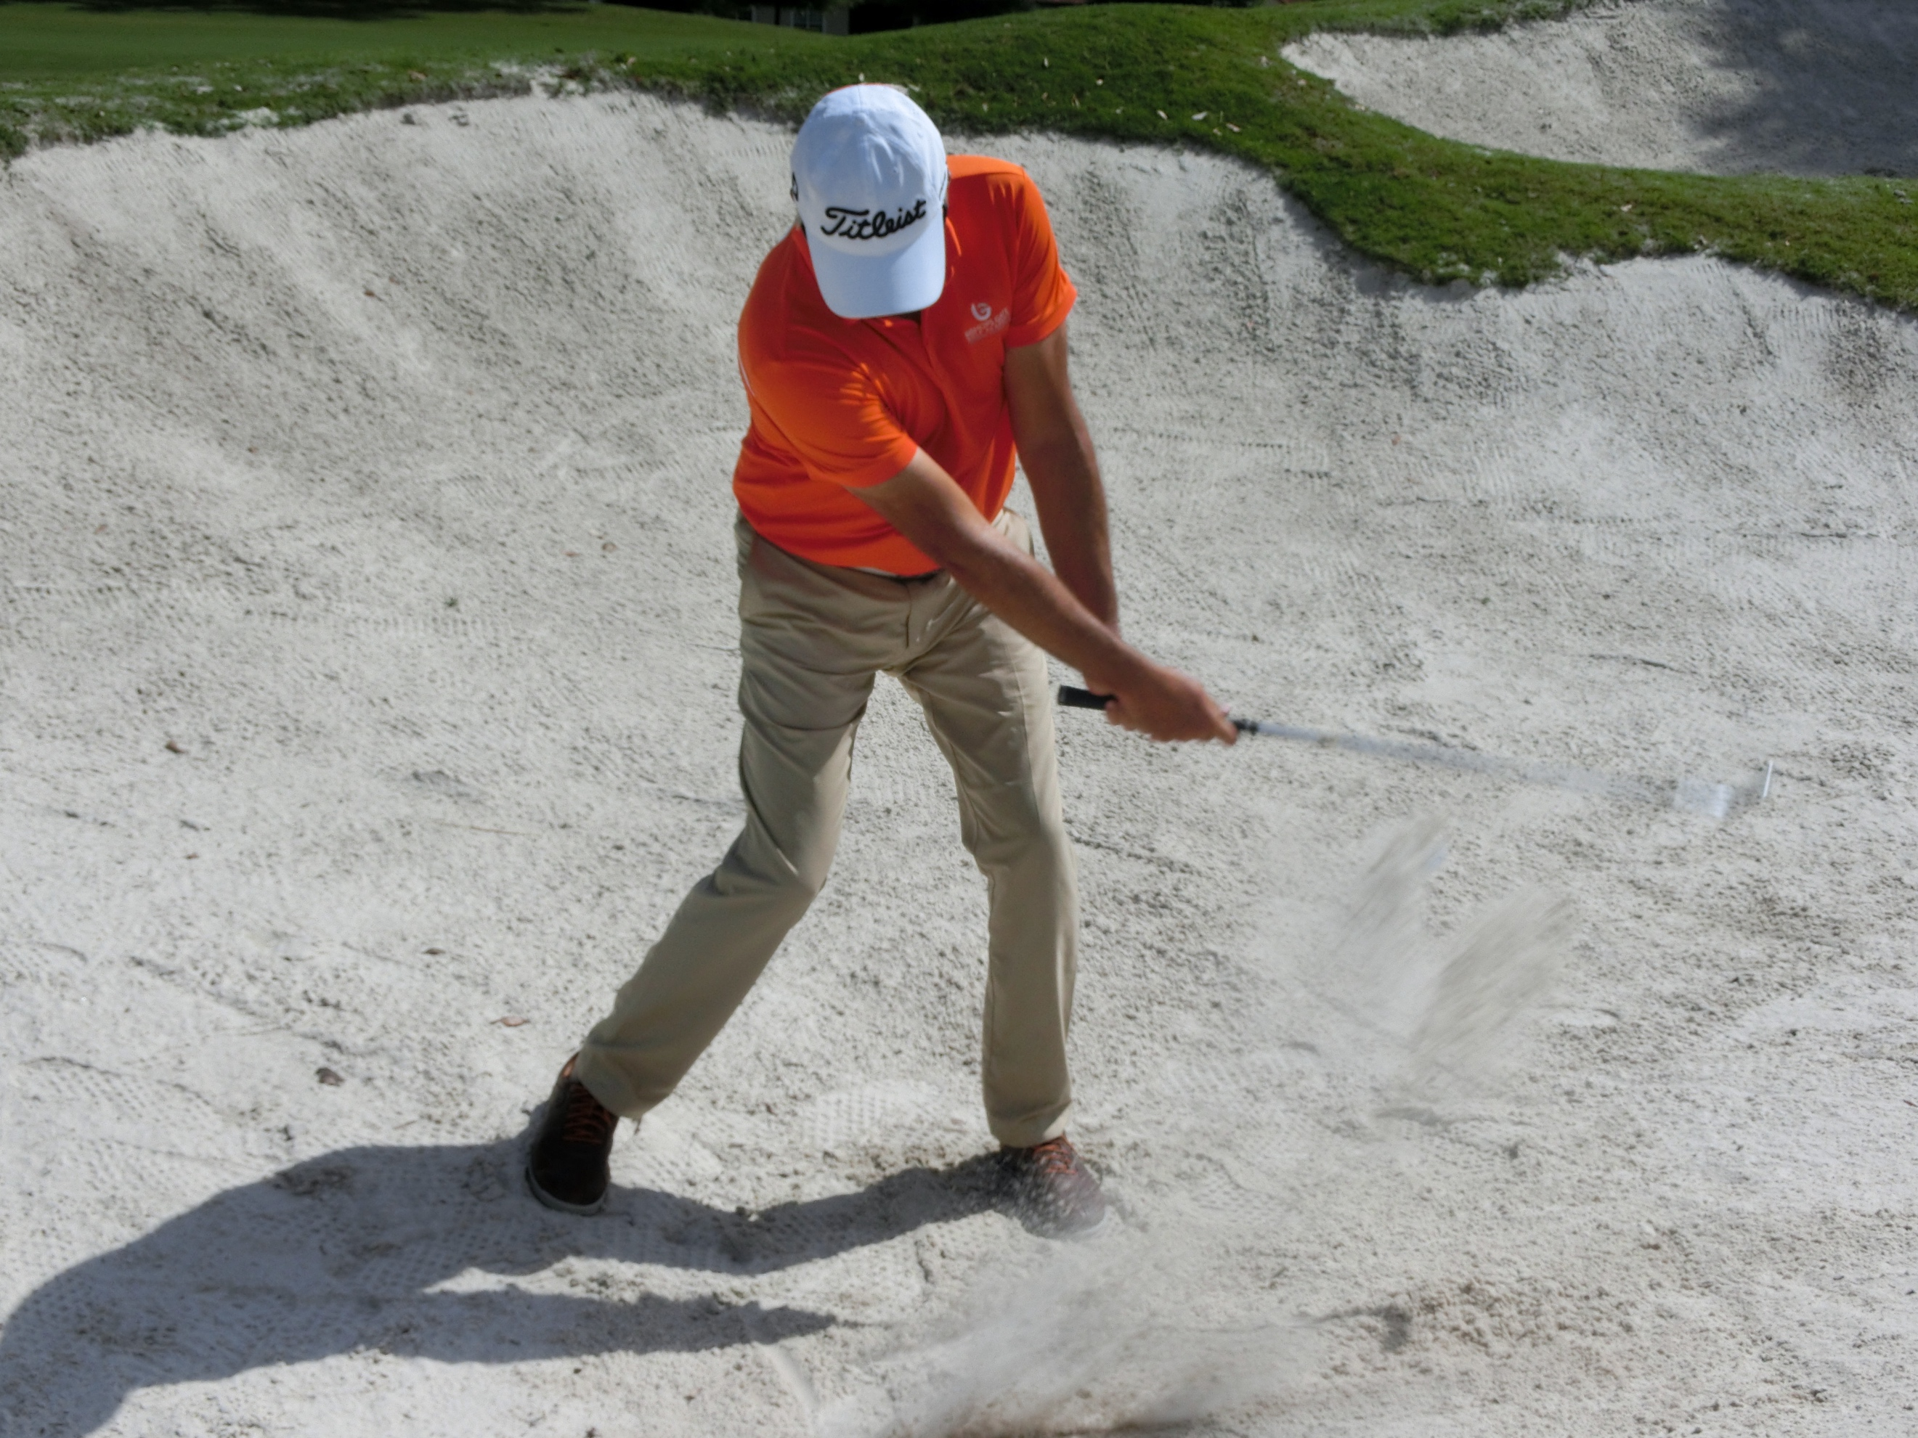
Sure-out bunker Shot:
Goal: To give confidence to a player who has lost it and to have an emergency shot for a good player. It works on the premise of just using the bottom half of the traditional bunker shot, creating a wide ‘U’ shaped half swing, which allows the club to skid.

Set-up:
- Square set up.
- Ultra-wide stance.
- Lean weight 70/30 left.
- Ball in center.
- Grip down the club and lock arms into a straight ‘V’.
- Engage abs.

Motion:
- Lock arms and use a strong turn of the abs and hips keeping the arms locked.
- If the ball is at 6 o’clock when observed from the front, then the stroke goes only as far as 9 o’clock to 3 o’clock with the arms staying locked.

Swing styles:
In order to teach effectively, our coaches have an awareness of different swing types and styles. This knowledge allows the coach to create an adaptive style and approach rather than a “cookie cutter” method. This requires skill and craft.

There are many ways to swing a golf club that have proved effective over the years. That is the beauty of the game - there is not one way to do it. As a coach, you need to know different styles of swing and how they work. One size does not fit all in golf. If you had Paul Azinger for a lesson and changed his clubface, he probably would never have been the accurate player and champion that he was. If you follow a method of teaching, you would have changed it and screwed up a great champion most likely. So, you owe it to your students to study how different swing styles work. That knowledge pool will be vital as you climb the ladder. Great teachers have a vast knowledge pool and know what to pull out and when, to suit their audience.

At IJGA, we have certain ideals (See Ideals and Flow Generics section) we would like to see in some swings. But it is felt that a coach should understand how differing body styles and movement patterns should be catered to. Below are some examples of certain swing styles:

- Classic two axis- Faldo
- One Axis/One plane- Hogan
- Shut to open- Azinger, Duval
- Rotary/toe up, toe up- Norman
- Leverage/Compressor- Campbell
- Picker- Donald
- Stack and tilt- Rock
- Idiosyncratic- Furyk, Bubba

Overall:
I hope you have found this handbook useful and will refer back to it in the future. I also hope that you have enjoyed your IJGA summer camp and we will see you again one day!

Happy Golfing

Jonathan Yarwood and team

Player notes:


Planning is the Most Important Step in College Placement
Boasting a near 100% college placement rate, the International Junior Golf Academy (IJGA) approach to college preparation has proven effective time and time again. Our students have received over $52 million in scholarships and our alumni have gone to attend schools with prestigious golf programs such as Georgia Tech, Princeton, Dartmouth, Oklahoma State University, Texas A&M, Notre Dame, Yale, University of Alabama, UCLA and Boston College. Ultimately, our students have gone on to have successful careers in the PGA, LPGA, and European Tours, with some alumni reaching the ranks of famous golfers.

Your College Golf Resource Center
With limited college golf team spots and scholarships available, you need an edge. Download all the IJGA College Planning & Placement articles & resources here.
- Top 10 Questions to Ask the Coach When Considering College Golf Programs
- Your College Roadmap

- Collegiate Golf FAQs
- Typical College Golfer Scoring Averages
- What Prospective College Golfers need to Know about Scholarships and the NCAA
- The Teen Brain (and How to Deal With It)
- Overlooked College Golf Programs
- Best Small College Golf Programs
- Quiz – What Schools Are Right for Me?


